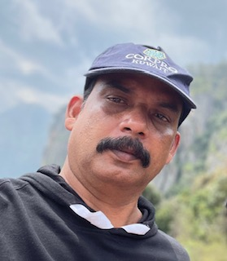
EDUCATION:
Master of Business Administration (Sports Management)
Tamilnadu Physical Education and Sports University, Tamilnadu
Master of Physical Education
Centre for Physical Education, University of Calicut
Bachelor of Physical Education
Centre for Physical Education, University of Calicut.
National Eligibility Test
University Grants Commission

SERVED AS:
Member of the Board, Calicut University team selection committee.
Member of the Board, Kerala Public Service Commission to select officers for various departments.
Additional Chief Superintendent, Calicut University Examinations.
Associate NCC Officer, sixth company, MES Asmabi college, P.Vemballur.

MEMBERSHIP:
Executive committee member, TDBA
Executive committee member, TDAAA
Member, Kerala State Volleyball Referees Panel
EXPERIENCE:
Assistant Professor at MES Asmabi college, P.Vemballur (2009 onwards)
Lecturer on contract at Sree Krishna college, Guruvayur (2001 to 2009)

Lt. M.B.Bindil
Assistant Professor
MES Asmabi College, P.Vemballur
P.Vemballur.

