Two Day National Seminar on Cultural Studies at the Crossroads: Rethinking Power, Identity and Representation

The Research Department of English, MES Asmabi College, P. Vemballur in collaboration with Kerala Sahitya Akademi organised two day National Seminar titled “Cultural Studies at the Crossroads: Rethinking Power, Identity and Representation” on 22 and 23rd January 2026. Dr. Reshmi S, the Convenor of the programme welcomed the gathering. Dr. Sameena Kalathodi, Principal of MES Asmabi College delivered the presidential address. Dr. Anu Kuriakose, Assistant Professor, Department of Humanities and Social Sciences, National Institute of Technology inaugurated the session and delivered Keynote address. Dr. Sanand C Sadanandan, Vice Principal of MES Asmabi College, Smt. Jameelathu KA, Faculty of English, Dr. Dhanya PR, IQAC Co-ordinator of MES Asmabi College felicitated the occasion. Smt. Mona MV, faculty of English delivered the vote of thanks.

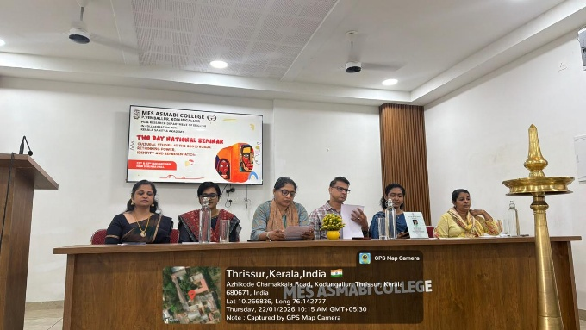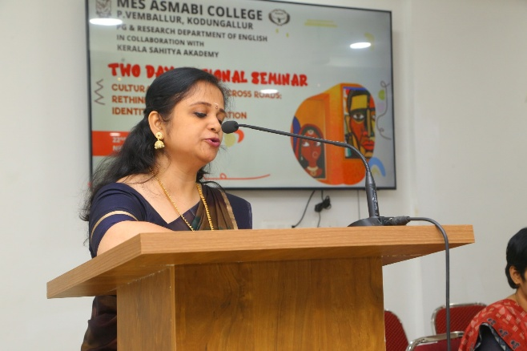

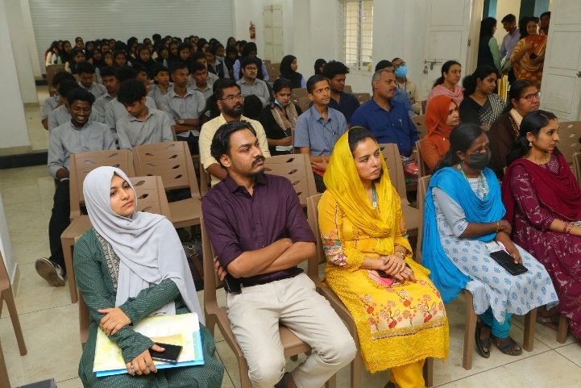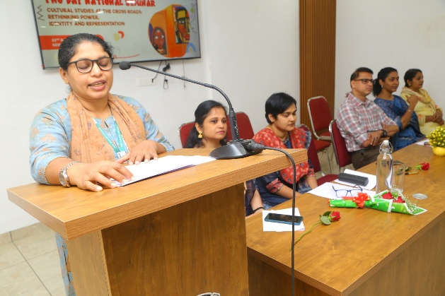
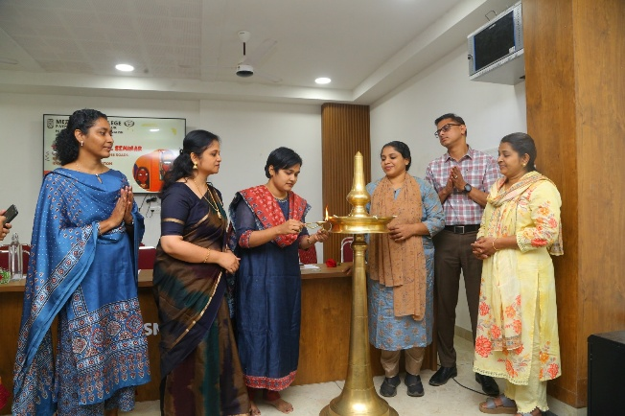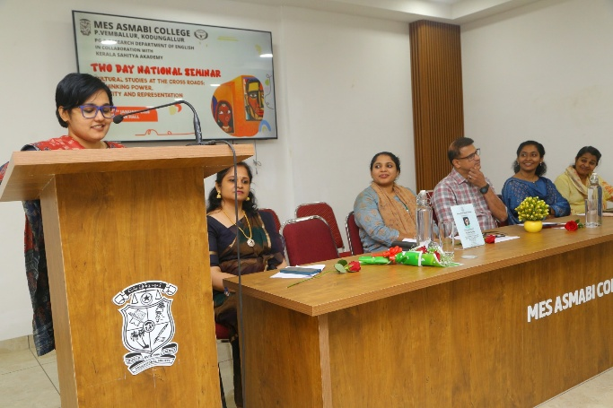

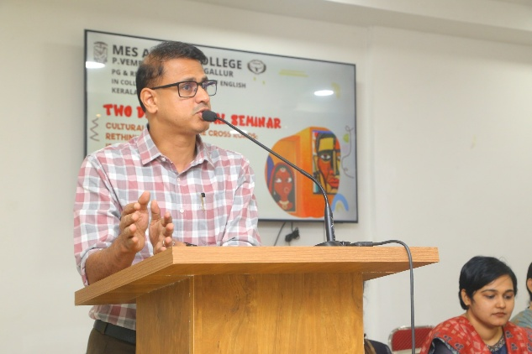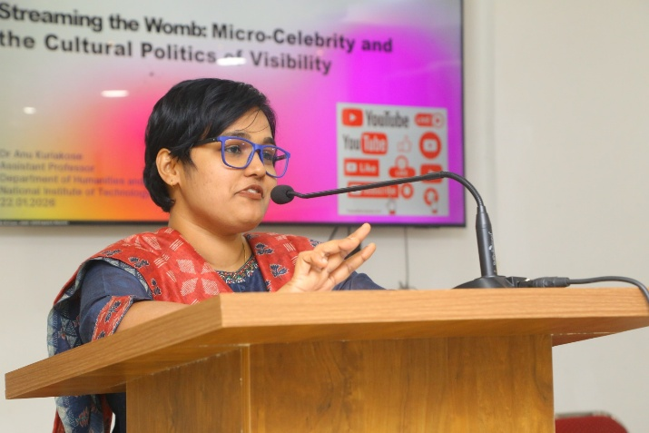

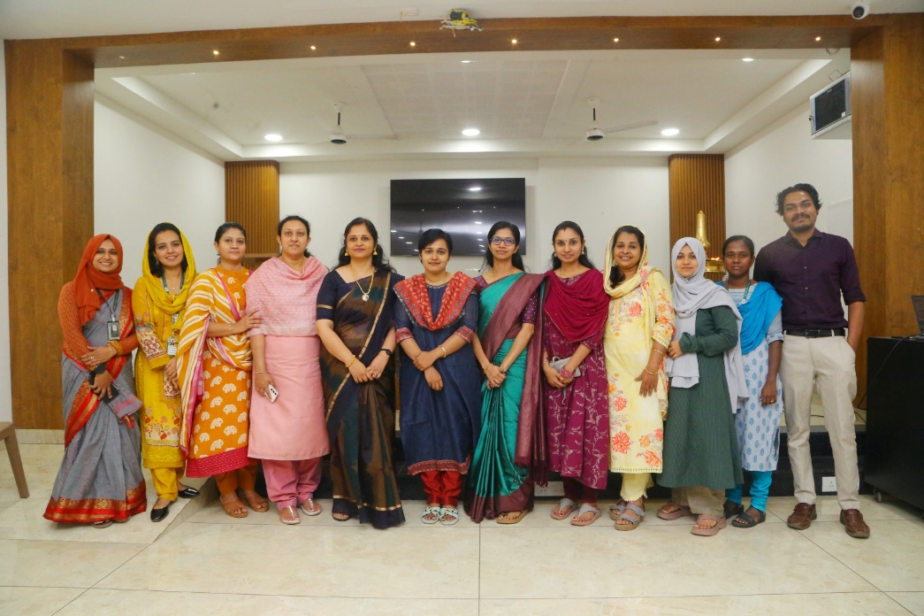
Inaugural session was followed by Plenary session 1 with the topic “Streaming the Womb: Micro-Celebrity and the Cultural Politics of Visibility” by Dr. Anu Kuriakose on 22nd January 2026. This session was very resourceful and insightful when it became interactive. Dr. Babitha, Assistant professor from SN College, Nattika chaired offline session 1. Dr. Jayaprakash, Assistant Professor, Polytechnique college and Dr. Shinoj PV from Kerala Kalamandalam chaired parallel session 2 and 3 respectively. Dr. Shweta Meena, Assistant Professor of English from University of Rajasthan, Jaipur handled session 2. She handled the session titled “Deciphering Dreamtime Narrative: Assertion of Australian Aborigine’s Sacredness and Identity” on 22 January 2026 at 2pm-3pm. Online presentation sessions 1,2,3,4 and 5 were conducted.
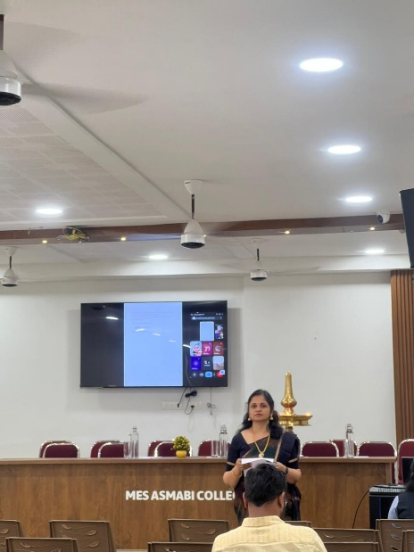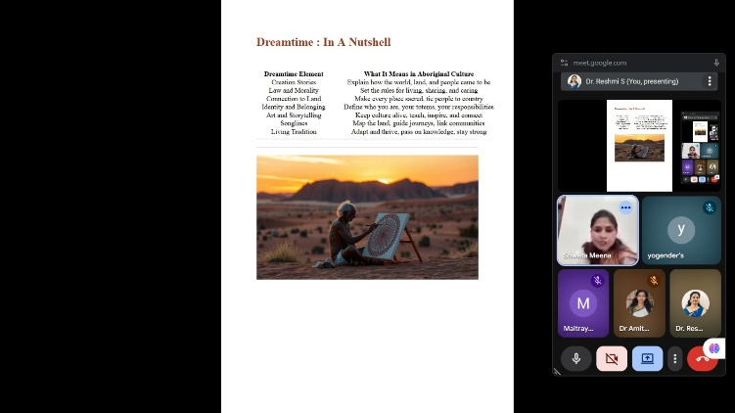

Day 2 of the National Seminar began with welcome speech by Dr. Reshmi S. Dr. KS Ragini, Assistant Professor of Media Studies, Malayalam University, Tirur, Malappuram delivered plenary session 3 on the topic “Media and Culture Representation”. After the session, Dr. Ragini Chaired a session. Offline sessions 4,5 and 6 were organised in parallel venues. In the afternoon, Online sessions 6,7,8,9,10,11 and 12 were conducted. The seminar was a grand success with three plenary sessions and 19 paper presentation sessions.
