CHIEF MINISTER’S MEGA QUIZ 2026

As per the direction received from Collegiate Education, MES Asmabi College conducted Chief Minister’s Quiz on January 12, 2026 at Old Seminar Hall. Dr. Reshmi S, Assistant Professor of English coordinated the programme. 26 students representing various classes were the participants of the quiz. The college level quiz began at 10.30 am with a set of 30 questions. Dr. Reshmi S was the quiz master and she shared the guidelines with the students. The quiz continued until 11.30 am. Based on the answer key, the papers were evaluated by the faculties namely Smt. Sabitha MM, Smt. Reshma TM and Mr. Shan Mohammed from English department.
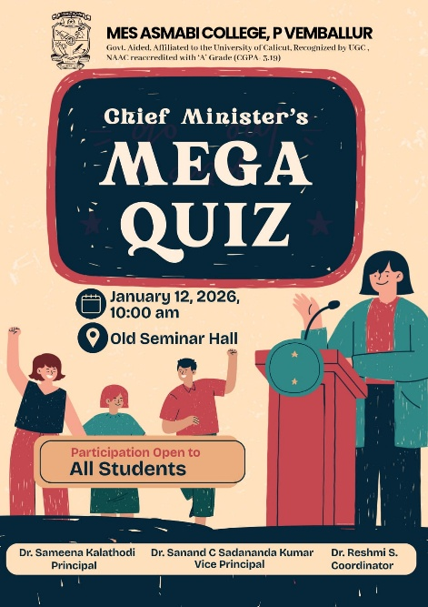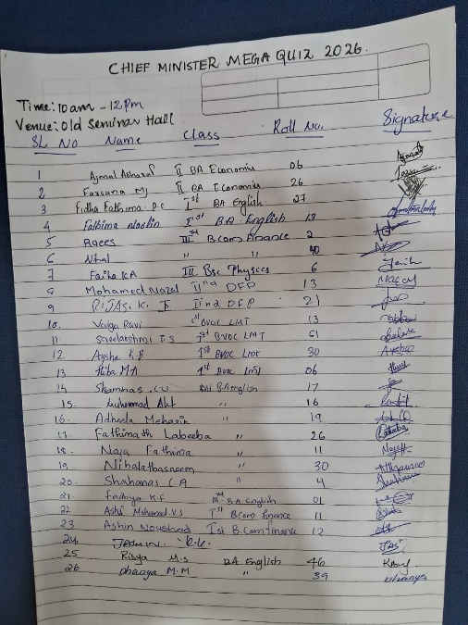

Here is the list of Stage 1 winners:
Team A
1. Fadhiya KF(III BA English)
2. Sreelakshmi TS (I BVOC Logistics)
Team B
3. Faiha KA(III BC Physics)
4. Ashin Noushad KN (I BCom Finance)
All these students were selected to district level Quiz competition scheduled on February 2nd 2026 at St. Mary’s college, Thrissur at 1 pm.

