
DEPARTMENT OF MALAYALAM
M E S ASMABI COLLEGE, P. VEMBALLUR

Ramayanam Quiz

REPORT

Date: August 05, 2025

Time: 10.30 AM
Venue: Room No 16
Agenda: Dept.of Malayalam &Botany jointly organized Ramayanam Quiz.
Student participation: 26 students
Staff participation: 6

Report:
As a part of Ramayana Masacharanam ,Malayalam department in collaboration with Botany conducted Ramayanam Quiz on 05.08.2025.The Quiz has been conducted based on Titled ‘Ramayanam”. Among 26 members were participated.
First position-Dept. of Aqua culture
Second position- Dept.of Economics

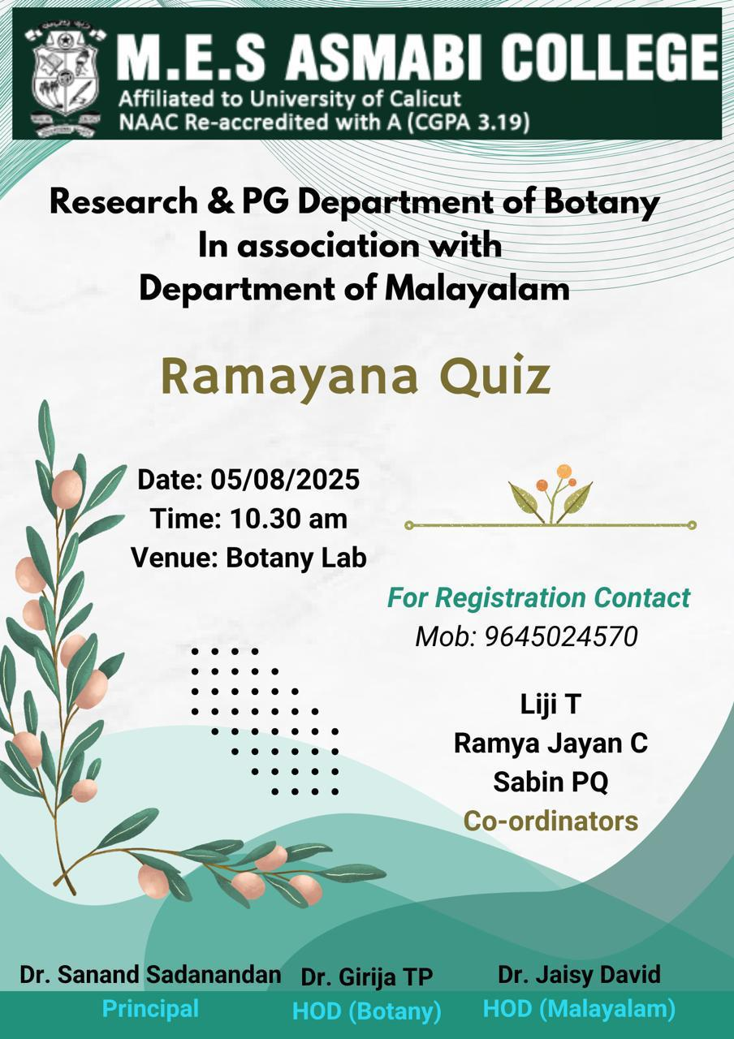

Ramayanam Quiz Brochure conducted on 05.08.2025

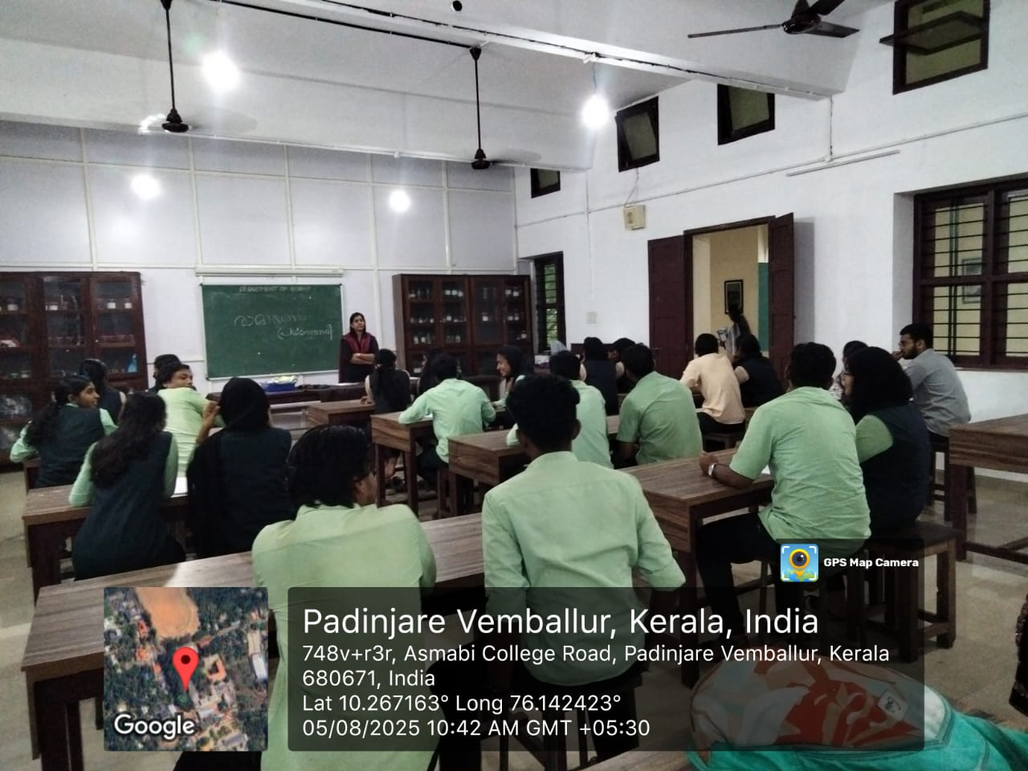

Dept.of Malayalam conducted Ramayanam Quiz on 05.08.2025

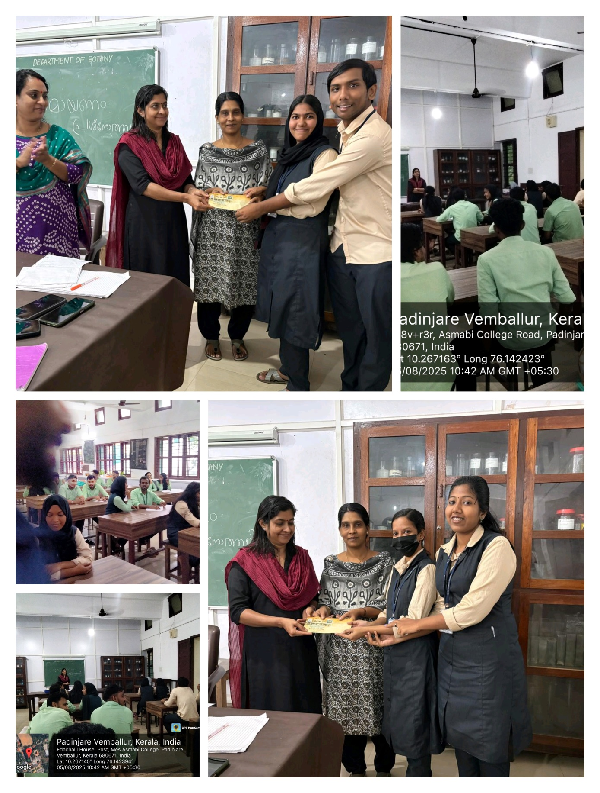

Dept.of Malayalam conducted Ramayanam Quiz on 06.08.2024

:

----

