Report on the National Webinar: "Premchand ke Katha Sahitya Mein Yatharth Chitran" 202.08.2025
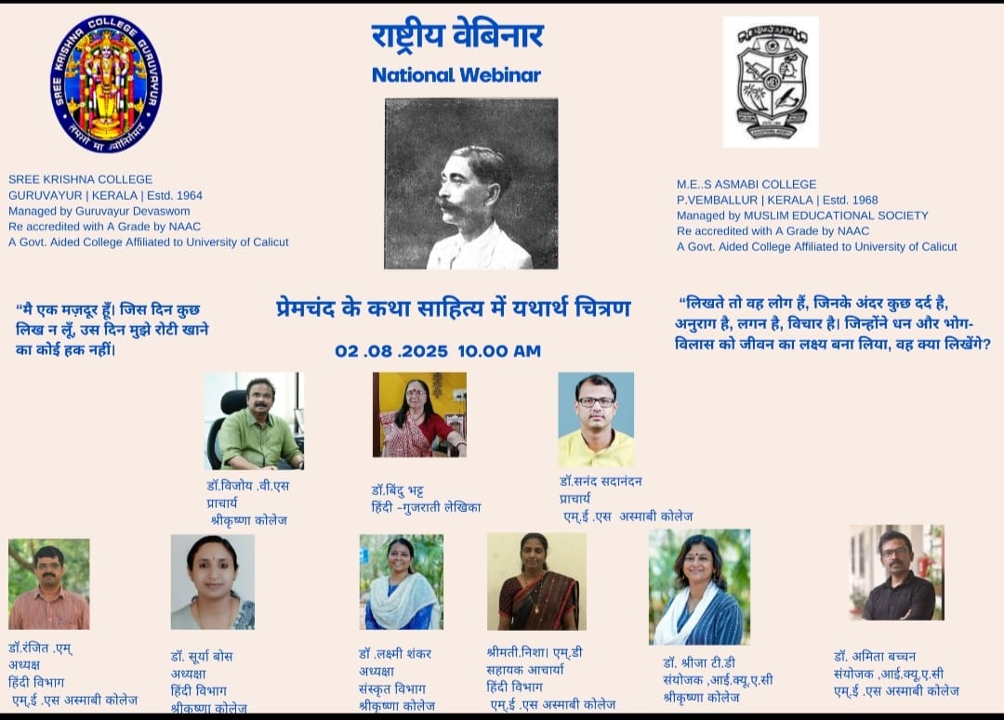

Program Objectives
The main objectives of the webinar were:
- To analyze the element of realism (yatharthvaad) in Premchand's narrative literature.
- To explore how Premchand’s works reflect the socio-economic and cultural conditions of his time.
- To provide a platform for academic dialogue among scholars, researchers, and students on the significance of Hindi literary heritage.
- To encourage intercollegiate collaboration and promote critical thinking among literature students.
Report
The Departments of Hindi of MES Asmabi College and Sree Krishna College, Guruvayur, jointly organized a National Webinar on the topic “Premchand ke Katha Sahitya Mein Yatharth Chitran” on 2nd August 2025. The event brought together scholars, students, and literature enthusiasts from across the country to explore the themes of realism and social reflection in the works of the legendary Hindi writer Munshi Premchand.
The session commenced with a warm welcome address by Dr. Surya Boss,HOD of Hindi,Sreekrishna College,Guruvayur who set the tone for the webinar by emphasizing the continued relevance of Premchand’s literary contributions in today’s socio-cultural context.
This was followed by the presidential address by Dr. Ranjith M,HOD,Department of Hindi of MES Asmabi College,Kodunagallur, who highlighted the importance of interdisciplinary and inter-institutional collaboration in promoting critical literary discourse. He elaborated on how Premchand’s narratives mirror the struggles of common people and the socio-political challenges of his time.
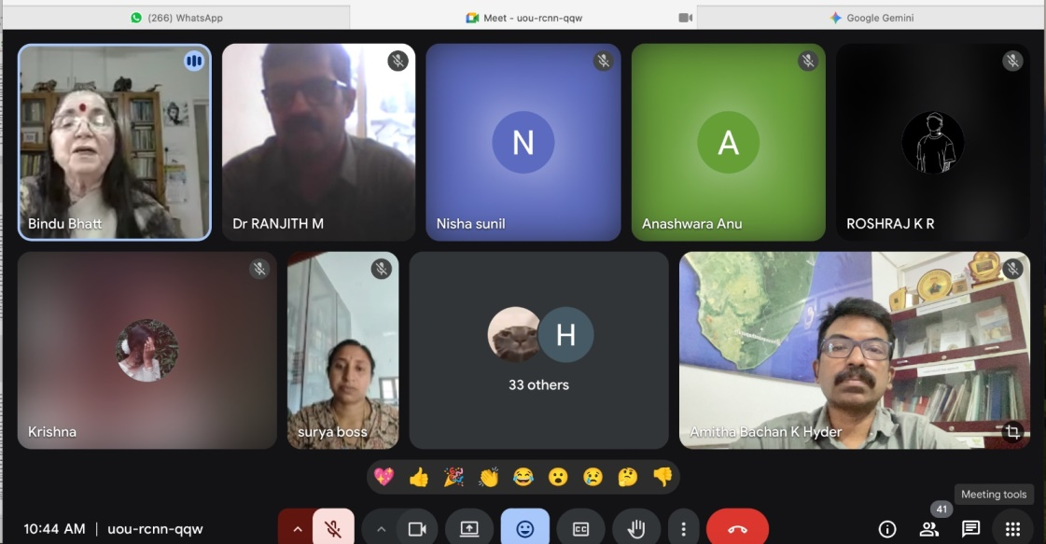
The chief guest of the webinar was Dr. Bindu Bhatt, a distinguished Hindi-Gujarati writer and academician. Dr. Bhatt delivered an insightful keynote speech analyzing the themes of realism in Premchand’s short stories and novels, drawing connections between his fictional characters and the lived realities of early 20th-century India. Her address was deeply appreciated by the participants for its scholarly depth and literary sensitivity.
The event also featured felicitation by Dr. Amitha Bachan,IQAC Coordinator of MES Asmabi College, who commended the organizing teams for bringing together a meaningful platform to revisit the legacy of Premchand. He stressed the need for young scholars to engage with vernacular literature in a critical and informed manner.
The webinar concluded with a vote of thanks delivered by Ms. Nisha M D, who expressed gratitude to all the speakers, participants, and organizing committee members for their active participation and support in making the event a success.
The webinar was well-received and served as an enriching academic experience, underlining the timeless relevance of Premchand’s work and the continued need to reflect on realism in literature.
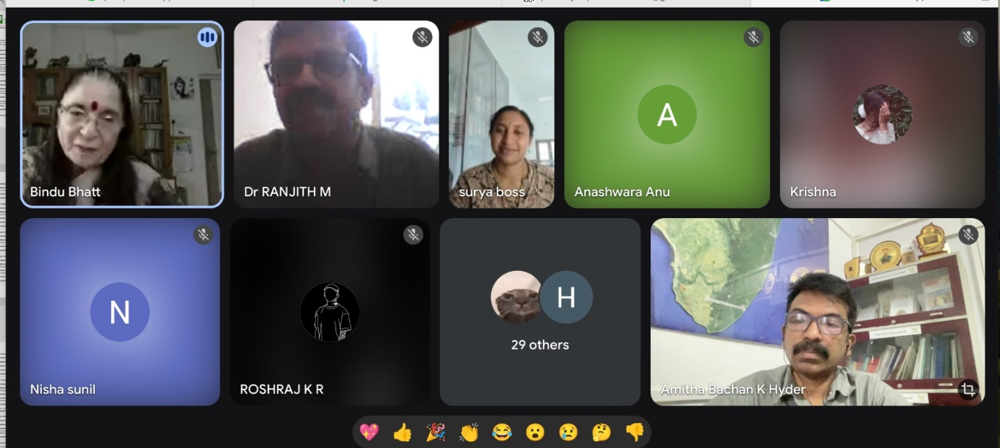

Participant Feedback
The webinar saw enthusiastic participation from faculty members, research scholars, and students across various institutions in India. A structured feedback form was circulated after the session. Highlights from the feedback include:
- 85% of participants rated the webinar as “Excellent” in terms of content, organization, and relevance.
- Many appreciated the clarity and depth of Dr. Bindu Bhatt’s keynote address.
- Students noted that the webinar helped them gain a deeper understanding of how literature reflects real social structures and historical conditions.
Conclusion
The National Webinar on "Premchand ke Katha Sahitya Mein Yatharth Chitran" successfully met its objectives, offering participants a meaningful engagement with one of Hindi literature's most significant figures. It fostered academic dialogue, critical appreciation of literary realism, and encouraged continued exploration of Hindi literary texts in academic and cultural contexts.

