Report on Financial Literacy Programme
Organized by the Department of Economics
MES Asmabi College, P. Vemballur
Date: 15th July 2025 | Time: 11:00 AM | Venue: New Seminar Hall
The Department of Economics, MES Asmabi College, P. Vemballur, conducted a Financial Literacy Programme on 15th July 2025 at 11:00 AM in the New Seminar Hall. The event was part of the department’s ongoing efforts to empower students with essential financial knowledge and skills for sustainable financial well-being.
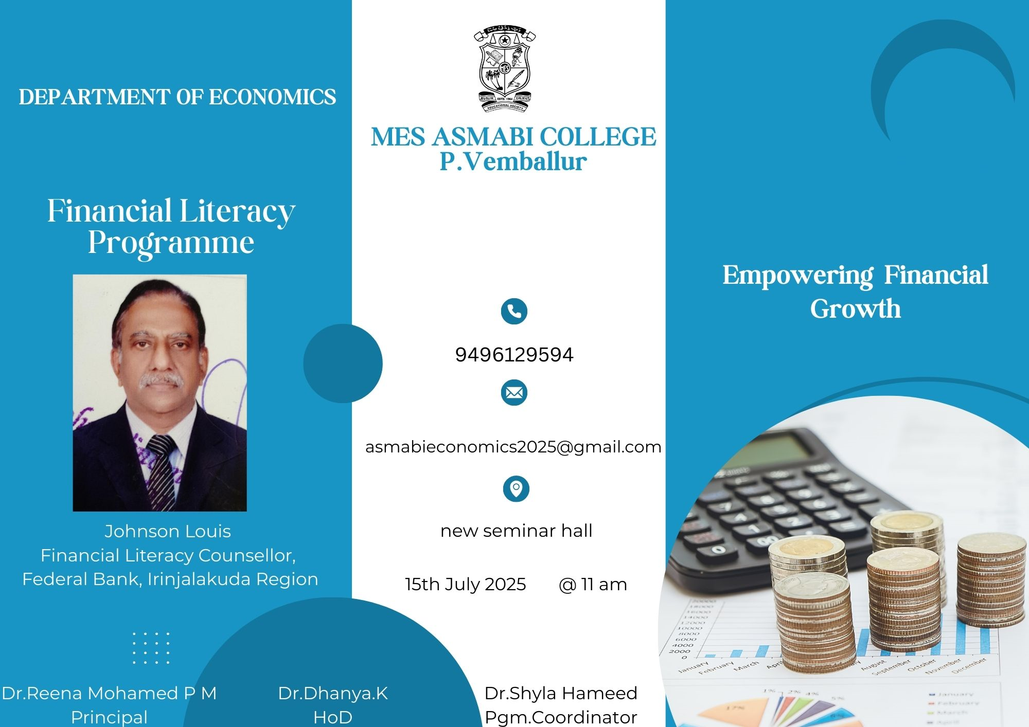

Resource Person:
The session was led by Mr. Johnson Louis, Financial Literacy Counsellor, Federal Bank, Irinjalakuda Region. With his rich experience in banking and financial education, Mr. Louis delivered an insightful session focused on practical aspects of personal finance management.

Dignitaries Present:
- Dr. Reena Mohamed P M, Principal of MES Asmabi College, inaugurated the programme and addressed the students on the importance of developing financial literacy at a young age.
- Dr. Dhanya K, Head of the Department of Economics, welcomed the guest and participants, emphasizing the department’s commitment to equipping students with real-world skills.
- Dr. Shyla Hameed, Programme Coordinator, ensured the smooth execution of the event and highlighted the relevance of financial literacy in today’s changing economic

- env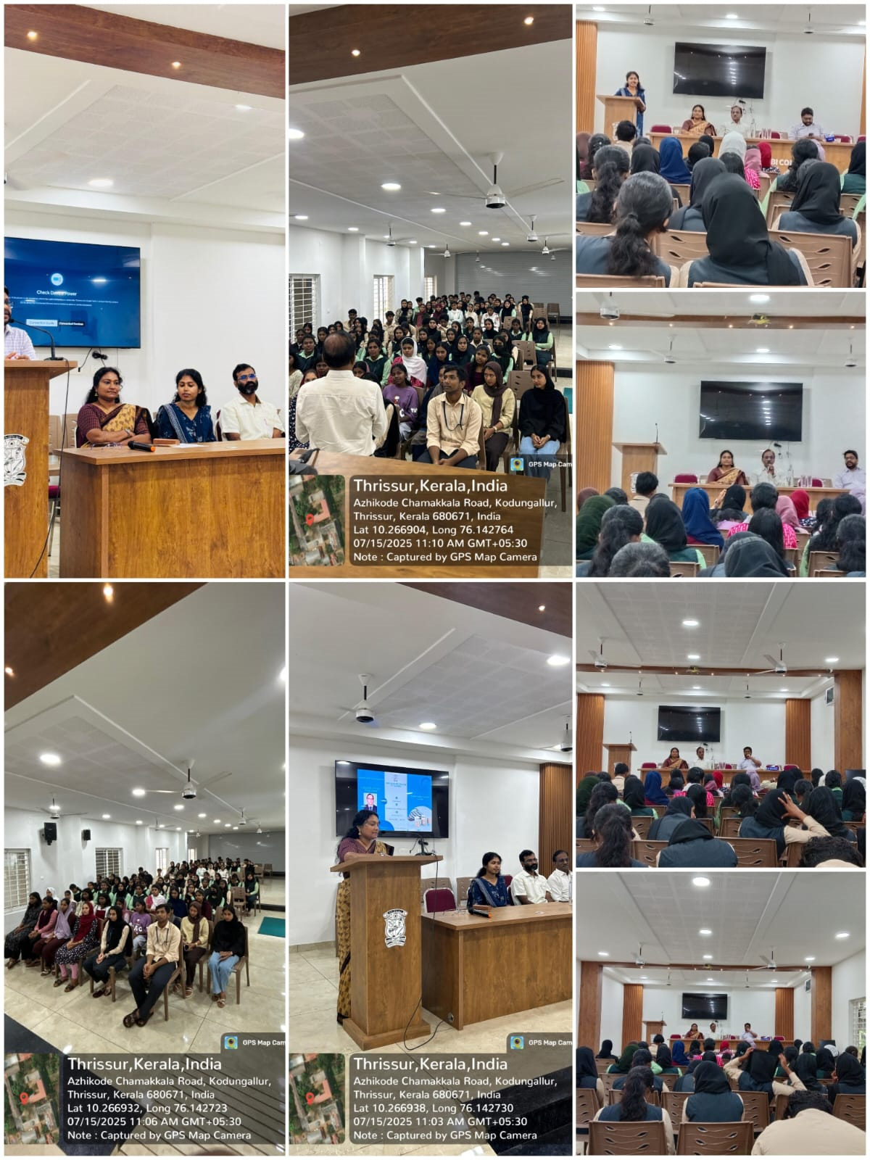ironment.

Key Topics Covered:
- Basics of Personal Finance: Understanding savings, income planning, budgeting, and financial discipline.
- Banking Literacy: How to use banking services effectively, including types of accounts, digital banking, and cyber safety.
- Credit and Loans: Responsible borrowing, understanding interest rates, credit scores, and debt management.
- Investment Awareness: Importance of early investments, various investment instruments like fixed deposits, mutual funds, and insurance.
- Government Schemes: Overview of financial inclusion initiatives and schemes available for students and youth.

Student Engagement:
The session was highly interactive, with students actively participating in the Q&A session. The speaker answered questions related to student banking, mobile banking safety, investment options, and loan handling with clarity and encouragement.

Outcome:
The programme successfully raised awareness about key financial concepts among students and helped them understand how to make informed financial decisions. It empowered participants with the confidence to manage their personal finances efficiently and responsibly.

Conclusion:
The Financial Literacy Programme was a valuable addition to the academic initiatives of the Department of Economics. It emphasized the department’s vision of producing financially aware and responsible citizens.

