Report on World Population Day Observance
Organized by the Department of Economics, Fine Arts and Literary Clubs
MES Asmabi College, P. Vemballur
Date: 11 July 2025 | Time: 1:30 PM | Venue: MS 07
The Department of Economics, in association with the Fine Arts and Literary Clubs of MES Asmabi College, observed World Population Day on 11th July 2025 through an Inter-Departmental Essay Writing Competition. The event was held at 1:30 PM in room MS 07, with enthusiastic participation from various departments.
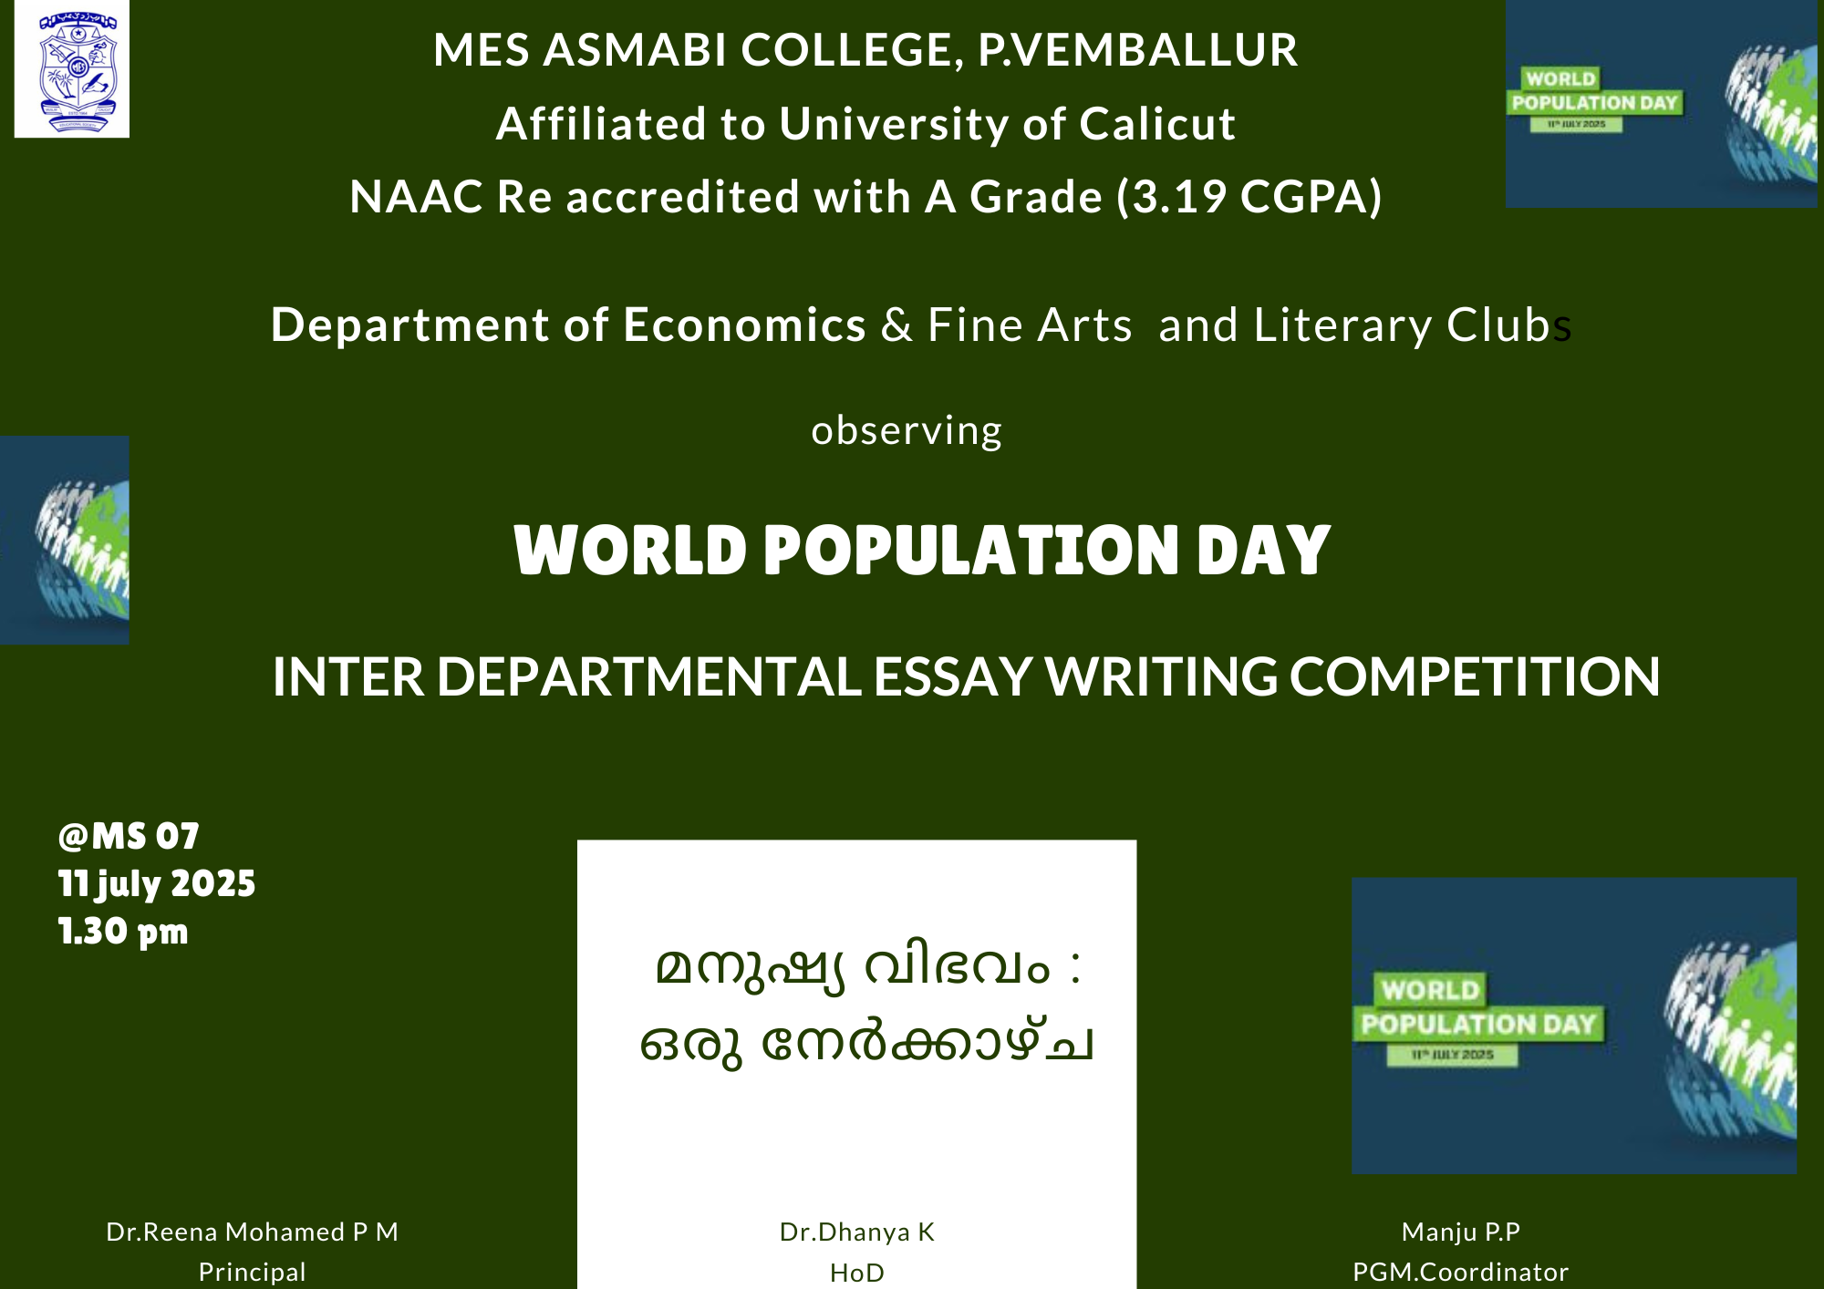

Objective of the Programme:
The primary aim of the event was to create awareness among students about the growing challenges posed by population explosion and the need for sustainable development. World Population Day, observed globally on July 11, serves as a reminder of the urgency to address population-related issues through education and policy.

Theme:
The essay competition was conducted in Malayalam under the theme:
"മനുഷ്യ വിഭവം: ഒരു നേർക്കാഴ്‌ച"
(Translation: Human Resources: A Positive Perspective)

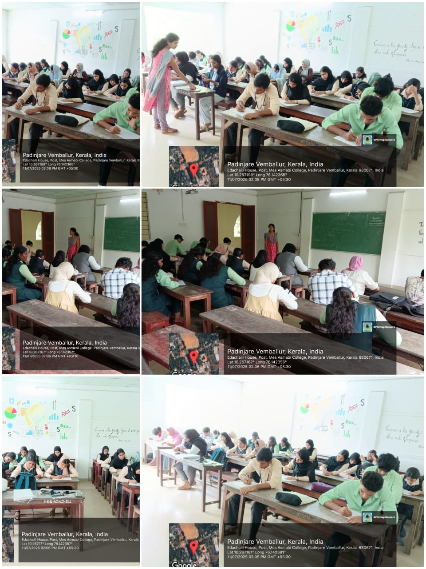

Event Proceedings:
- The programme was inaugurated under the guidance of Dr. Reena Mohamed P M, Principal of MES Asmabi College, who highlighted the importance of understanding population dynamics in economic planning and social welfare.
- Dr. Dhanya K, Head of the Department of Economics, welcomed the participants and spoke about the role of youth in driving sustainable development.
- Manju P.P, Programme Coordinator, coordinated the smooth execution of the event and encouraged student involvement in similar knowledge-building activities.

Participation:
Students from various departments actively participated in the essay competition, presenting their views on population challenges, demographic transitions, and the value of human capital in national development.

Outcome:
The event was a great success in fostering critical thinking, writing skills, and awareness on a global issue of prime importance. It served as a platform for students to articulate their understanding and propose solutions to manage population growth effectively.

Conclusion:
The Department of Economics, in collaboration with the Fine Arts and Literary Clubs, ensured a meaningful observance of World Population Day. The event reinforced the significance of academic engagement in addressing pressing societal issues and highlighted the power of informed youth in shaping a sustainable future.

