Report on Alumni Interaction – Legacy Talks
Organized by the Department of Economics, MES Asmabi College
Date: 11 July 2025 | Time: 10:30 AM | Venue: New Seminar Hall
The Department of Economics, MES Asmabi College, P. Vemballur, organized an enriching alumni interaction programme titled “Legacy Talks” on 11th July 2025 at 10:30 AM in the New Seminar Hall. The session aimed at inspiring current students through the valuable experiences and insights of successful alumni.
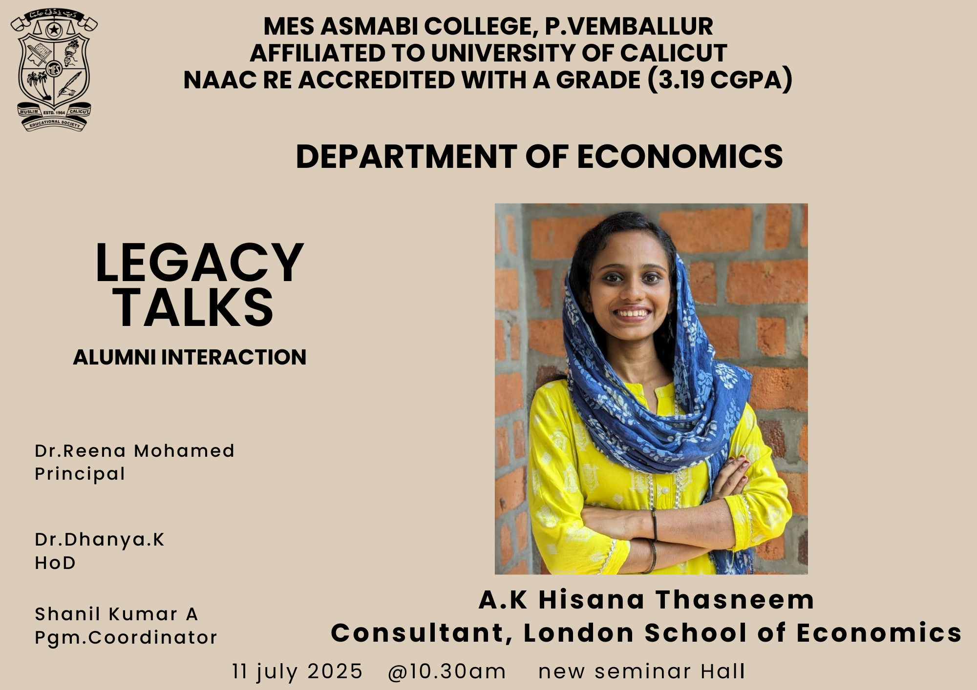
A.K Hisana Thasneem, an esteemed alumna of the department and a Consultant at the London School of Economics, was the keynote speaker of the event. Her presence and words served as a motivation to the budding economists of the institution.
- Inauguration:
The programme began with a warm welcome by Mr. Shanil Kumar A, Programme Coordinator, followed by an inaugural address by Dr. Reena Mohamed, Principal of MES Asmabi College.
Dr. Dhanya K, Head of the Department of Economics, spoke about the importance of maintaining strong alumni connections and the role of alumni in mentoring students.
- Legacy Talk by A.K Hisana Thasneem:
Ms. Thasneem shared her academic and professional journey, offering insights into her work with the London School of Economics. She discussed her experiences in the global economic landscape and emphasized the importance of perseverance, skill development, and staying connected with one's roots. Her story served as a source of inspiration, particularly for students aspiring to pursue higher studies and careers abroad.
- Interactive Session:
The talk was followed by an engaging interactive session, where students eagerly raised questions related to career guidance, higher education opportunities, and global economic trends. Ms. Thasneem addressed all queries with enthusiasm and depth.
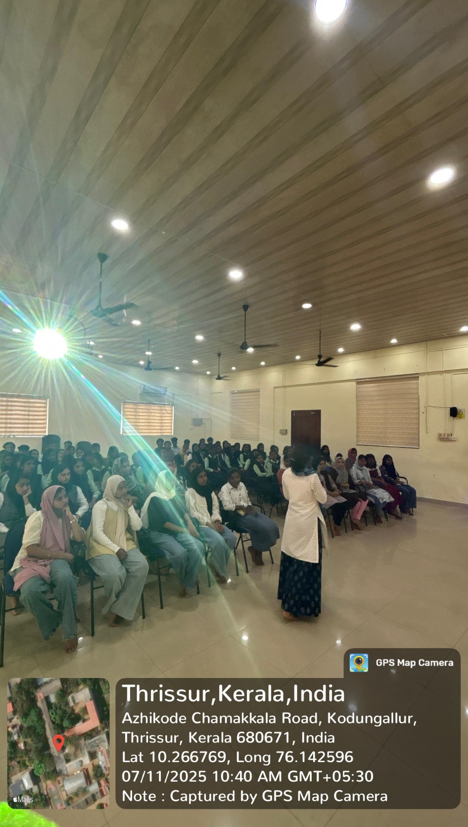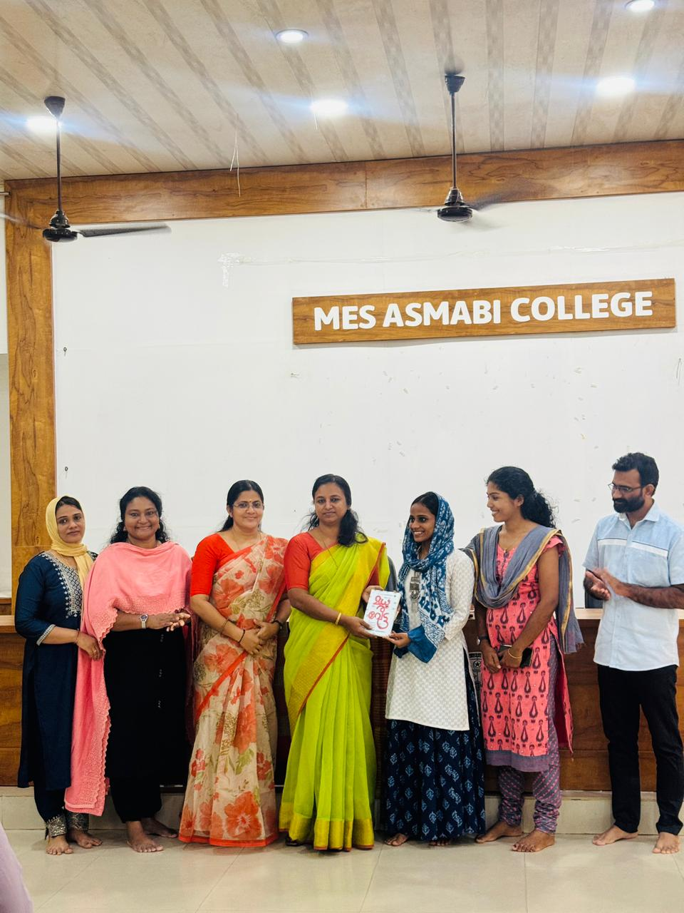

Conclusion:
The session concluded with a note of thanks to the guest and attendees. The event successfully bridged the gap between past and present students, reinforcing the importance of legacy, mentorship, and community.
Outcome:
The alumni interaction was an inspiring experience for all attendees. It not only strengthened the alumni-student bond but also opened new perspectives for the students regarding their academic and professional futures.

