BRIDGE COURSE

Report on Campus Tour – Library Visit
Organized by the Department of Economics
MES Asmabi College, P. Vemballur
Date: July 4, 2025
Venue: P.K. Abdulla Memorial Library
As part of the Bridge Course activities for first-year undergraduate students, the Department of Economics organized a Campus Tour with a special focus on the Library Visit on July 4, 2025. The initiative aimed to familiarize new students with the academic infrastructure and resources available on campus, especially the central library.
The tour began with a brief orientation session at the P.K. Abdulla Memorial Library, where students were introduced to the layout, rules, and facilities of the library. The library houses an extensive collection of academic books, journals, reference materials, and digital resources that support the learning and research needs of students and faculty alike.

Objectives of the Visit:
- To introduce students to the academic support system available on campus.
- To encourage reading and the use of library resources for academic excellence.
- To help students understand the importance of independent learning and research.
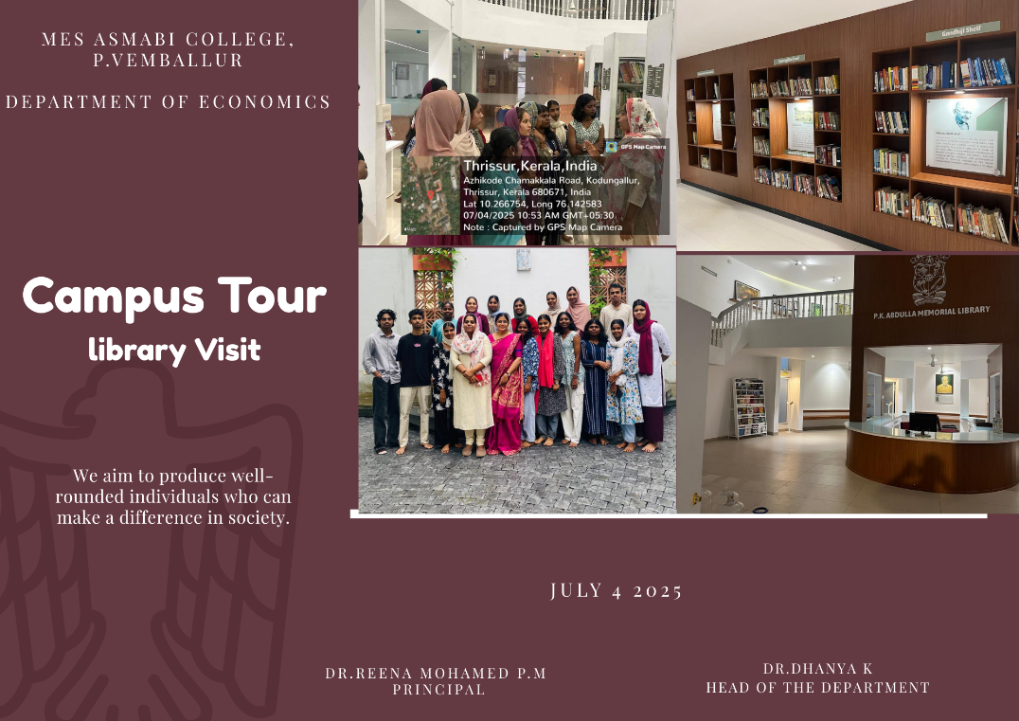

Highlights of the Visit:
- Students explored various sections of the library, including the Gandhiji Shelf, general reference, and digital resource zones.
- The library staff provided an overview of the book borrowing system, digital catalog, and reading spaces.
- The visit concluded with an interactive Q&A session where students clarified their queries regarding library access and resource usage.
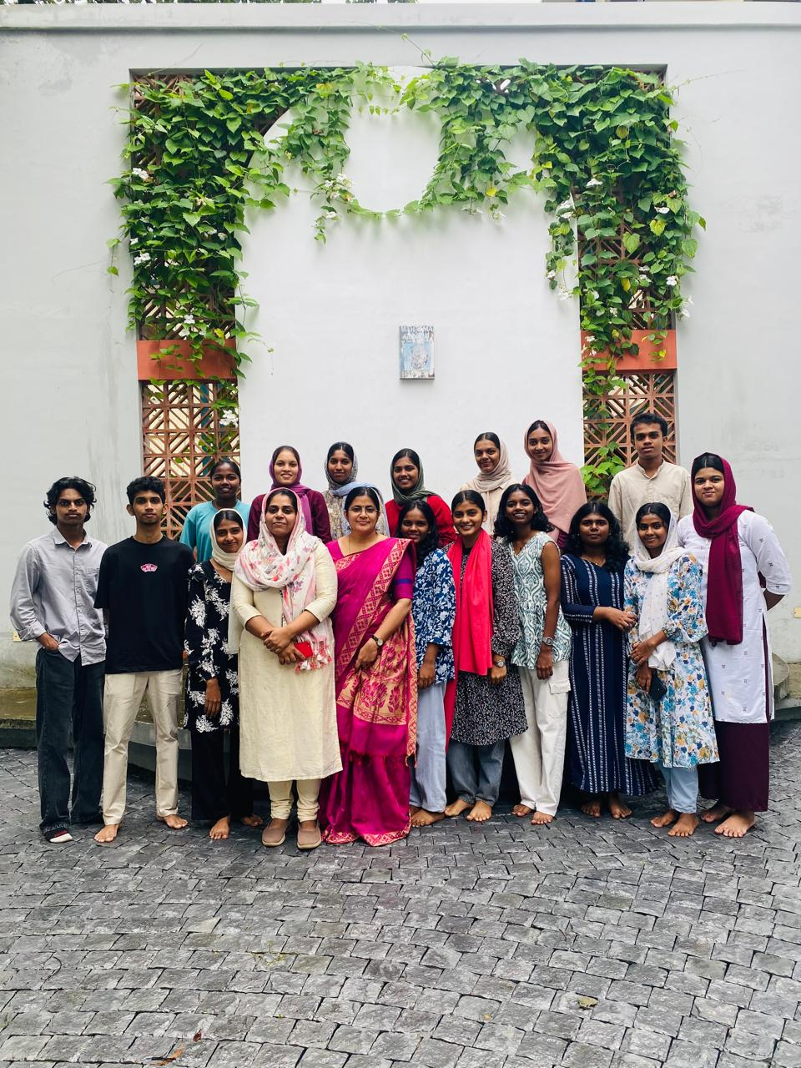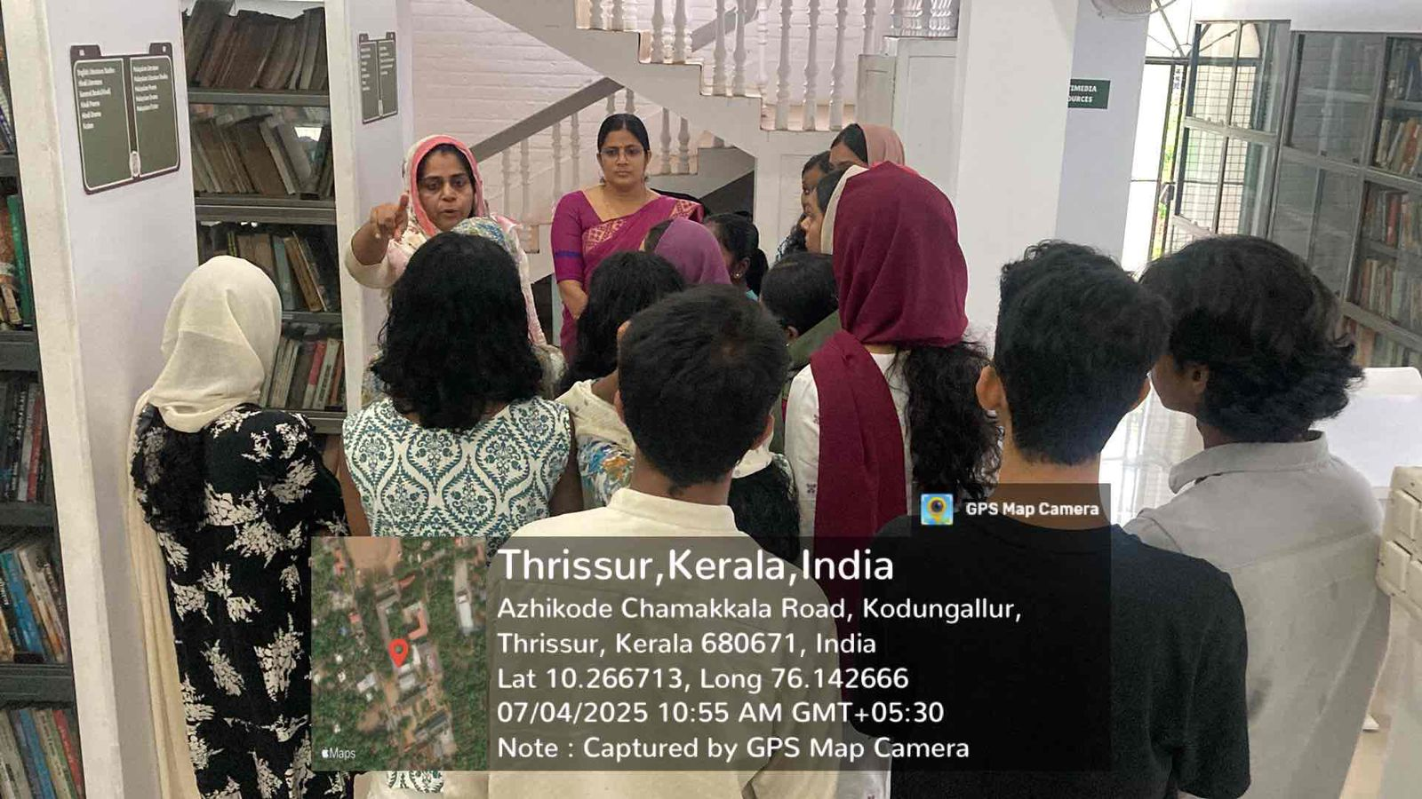
The event was coordinated under the leadership of Dr. Dhanya K, Head of the Department of Economics. Dr. Reena Mohamed P.M, Principal of MES Asmabi College, appreciated the initiative and emphasized the significance of developing strong academic habits from the beginning of the undergraduate journey.
Overall, the session was highly informative and well-received by the students. It served as a key step in helping them integrate into the academic environment and motivated them to make full use of institutional resources.

