Report on Ice Breaking Session – Bridge Course 2025
Organized by the Department of Economics, MES Asmabi College, P. Vemballur
Date: July 3, 2025
Venue: Department of Economics Classroom

As part of the Bridge Course initiative for the newly admitted first-year students of the Department of Economics, MES Asmabi College, an Ice Breaking Session was conducted on July 3, 2025. The primary objective of this session was to create a welcoming atmosphere, foster peer relationships, and ease the transition of students into college life.
The session was formally inaugurated by Dr. Reena Mohamed, Principal of MES Asmabi College, who emphasized the importance of building strong student bonds and creating an inclusive learning environment. Dr. Dhanya K, Head of the Department of Economics, delivered the welcome address and encouraged students to actively participate and express themselves freely.
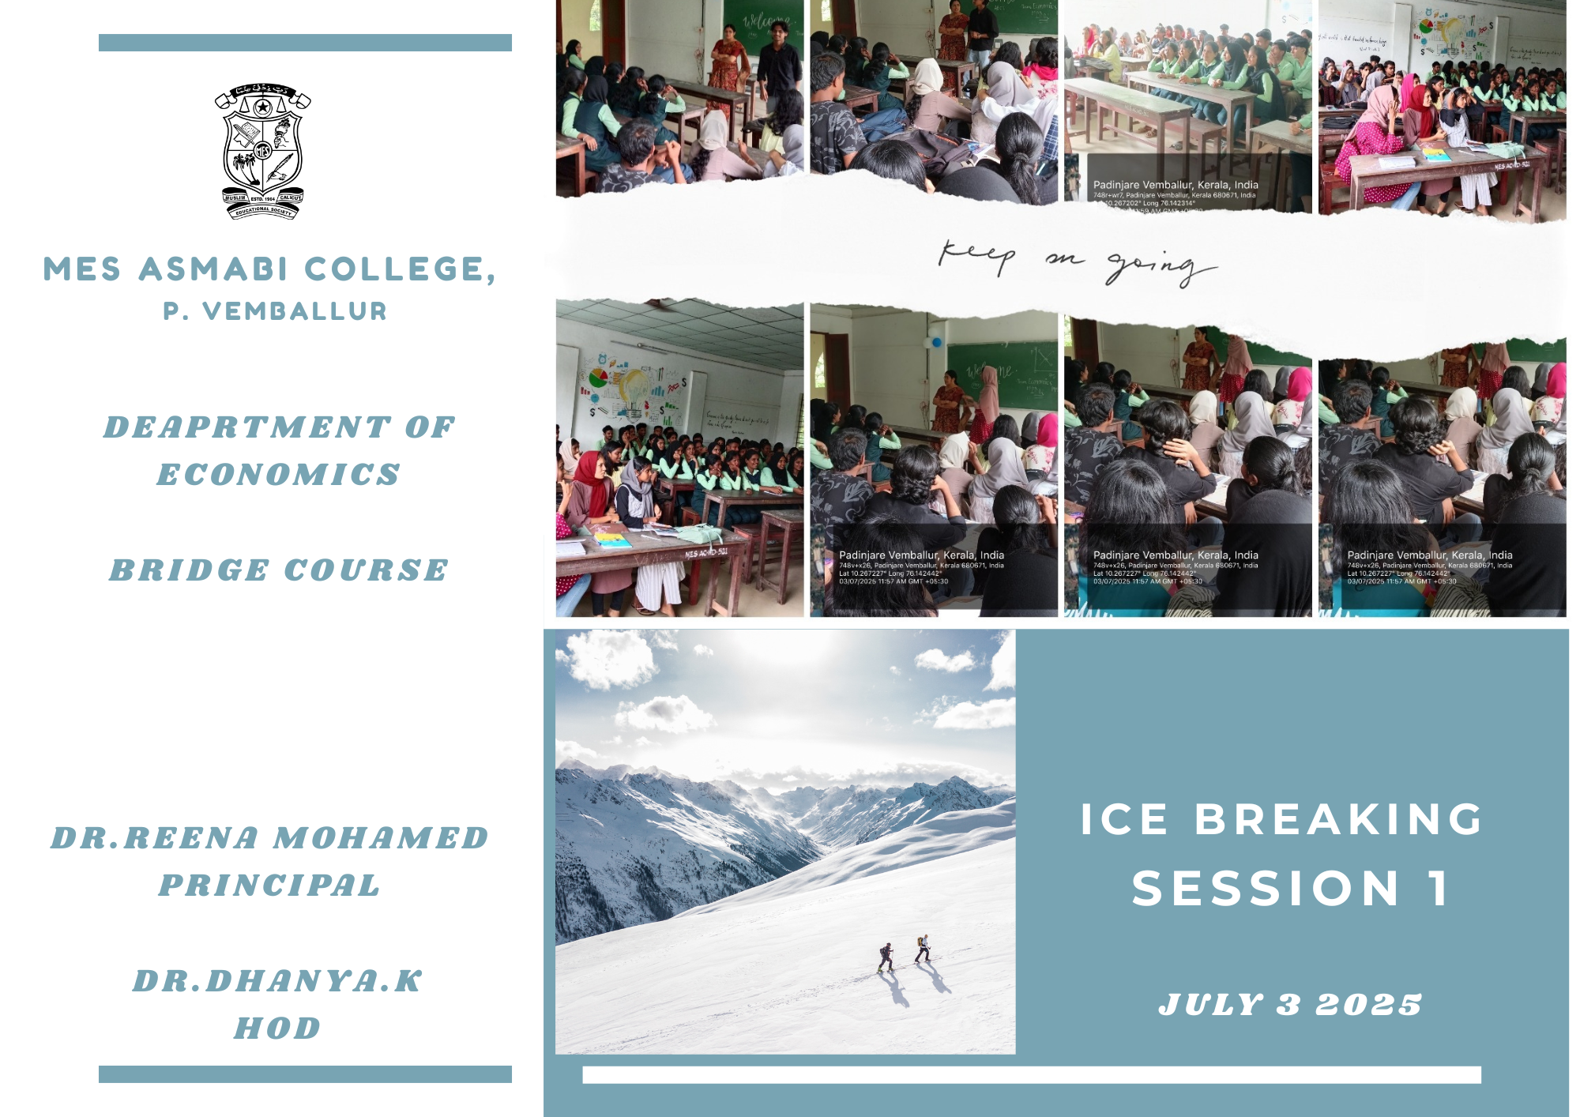

Highlights of the Session:
- The session included fun and engaging activities aimed at helping students introduce themselves and get to know their classmates.
- Ice-breaking games and informal interactions allowed students to share their aspirations and expectations from the course.
- Senior students and faculty members facilitated the session, offering support and guidance to ease any anxieties among the freshers.
- The session also provided a brief overview of the academic journey ahead and the various opportunities offered by the department.
The enthusiastic participation of the students made the session lively and impactful. It successfully set a positive tone for the upcoming academic year and helped establish an encouraging rapport among the new entrants.
The department intends to continue such interactive sessions throughout the bridge course to promote a student-friendly and inclusive academic culture.

