REPORT ON INTERNATIONAL YOGA DAY OBSERVANCE
Organized by: Department of Economics & Physical Education
MES Asmabi College
Date: 20th June 2025
Venue: MS Block
As part of promoting health and well-being among students and staff, the Department of Economics and the Department of Physical Education, MES Asmabi College, jointly organized the Observance of International Yoga Day on June 20, 2025, in the MS Block. The theme for the event was "Celebrating Health and Wellness."
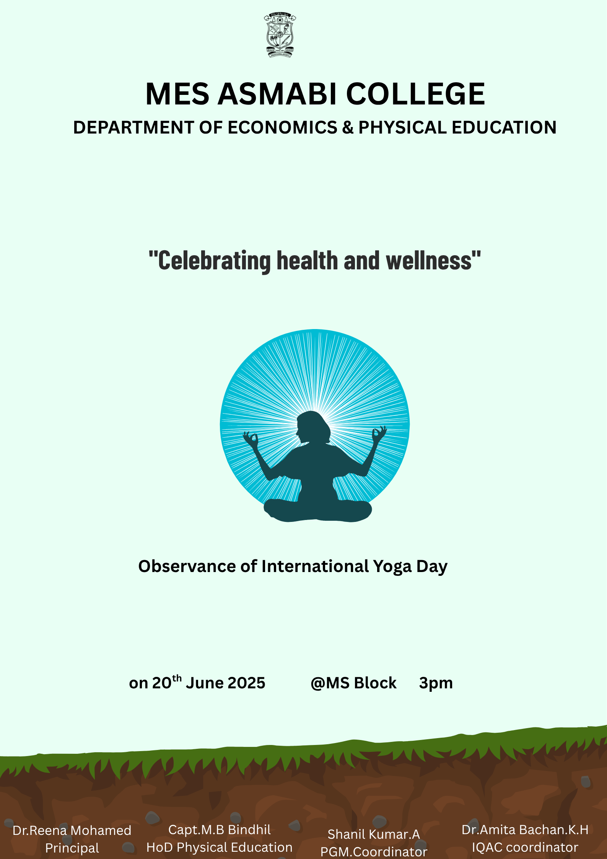
The program aimed to spread awareness about the importance of yoga in daily life and to motivate the college community to embrace a healthy lifestyle through the practice of yoga. The session began with a brief welcome and address, emphasizing the physical, mental, and spiritual benefits of yoga.
The event witnessed active participation from students and faculty members. Under the guidance of experienced yoga trainers, participants engaged in a series of yoga postures (asanas), breathing exercises (pranayama), and meditation. The trainers explained the health benefits of each posture, making the session both informative and rejuvenating.
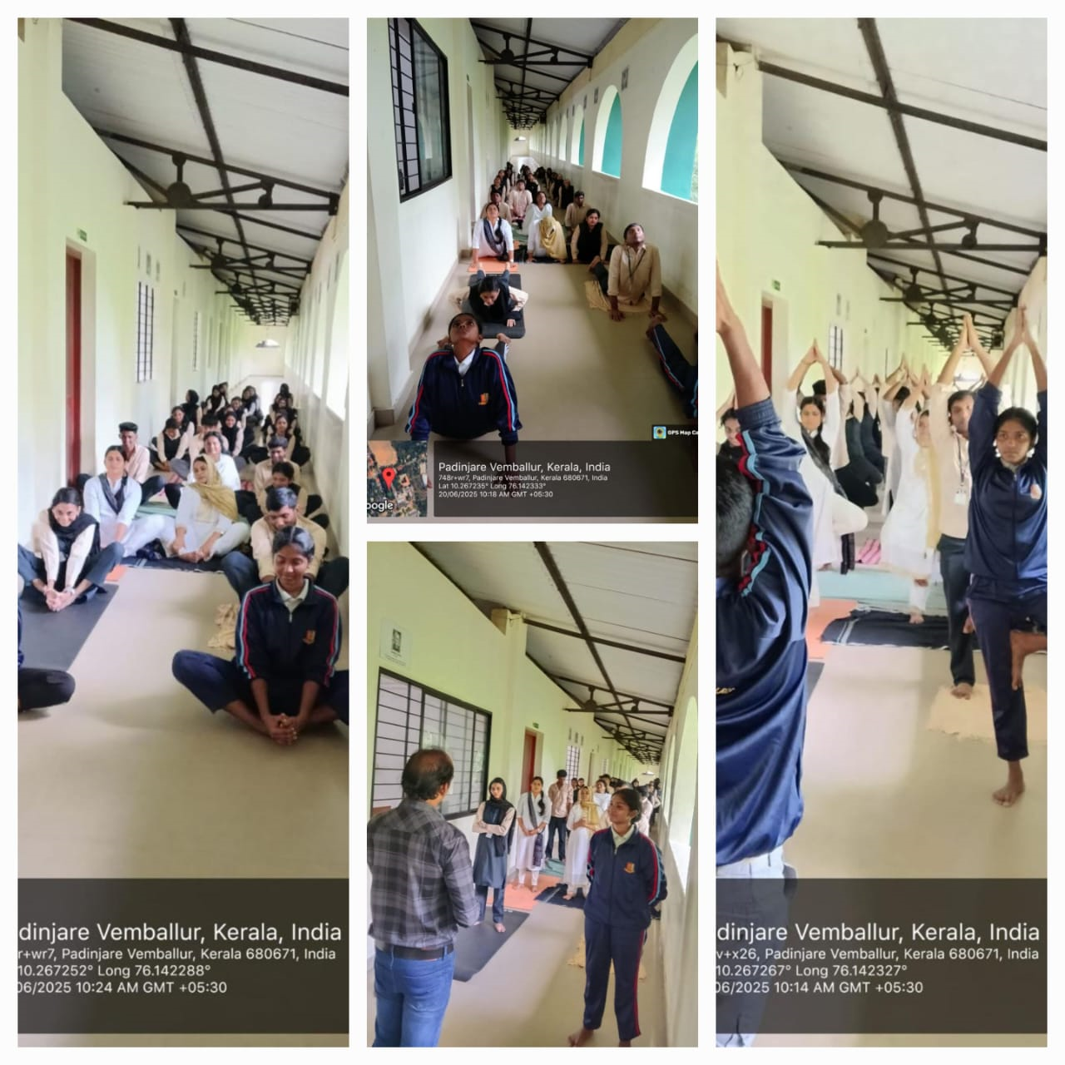
The program was organized under the leadership of:
- Dr. Reena Mohamed – Principal
- Dr.Dhanya.K -HoD Economics
- Capt. M.B. Bindhil – HoD, Physical Education
- Shanil Kumar A. – PGM Coordinator
Their collective efforts and coordination ensured the smooth and successful conduct of the event. The participants expressed enthusiasm and appreciation, noting the calming and energizing effect of the session.
The observance of International Yoga Day thus served as a reminder of the timeless relevance of yoga and reinforced the college’s commitment to holistic education and wellness.

