REPORT ON READING DAY OBSERVANCE
Organized by: Department of Economics, MES Asmabi College
Date: June 19, 2025
Time: 1:30 PM
Venue: New Seminar Hall

As part of Reading Day observance, the Department of Economics, MES Asmabi College, organized a vibrant and thought-provoking panel discussion on the topic "മുഖ്യധാര മലയാള സിനിമകളുടെ ഒരു സാമ്പത്തിക വായന" (An Economic Reading of Contemporary Malayalam Cinema) on June 19, 2025, at the New Seminar Hall. The event commenced at 1:30 PM with a rich gathering of students, faculty members, and invited guests.
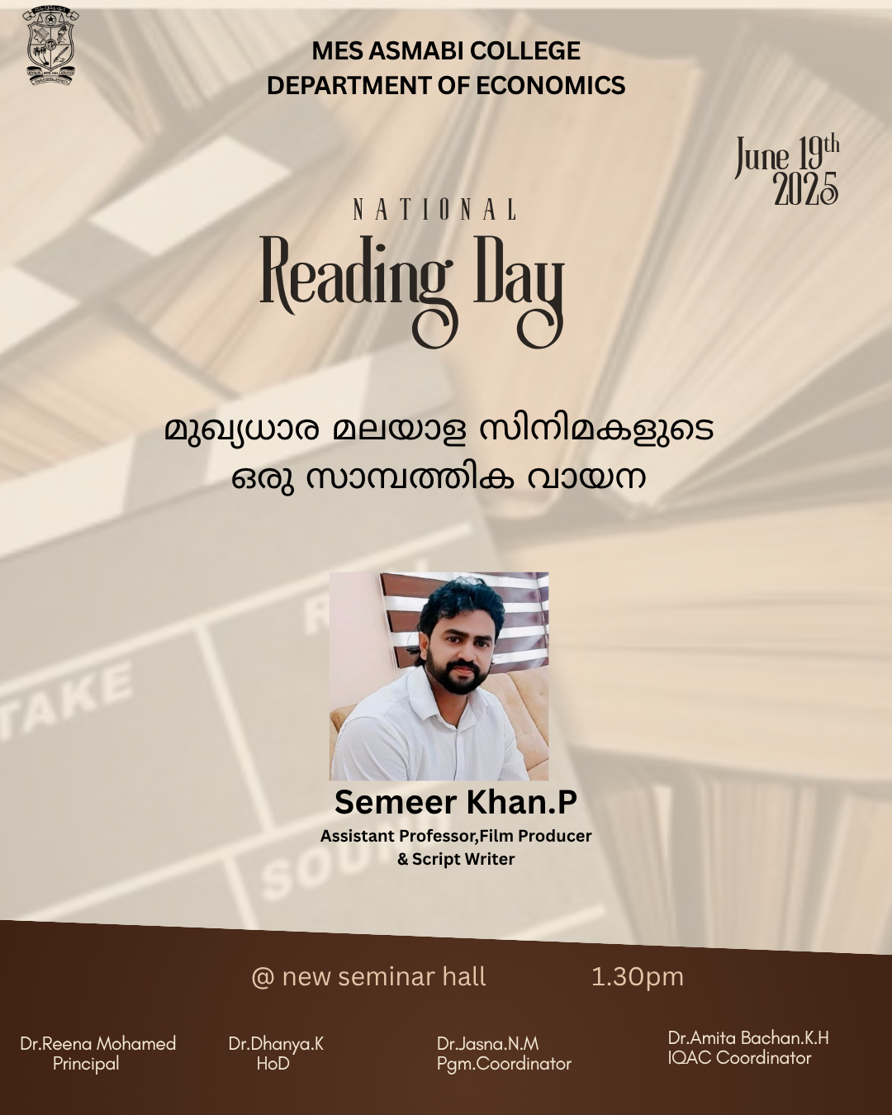
The program was graced by the presence of Mr. Semeer Khan, a well-known cinephile and speaker, as the Guest of Honour. His introductory reflections on the intersection of art and economics set the tone for the discussion. His speech captivated the audience by highlighting how economic trends and consumer behaviour shape the Malayalam film industry.
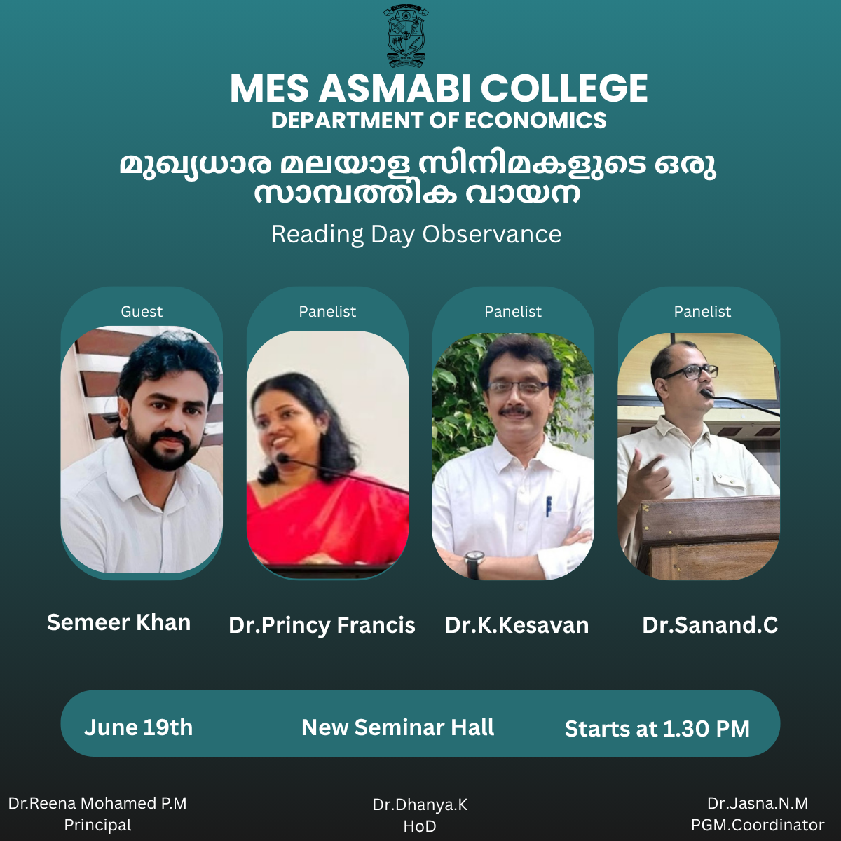
The panel discussion featured three distinguished academicians:
- Dr. Princy Francis, who offered a gendered perspective on film economics and the portrayal of socio-economic realities in contemporary cinema.
- Dr. K. Kesavan, who elaborated on the evolution of economic narratives in Malayalam films from the 1980s to the present day, tracing the socio-political changes they reflect.
- Dr. Sanand. C, who shared insights on the economic viability of offbeat cinema and the changing production-consumption dynamics in the OTT era.
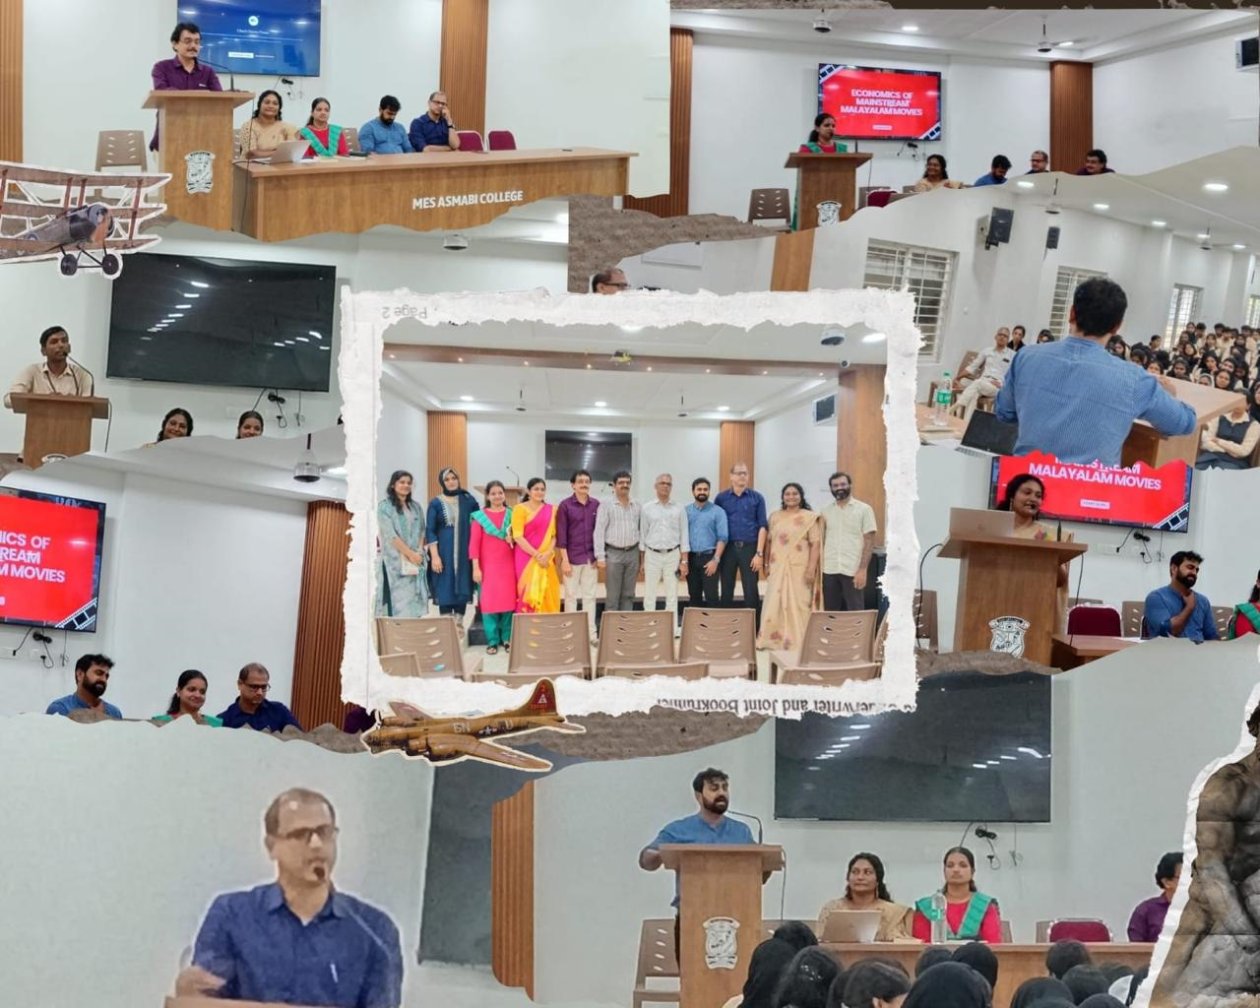
The program was coordinated under the leadership of Dr. Dhanya K, Head of the Department of Economics, and Dr. Jasna N.M, PGM Coordinator. The college Principal, Dr. Reena Mohamed P.M and Dr. K.P Sumedhan,Director Self Financing courses extended their best wishes for the success of the event and appreciated the department's effort in integrating literature, cinema, and economics.
The session was highly interactive, with students engaging in meaningful discussions and raising thoughtful questions. The event proved to be an intellectually enriching experience that celebrated the spirit of reading and critical thinking beyond books, emphasizing the relevance of cinema as a medium of economic and cultural analysis.

