MES ASMABI COLLEGE, P.VEMBALLURA
DEPARTMENT OF ECONOMICS
WORLD FOOD SAFETY DAY-JUNE 7

Report on “Thanal – Nature Awareness and Social Responsibility Program”
Organized by: Department of Economics, MES Asmabi College, P. Vemballur
Date: 12th June 2025
The Department of Economics, MES Asmabi College, P. Vemballur, organized a compassionate and socially committed initiative titled “Thanal – Nature Awareness and Social Responsibility” on 12th June 2025. The program aimed to foster awareness about environmental conservation and simultaneously promote a strong sense of social responsibility among students and the community.
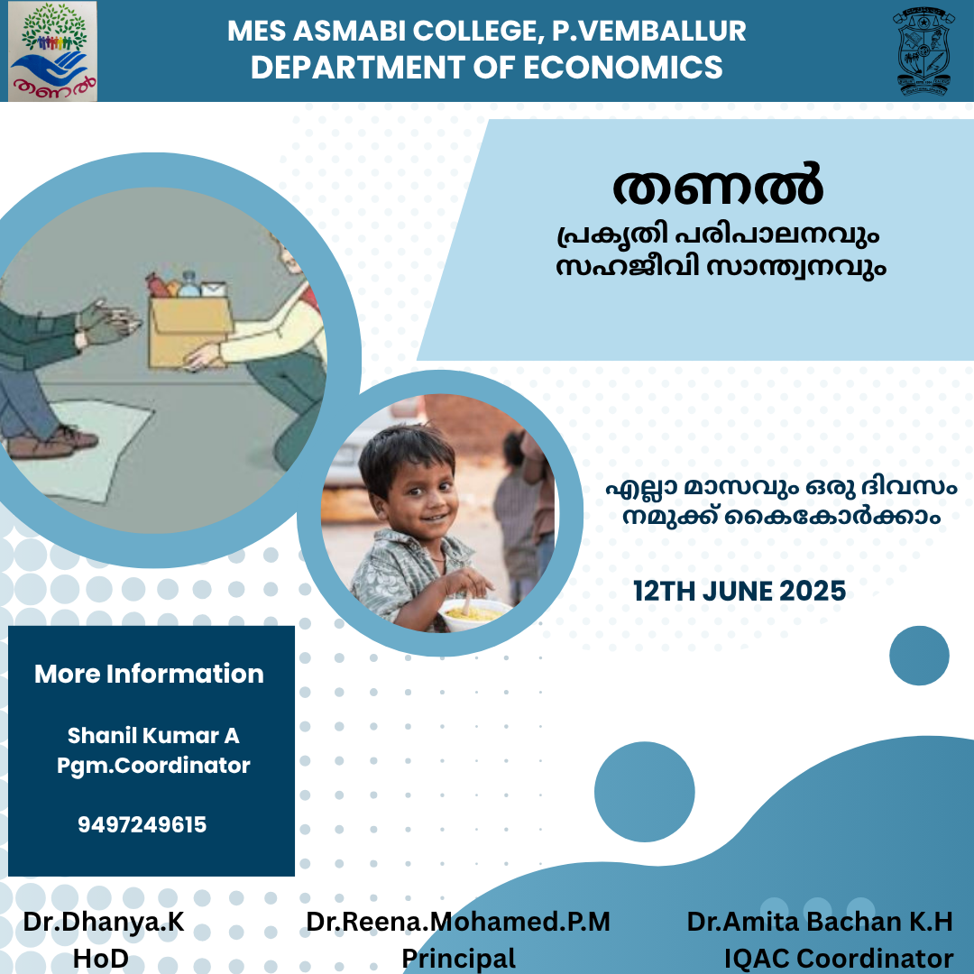

Objectives:
- To encourage eco-friendly practices among students.
- To instill values of empathy, sharing, and social service.
- To extend help and support to underprivileged sections of society.
The theme of the day was “Let no one go hungry, not even for a day”, emphasizing the importance of addressing hunger and food insecurity within local communities. Students and faculty actively took part in the initiative by collecting and distributing food and other essential items to those in need.
The program witnessed overwhelming participation from students, who were motivated to contribute and engage in service activities. It not only provided immediate help to the needy but also created awareness on the importance of reducing food waste and sharing resources.
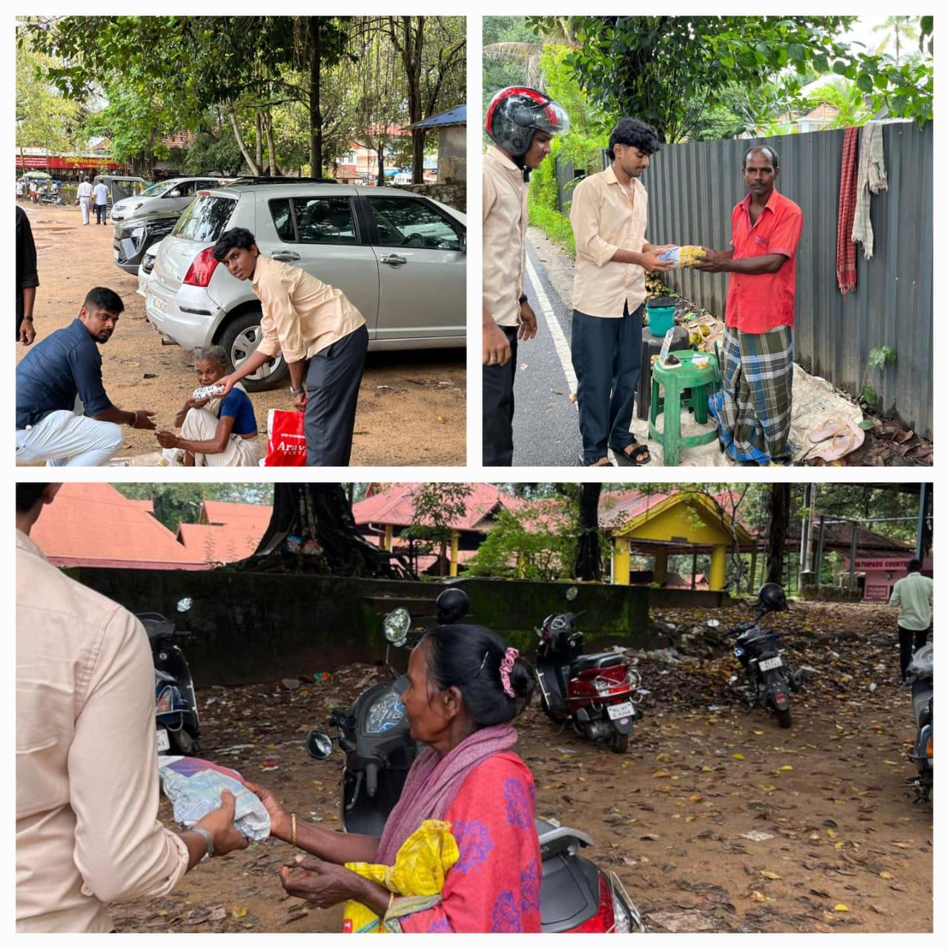

Coordinators and Support:
- Programme Coordinator: Mr. Shanil Kumar A
- HoD, Department of Economics: Dr. Dhanya K
- IQAC Coordinator: Dr. Amita Bachan K.H
- Principal: Dr. Reena Mohamed P.M
This program served as a model for integrating education with community service and was deeply appreciated by all stakeholders. It successfully demonstrated that academic institutions can play a pivotal role in building a compassionate and sustainable society.

