Report on “ECO-LOGISTICS: Moving Forward with Nature”, observance of World Environment Day June 5 2025
The Department of Logistics Management, MES Asmabi College, P. Vemballur, observed World Environment Day on June 5, 2025, by organizing a vibrant and meaningful event themed “ECO-LOGISTICS: Moving Forward with Nature.” The program aimed to create awareness among logistics students about the importance of sustainability in logistics practices and to promote environmental responsibility.
The event featured two major activities: an E-Poster Making Competition and a Green Logistics Quiz Competition. The E-Poster Making Competition invited students to submit digital posters based on the theme of eco-logistics. 15 entries were received from students. The Green Logistics Quiz Competition, held from 2:30 PM to 3:30 PM in the department, tested students’ knowledge of sustainable logistics practices.
Both events witnessed enthusiastic participation, with students showcasing creativity, awareness, and interest in green practices. The quiz was engaging and informative, creating a lively learning environment. Overall, the program succeeded in enhancing students’ understanding of eco-logistics and fostering a sense of environmental responsibility. The event was coordinated by Ms. Mamatha Thilak under the guidance of Principal Dr. Reena Mohamed and HOD Mr. Abdul Yafiz K M.

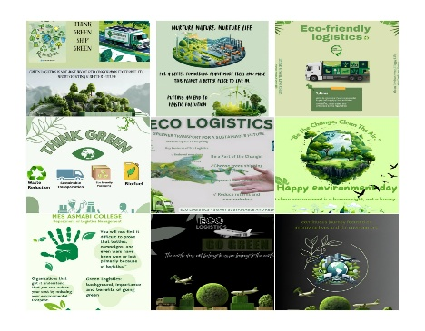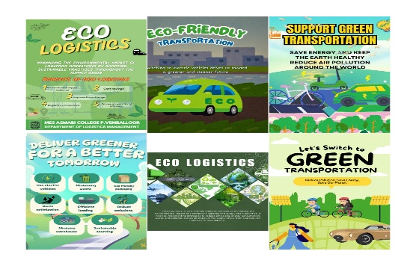
E-Posters Prepared by Students
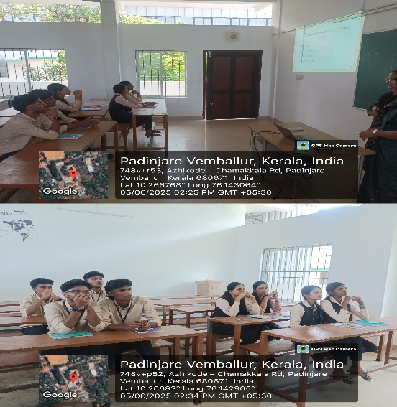
Green Logistics Quiz 2025

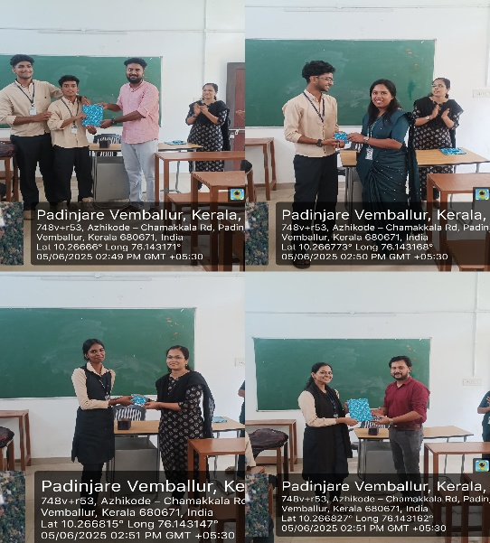
Prize Distribution to winners
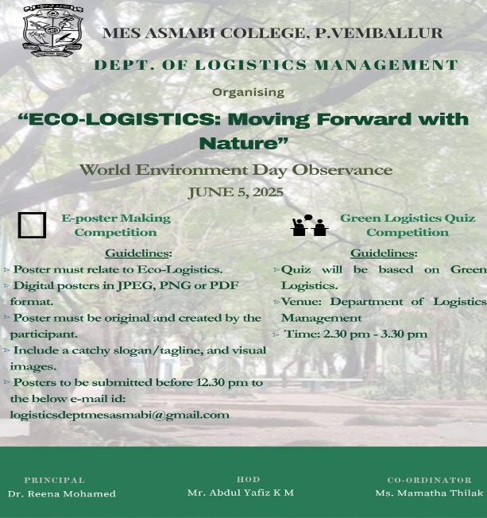
Brochure

