MES ASMABI COLLEGE, P.VEMBALLUR
DEPARTMENT OF ECONOMICS
Report on the Observance of World Environment Day 2025
Venue: Azheekkal Munambam Beach | Date: June 5, 2025

The Department of Economics, MES Asmabi College, observed World Environment Day on June 5, 2025, at Azheekkal Munambam Beach with a beach cleaning and environmental preservation initiative, aimed at spreading awareness on sustainable environmental practices and the importance of conserving marine and coastal ecosystems.
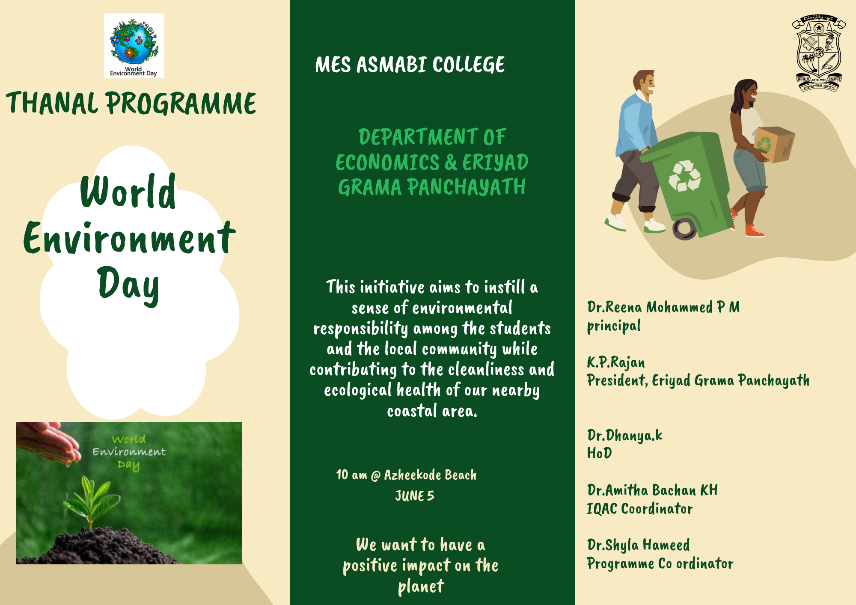
The programme was formally inaugurated by Shri. K.P. Rajan, President, Eriyad Grama Panchayath. In his inaugural address, he highlighted the vital role of local communities and youth in protecting nature and ensuring a cleaner and greener future.
Dr. Dhanya K, Head of the Department of Economics, delivered an insightful explanation of the programme’s objectives, focusing on the significance of collective action in environmental conservation, especially in coastal areas prone to pollution and degradation.
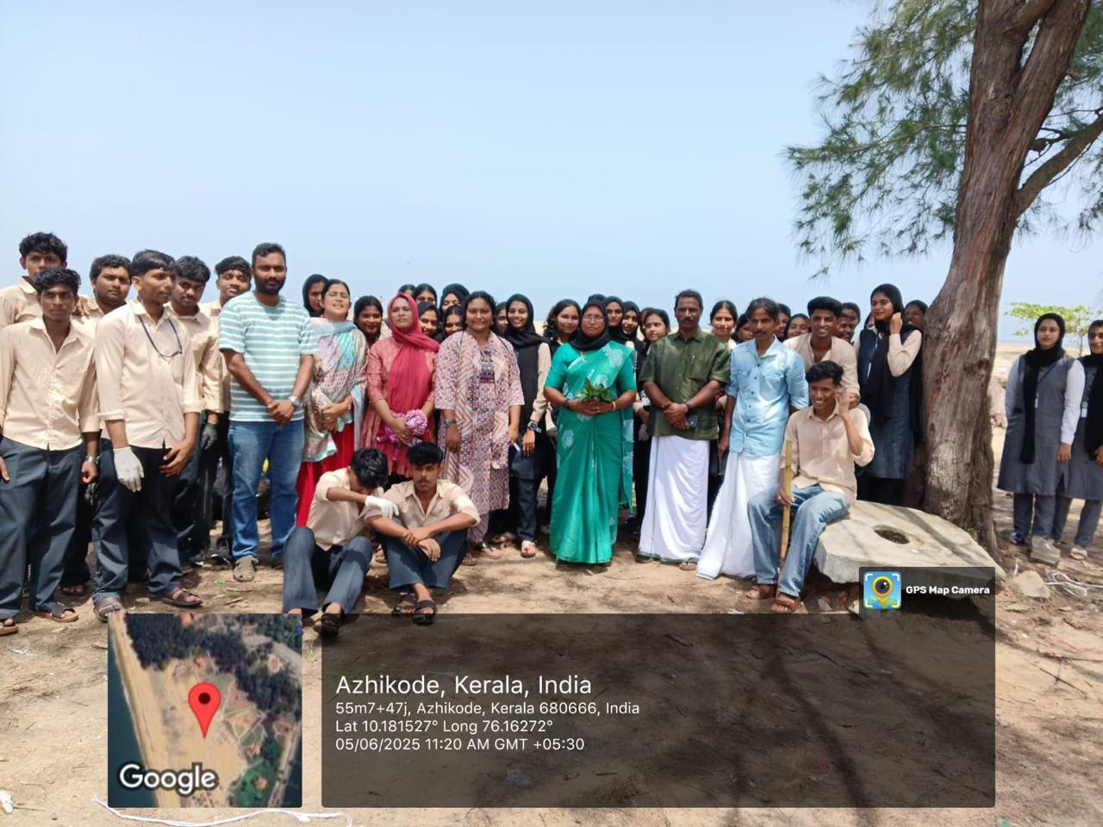
The gathering was warmly welcomed by Dr. Shyla Hameed, Programme Coordinator, who emphasized the importance of World Environment Day in promoting environmental consciousness among students and the community.
Mr. Shanil Kumar proposed the vote of thanks, expressing gratitude to all dignitaries, students, and volunteers for their active participation and support in making the event a success.
The event was graced by the presence of Dr.Jasna.N.M , faculty, Ms. Sarabi Ummer and Mr. Assim, representatives of Eriyad Panchayath, whose support and encouragement strengthened the community collaboration aspect of the programme.
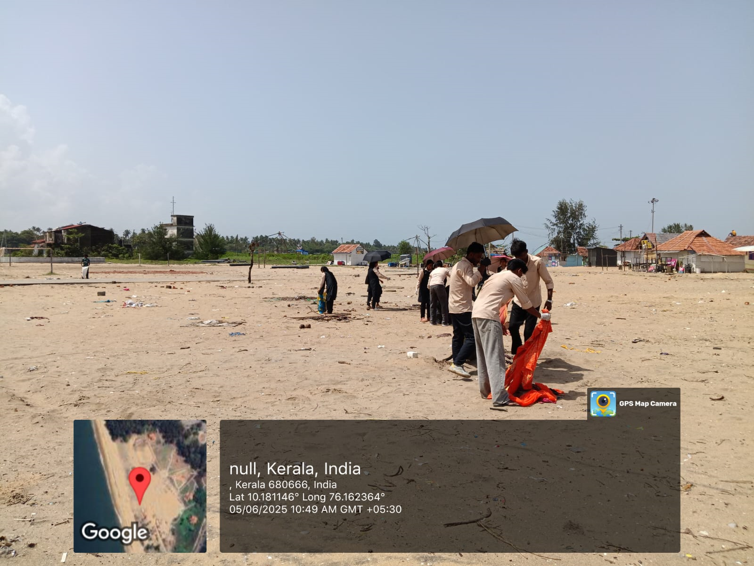
Volunteers, including students and faculty members, engaged in activities such as plastic waste removal, awareness campaigns, and preservation of existing beachside plants. The initiative stood as a testimony to the Department’s ongoing commitment to environmental stewardship and sustainable development.

