Karkkidakamaasacharanam 2024
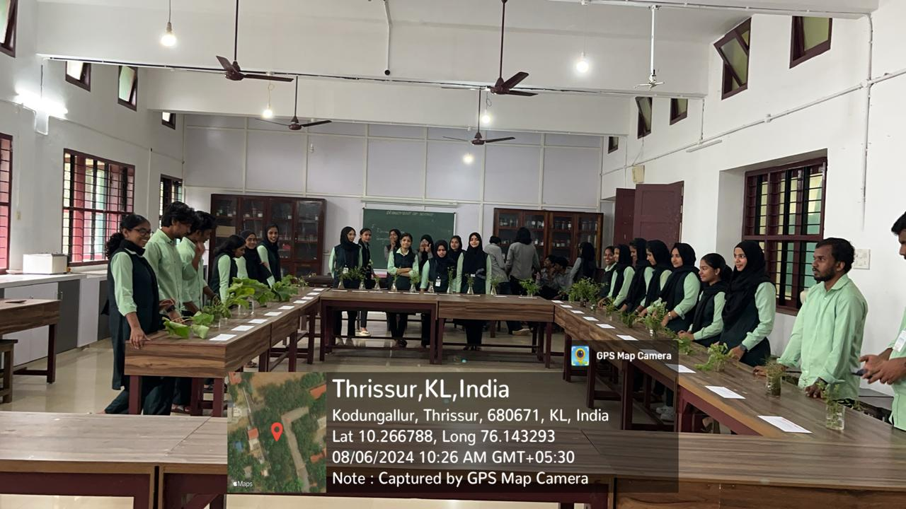
On August 6, 2024, the PG & Research Department of Botany, in association with the Bhoomitrasena Club and Green initiatives, organized ‘Karkkidakamaasacharanam 2024,’ a cultural and environmental initiative aimed at promoting traditional wisdom and biodiversity conservation. The event featured the preparation and distribution of ‘Karkkidaka Kanji,’ a nutritious medicinal porridge, to staff and students. Additionally, an exhibition of ‘Dhaspushpam’ and various edible leaves commonly used during the month of Karkkidakam was conducted. The event also included a quiz competition based on the story of ‘Ramayana,’ encouraging students to connect cultural heritage with environmental consciousness. These activities highlighted the importance of sustainable traditional practices and their relevance in contemporary green initiatives.
