
MES ASMABI COLLEGE , P VEMBALLUR
DEPARTMENT OF PSYCHOLOGY & CMHEP PROJECT

REPORT ON MANONEETHAM 2025 - FREE LEARNING DISABILITY ASSESSMENT CAMP
Manoneetham 2025 was a community-based initiative aimed at identifying and supporting children with learning disabilities at the primary level. The program was conducted at Sree Narayanapuram Panchayath, specifically for LP students up to the 4th standard, ensuring early detection and intervention for learning disabilities. The Department of Psychology at MES Asmabi College organized this event as part of its community outreach program, benefiting students, parents, and future psychologists alike.
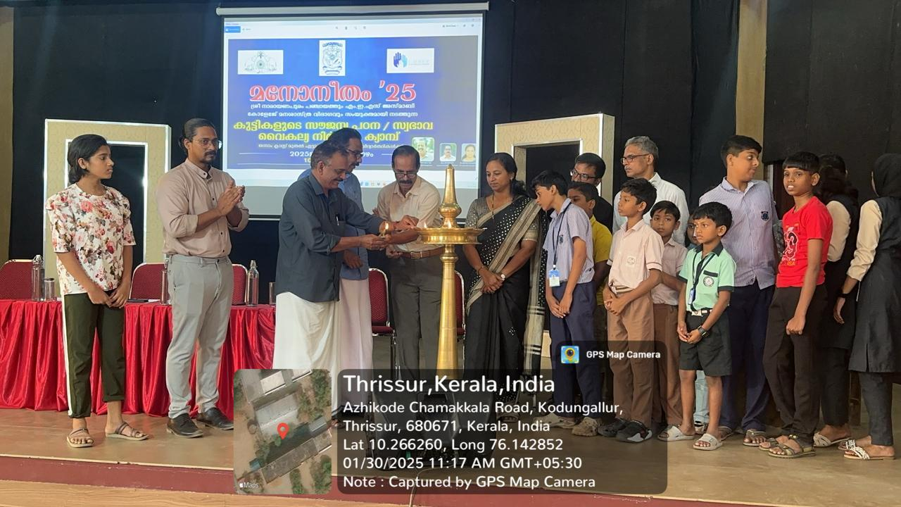
The official inauguration ceremony commenced at 10:00 AM at the auditorium of Sree Narayanapuram Panchayath. The event was graced by the presence of distinguished guests, including:
- Sri. M. S. Mohanan, President of Sree Narayanapuram Panchayath, who officially inaugurated the program.
- Mr. Ayoob, Chairman of the Panchayath Development Committee, who extended his support and encouragement for the initiative.
- Dr. Reena Mohammed, Principal of MES Asmabi College, delivered the presidential address, highlighting the significance of early identification and intervention in learning disabilities.
- Dr. K. P. Sumedhan, Director of the Self-Financing Department, and Dr. Amithabachan, IQAC Coordinator, delivered felicitations, emphasizing the role of psychology in community development.
The event marked the beginning of a significant collaboration between the academic and community sectors to address learning disabilities at the grassroots level.
Following the inaugural session, the assessment camp was conducted in the New Seminar Hall, where psychology students and experts worked together to evaluate young learners. The procedure included:

Training of Psychology Students
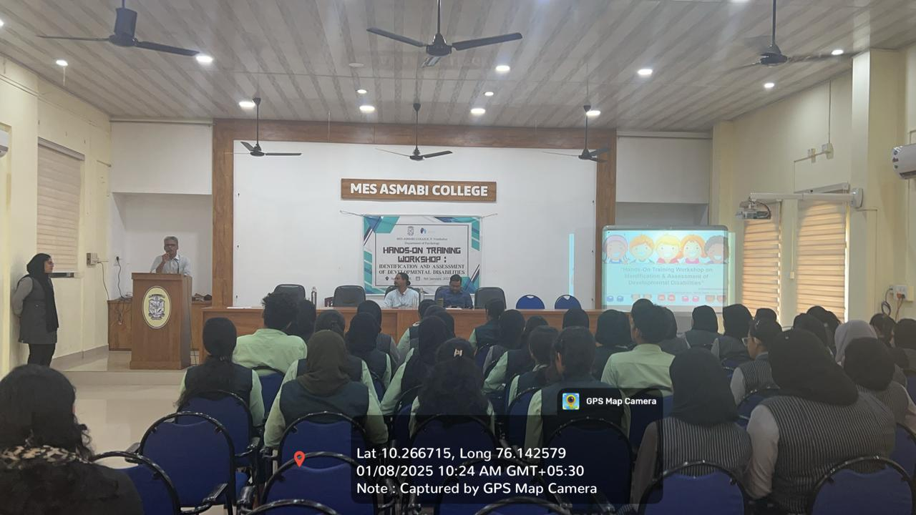
Prior to the assessments, Dr. Raheemudheen, Clinical Psychologist from Thrissur Mental Hospital, trained 50 psychology students from MES Asmabi College. The training covered:
- Understanding learning disabilities and their early indicators.
- Administering assessment tools effectively.
- Analyzing results to identify students needing further intervention.
Dr. Raheemudheen also designed a customized assessment scale tailored for this camp, ensuring a structured and efficient evaluation process.

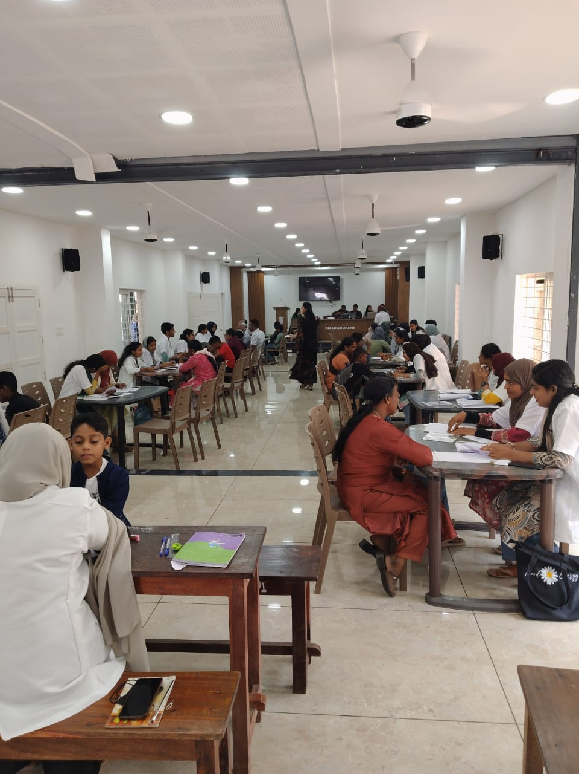
2. Assessment Process
- The camp ran from 9:00 AM to 5:30 PM, allowing ample time for screening students.
- 350 parents and students participated in the assessment, showing strong community interest in the initiative.
- Psychology students, under the supervision of experts, conducted assessments focusing on various learning parameters, such as reading, writing, comprehension, attention, and cognitive processing.

Outcome of the Camp
The camp successfully identified students requiring special attention:
- 150 students were flagged for further intervention based on the assessment results.
- Each student requiring additional support will be provided intervention through the Department of Psychology, MES Asmabi College.
- The intervention will be designed based on the severity and specific needs of the identified students.
Additionally, the psychology students involved in the camp gained valuable hands-on experience in clinical assessments, furthering their practical knowledge and enhancing their career preparedness in the field of psychology.

Future Prospects
- Regular follow-up programs will be arranged to ensure students receive continuous support.
- The psychology department plans to expand the initiative by integrating technology and more refined assessment tools in future camps.
- The camp has set a strong foundation for future collaborations between MES Asmabi College and local governing bodies to enhance mental health awareness and early intervention programs in schools.
Manoneetham 2025 was a highly successful program that not only benefited the children of SN Puram Panchayath but also provided experiential learning opportunities for psychology students. By bridging the gap between academic expertise and community needs, the camp has paved the way for sustained efforts in learning disability intervention and awareness. The overwhelming participation from students, parents, and the local administration signifies the importance of such initiatives, and we anticipate more impactful programs in the coming years.

Program coordinator HOD PrincipalBottom of Form
Aswathi K L Lathif Penath Dr.Reena Mohamed PM

