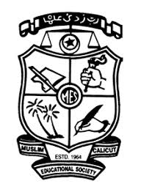
DEPARTMENT OF MALAYALAM
M E S ASMABI COLLEGE, P. VEMBALLUR

Reading week celebration
SEMINAR ,BOOK EXIBITION AND CULTURAL PROGRAMMES

REPORT

Date: June 19, 2024
Time: 10:00 AM
Venue: Auditorium
Agenda:Malayalam &Library jointly organized Reading week celebration.-SEMINAR ,BOOK EXIBITION AND CULTURAL PROGRAMME
Student participation: 321 students
Staff participation: 6
Resource Person: Malayalam writer Shri. E. Santhosh Kumar

Report:
As a part of Reading week ,Malayalam department in collaboration with College Library conducted reading week celebration on 19.06.2024.The seminar has been conducted based on Titled ‘Art of reading”.Renowned Malayalam writer writer Shri.E. Santhosh kumar Inaugurated and delivered seminar talk. The Seminar presided over by Dr. Reena Muhammad, Principal,MES Asmabi college. Dr.Jaisy David,HOD Department of Malayalam , Smt.Salilaha PI,Librarian and Dr.K. Kesavan,HOD Dept.of Aqua culture were also delivered talk in the seminar.Among 321 members were participated.As part of this vayanvaracharanam Students performed cultural activities. Books exhibition is also conducted by DC Books during the period of 19.06.24 to 20.06.2024.

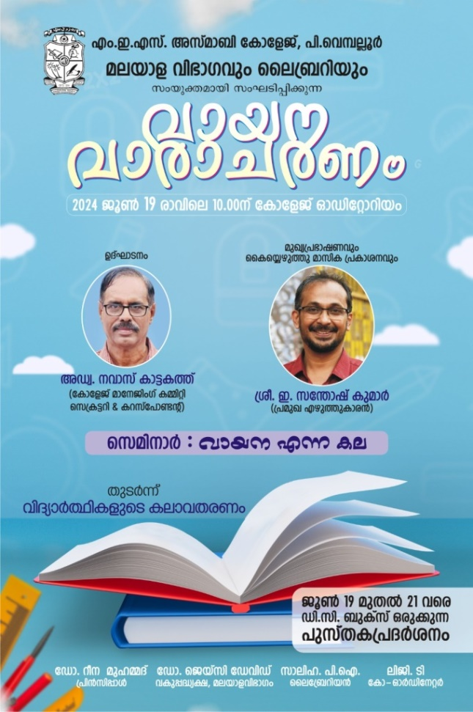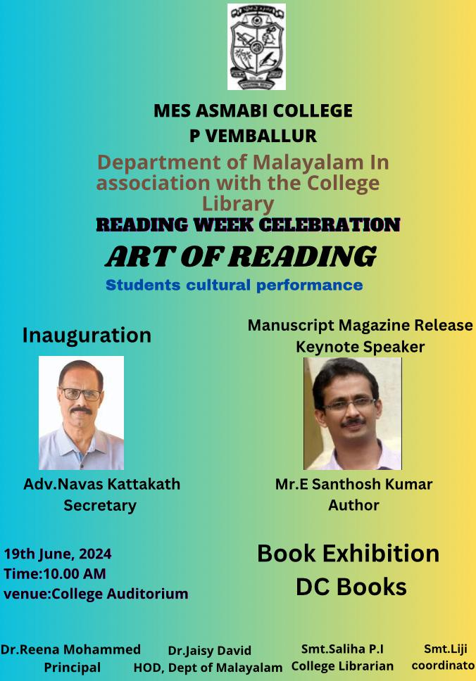

Reading day celebration Brochure Conducted by Dept. ofMalayalam
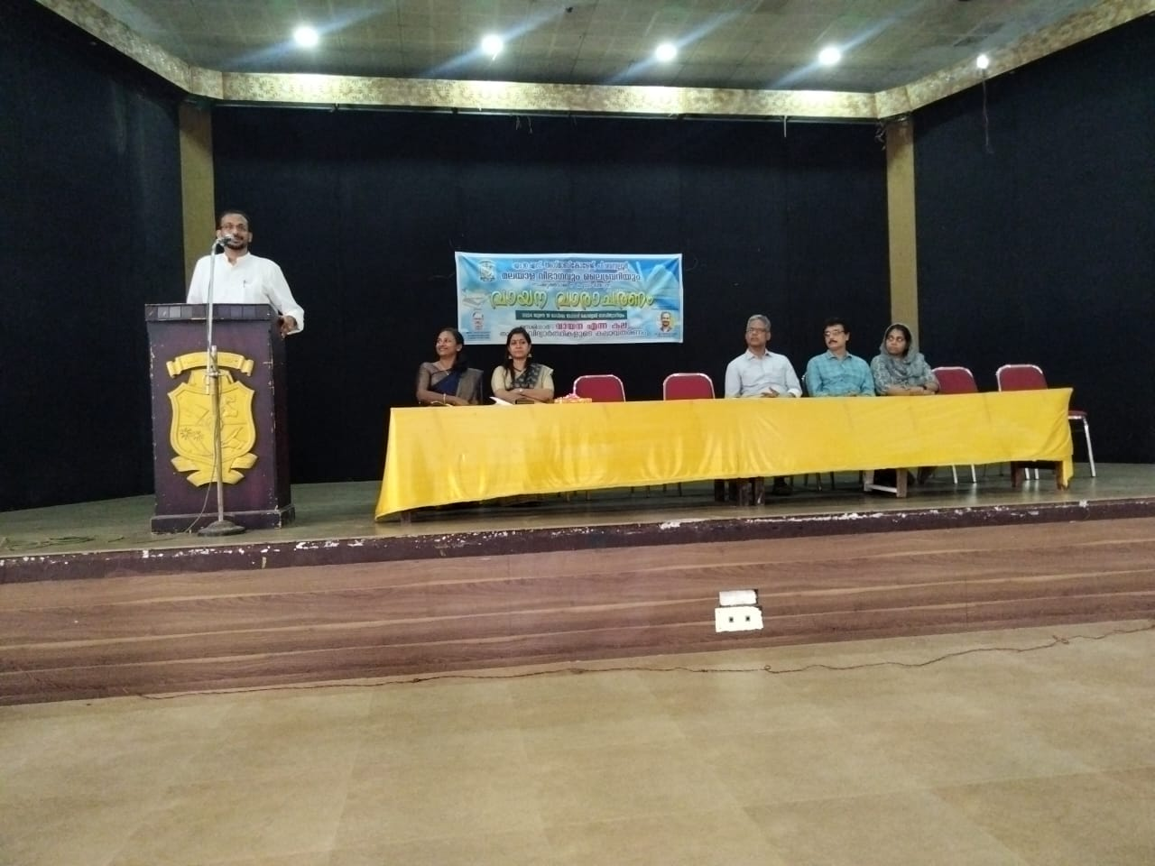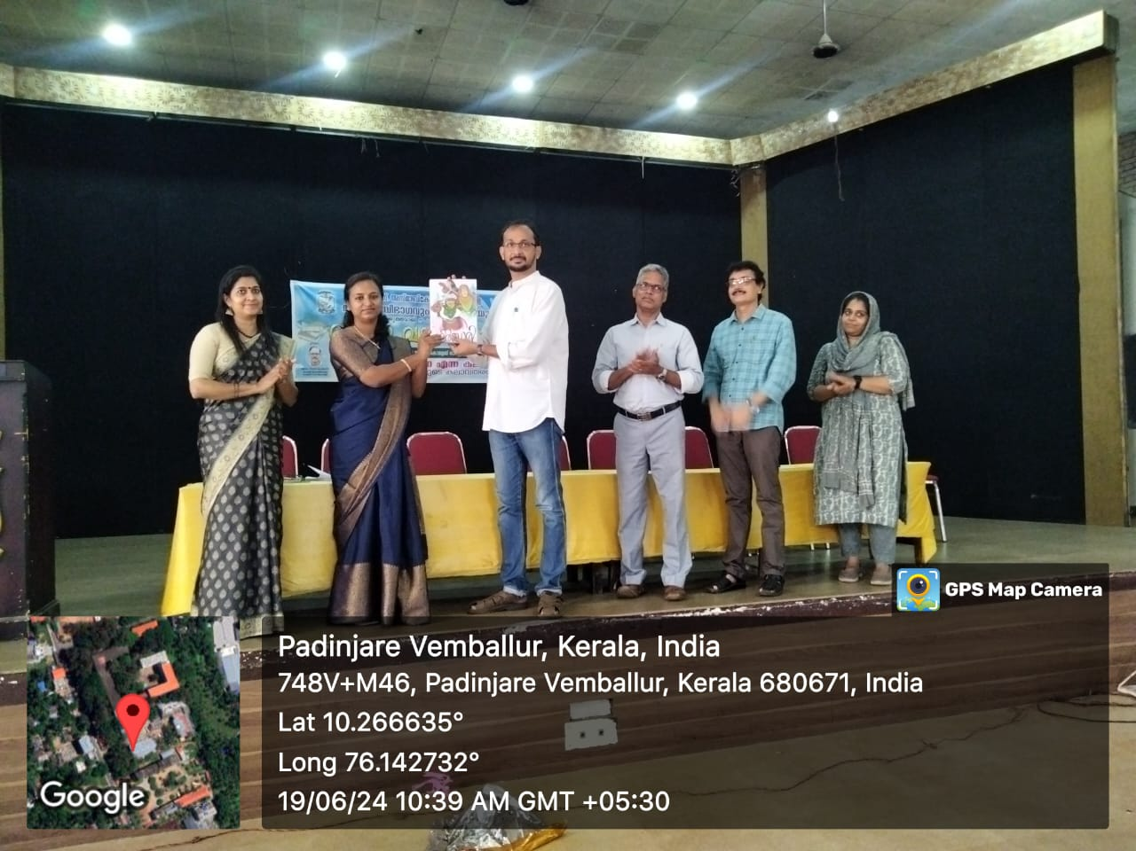

Reading day celebration Inauguration & Manuscript Magazine Releasing- organized by dept.of Malayalam on 19-06-2024

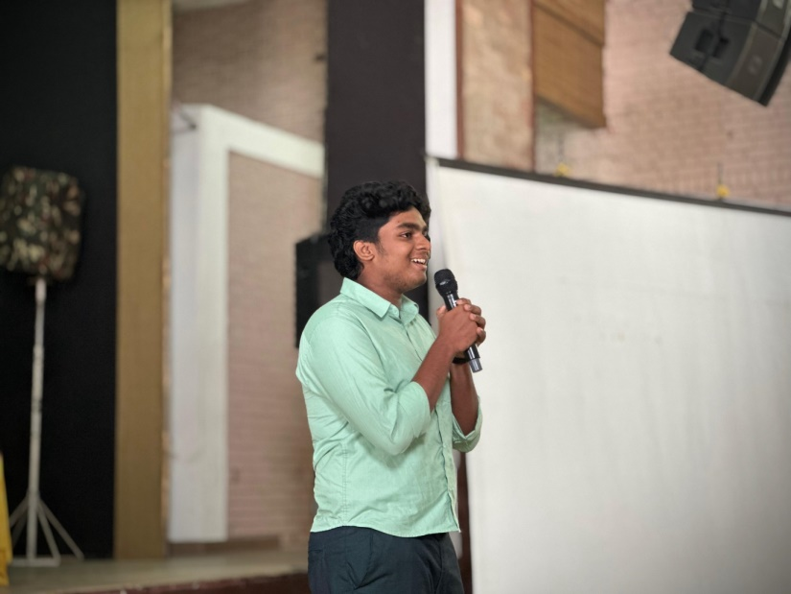
Malayalam Dept.conducted Reading day celebration on 19-06-2024- Malayalam Recitation

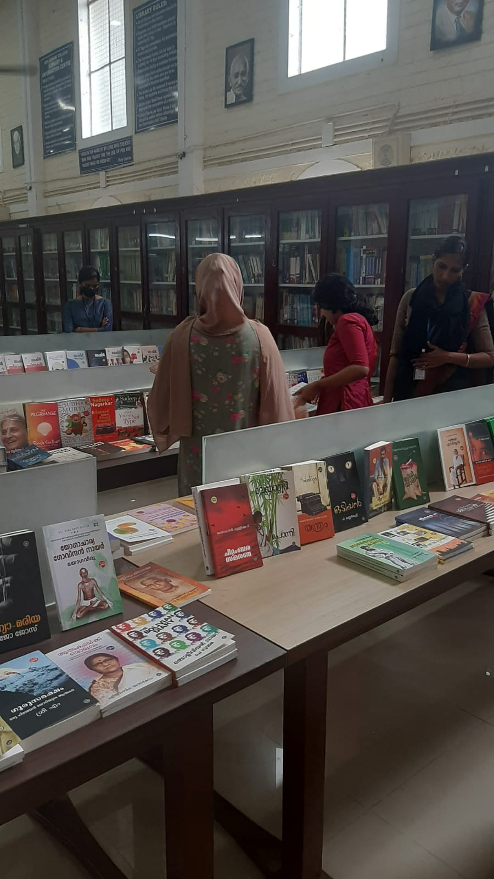

Malayalam dept. conducted Book Exibition(19-062024 to 20-06-2024)

DEPARTMENT OF MALAYALAM
M E S ASMABI COLLEGE, P. VEMBALLUR
The list of Cultural programmes is given below:

Sl. No | Item | Participants | Class | Signature
1 | Recetation | SAFIN SAJIN | II Bsc Botany
1 | Recetation | FATHIMA NUFAILA M | II BA Economics
1 | Recetation | SINSIYA M M | II B.Sc.Botany

:

----

