REPORT OF WORKSHOP ON IPR 2025
'PROTECTING INNOVATION THROUGH IPR: A HANDS-ON WORKSHOP ON PATENT SEARCH, FILING, LAWS AND PROCEDURES'
Date: 17-03-2025
Venue: Seminar Hall
Number of participants: 48 students and 5 teachers
The workshop titled 'Protecting Innovation Through IPR: A Hands-on Workshop on Patent Search, Filing, Laws and Procedures' was successfully conducted on March 17, 2025. The session was aimed at equipping participants with knowledge and practical skills regarding Intellectual Property Rights (IPR), focusing on patent search, filing, laws, and procedures. The session was led by Ms. Pyary Hasna Mehthab, a Registered Indian Patent and Trademark Agent. Her expertise in intellectual property rights provided valuable insights into various aspects of patent protection and its significance in research and innovation. The workshop was attended by a diverse group of participants, including research scholars, undergraduate, and postgraduate students. The interactive session allowed attendees to understand the complexities of IPR and its practical applications in their respective fields.
The session began with an overview of IPR, explaining its importance in protecting innovation and ensuring legal security for inventors. Participants were guided through various patent databases and search techniques to determine the novelty of an invention. A step-by-step guide on patent application filing was provided, detailing the necessary documentation and legal requirements. The session covered key provisions of Indian patent laws, international agreements, and case studies demonstrating their implications. Participants engaged in practical exercises related to patent searching and filing, enhancing their understanding of real-world applications.
The workshop proved to be an informative and engaging session, equipping attendees with essential knowledge on protecting their innovations through IPR. The event successfully raised awareness about the significance of patent protection in academia and research-driven innovation.
Photographs were attached.

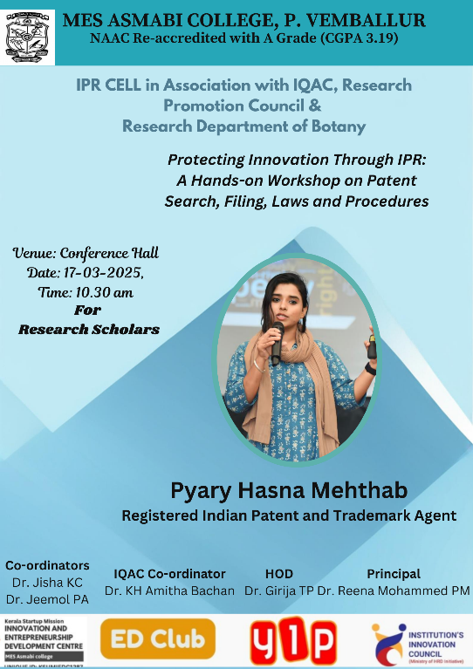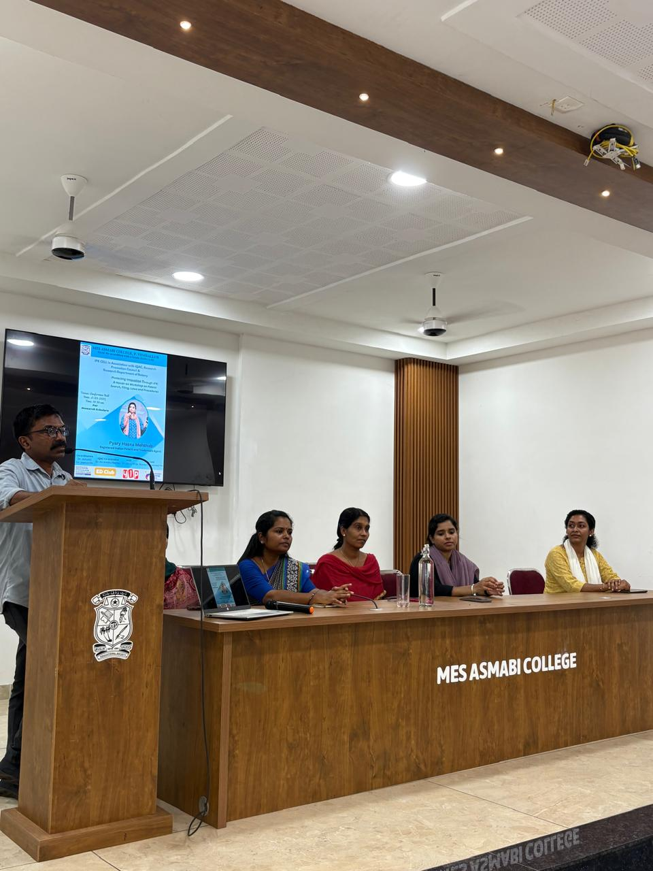

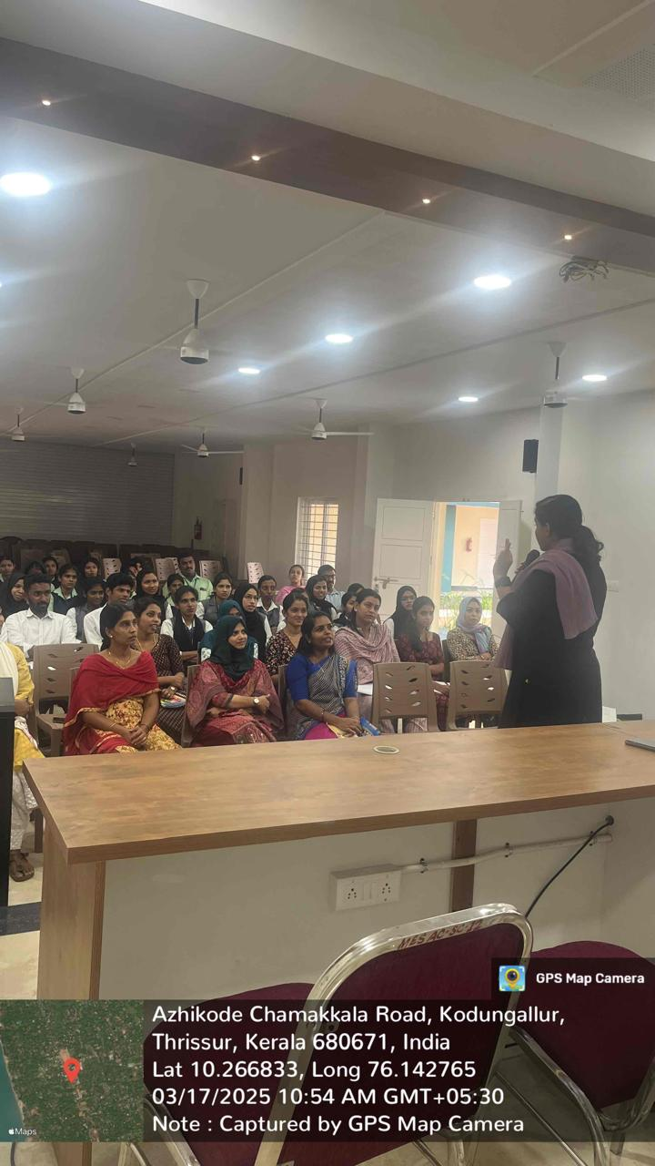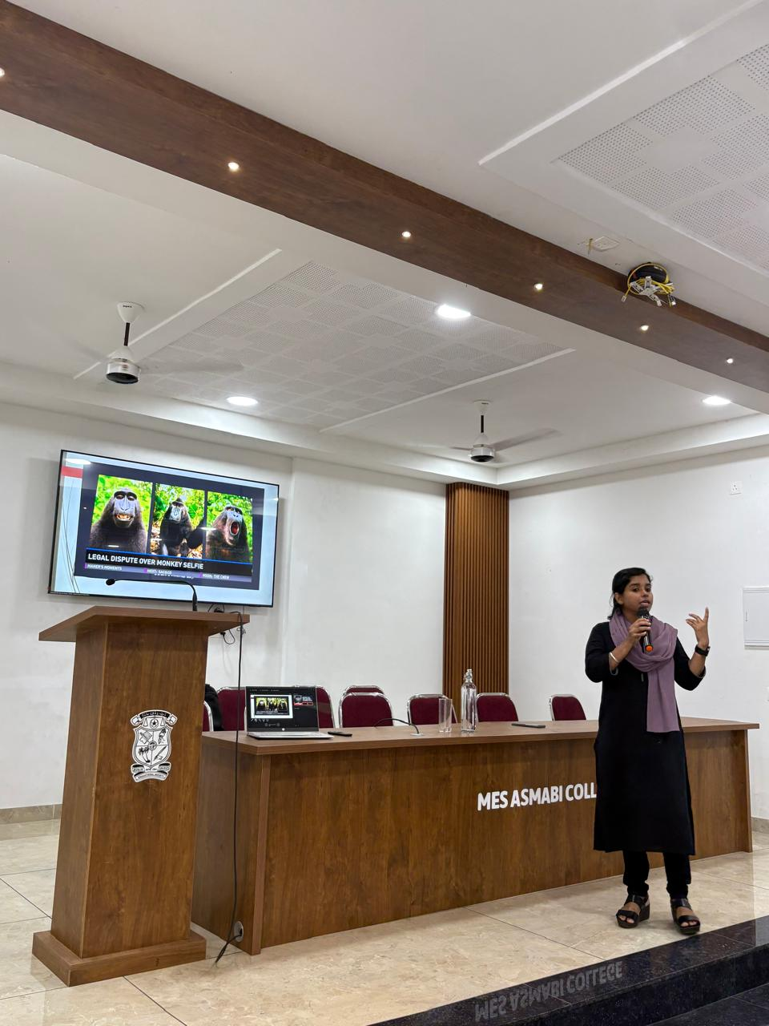
Brochure and Photographs of the programme

