MES ASMABI COLLEGE, P. VEMBALLUR
REPORT ON ‘WORKSHOP AND EXHIBITION ON ECO-FRIENDLY PRODUCTS’
Date: 26-03-2025
Venue: New Seminar Hall
Total number of participants: 55
Bhoomitrasena club in association with Department of Botany, IQAC and Green initiatives jointly organized a workshop cum exhibition on eco-friendly products on March 26, 2025. The resource person for the programme was Anu Kannanunni, a renowned entrepreneur in natural cosmetics. The event aimed to promote sustainable living practices by educating participants about the benefits and importance of using eco-friendly products, particularly in the cosmetics industry. The session began with an introduction to Anu Kannanunni’s entrepreneurial journey and her commitment to natural and sustainable cosmetics. She highlighted the harmful effects of synthetic chemicals commonly found in commercial products and emphasized the need for organic and eco-friendly alternatives.
Anu Kannanunni elaborated on the environmental and health benefits of using natural cosmetics. She explained how chemical-free products reduce pollution and minimize skin-related issues. She introduced various natural ingredients such as herbal extracts, essential oils, and organic butters that serve as safe alternatives in skincare and beauty products. Attendees learned how to make simple eco-friendly skincare products such as lip balms, face masks, and body scrubs using organic ingredients. The session also covered best practices for reducing waste, reusing packaging, and supporting ethical brands.
The workshop and talk by Anu Kannanunni successfully raised awareness about eco-friendly products and their significance in promoting sustainable living. The event provided valuable insights into the benefits of natural cosmetics while equipping attendees with practical skills to incorporate sustainable practices into their daily lives. Overall, it was a well-received and impactful session, inspiring many to make conscious choices for a greener future.
Brochure and photographs are attached.
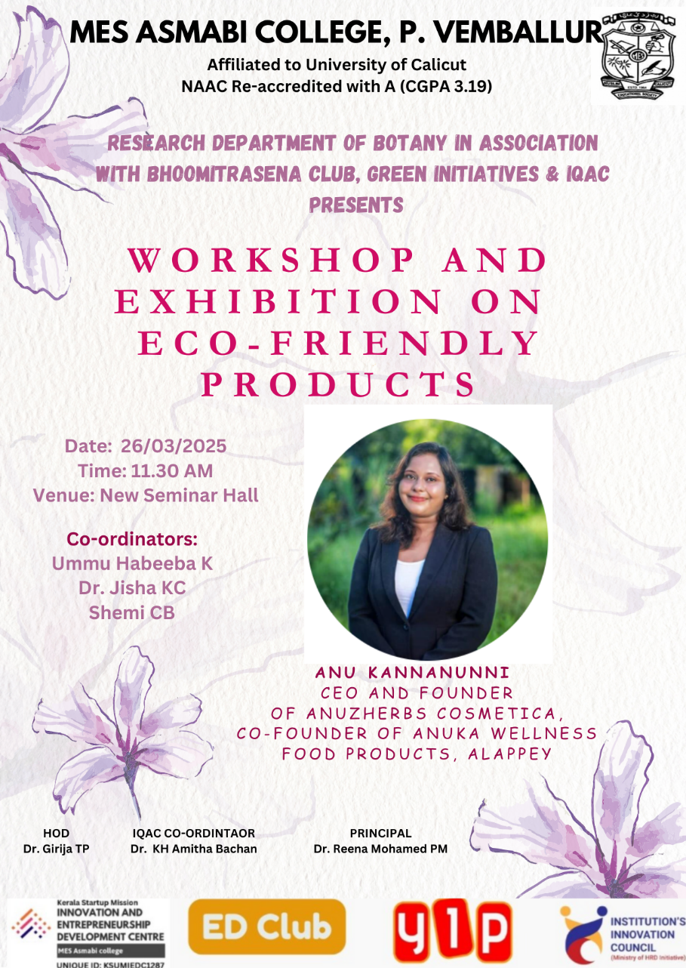
Brochure of the programme
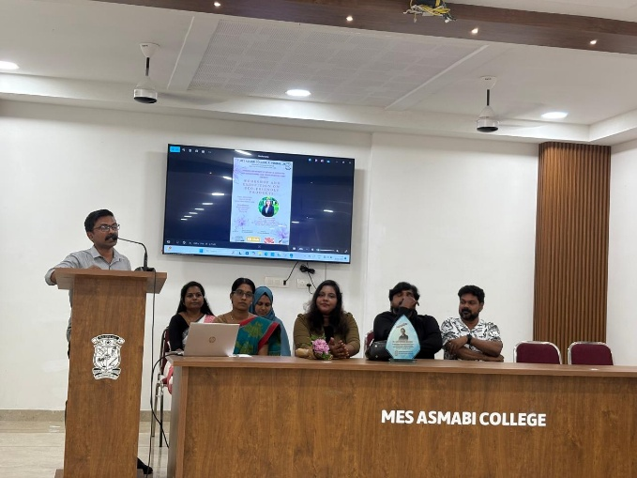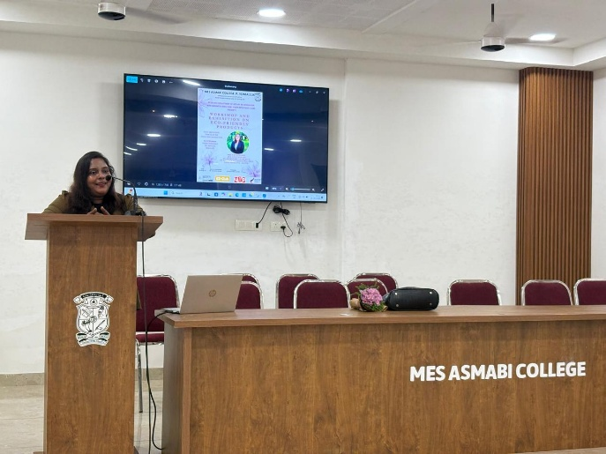
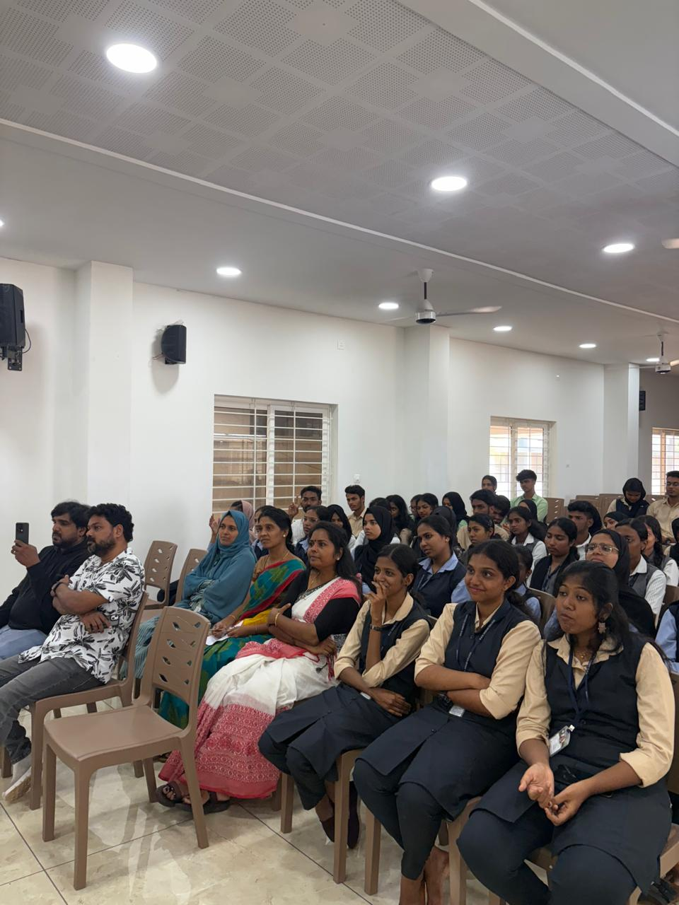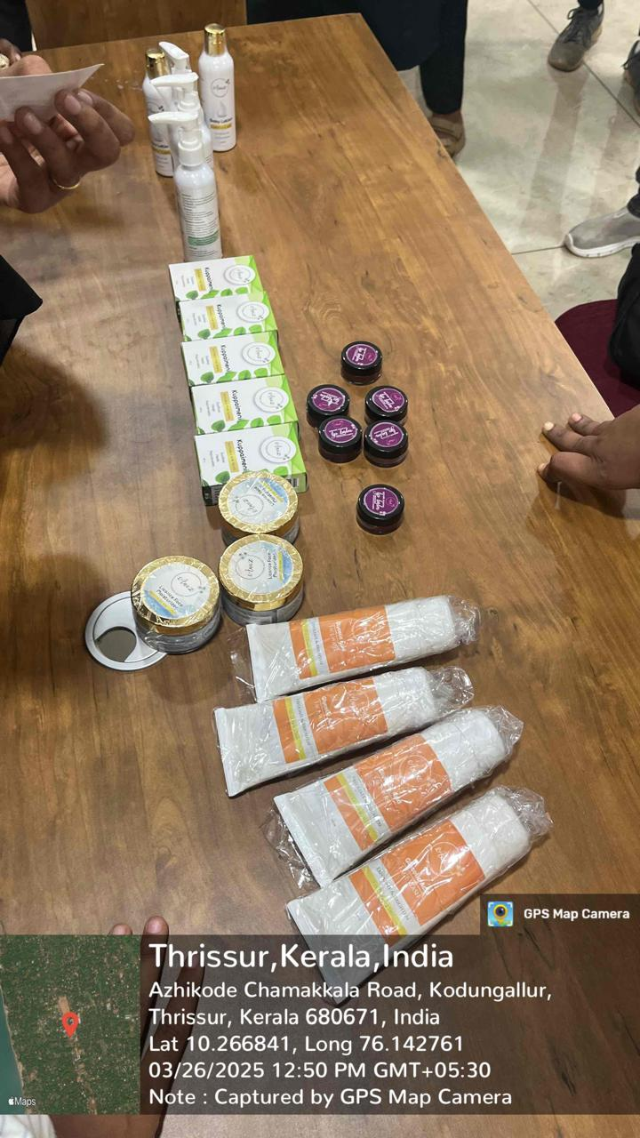
Photographs of the programme

