MESASMABICOLLEGE, P.VEMBALLUR DEPARTMENT OF ECONOMICS
MA ECONOMICS
Tutorial Report 2024-25

Tutor: Dr.JASNA NM

I MA class started on 4 /8/2024
Total Number of students in the Class:17 ( 16G 1B)
Representatives: Vishnu
PT A meeting conducted on on 18/11/2024
TIME : 9.30PMto12.30PM
VENUE: MEETING CONDUCTED in I MA Economics class room
Agenda:
- Progress report analysis.
- Feedback collection from parents about the academic performance

- Teachers Present:
  - Dr.Dhanya K
  - Dr.Shyla Hameed
  - Dr.Jasna NM (Tutor)
  - Sri.ShanilKumar
  - Dr.Jesla Galibdeen

Parents reported: 11Parents reported
Performance Analysis:
The result analysis of first internal examination was taken up for discussion. The performances of each student in comparison with the overall performance of the students were intimated to parents. The disciplinary processes of the department were also discussed like restriction of the use of mobile phone in the class rooms and wearing of complete uniform in the campus.
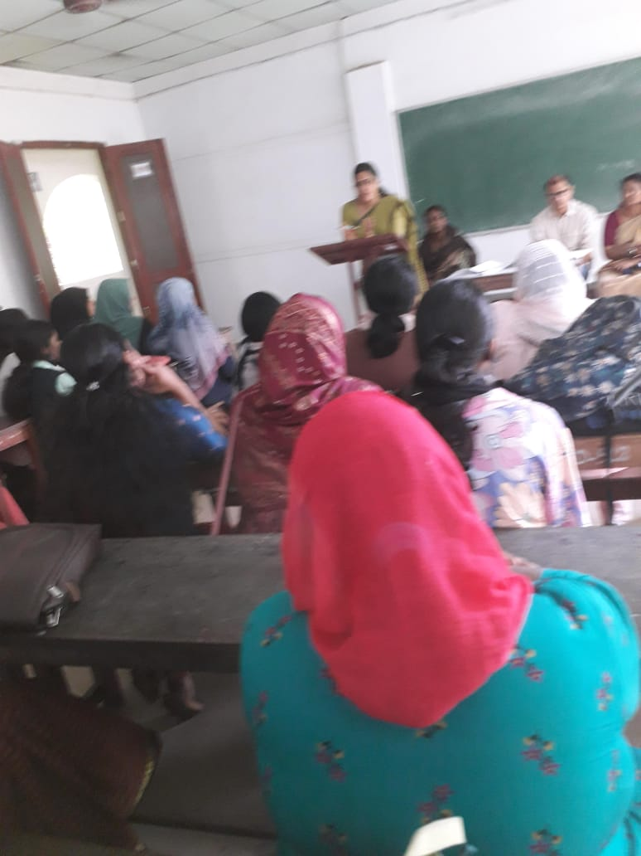

Outcomes of the meeting

• The department's general attendance and discipline were discussed by the HOD.
• The tutors gave a summary of the students' performance.
• The HOD graciously embraced the parents' comments about classroom participation and discipline.
• Individual student learning challenges were explored, and parents and students were encouraged to freely share their thoughts on the instructional strategies employed by all faculty members.
• The findings of the initial internal examination were also analyzed and discussed.

UNIVERSITY RESULT ANALYSIS 1SEM MA ECONOMICS 2024 2026
TOTAL NO OF STUDENTS 17
NO.OF STUDENTSWHO ATTENDEDALLEXAMS 17
NO.OF STUDENTS (FULLPASS) 14
TOTAL NUMBER OF A* 5
TOTAL NUMBER OF A 5
TOTAL NUMBER OF B* 4
FAILED: 3
PASS PERCENTAGE: 8

FIRST MA EONOMICS 2024-2026
INTERNAL EXAMS CONDUCTED FROM MARCH 17 to 20

TOTAL NO OFSTUDENTS : 17
NO. OF STUDENTS WHO ATTENDED ALL EXAMS :16
NO. OF STUDENTS (FULL PASS) :15

Student’s activities

Report on Economic Day Association
The Department of Economics at MES Asmabi College successfully conducted the Economic Day on February 3rd and 4th. The event aimed to provide a platform for students to explore and discuss various economic concepts and contemporary issues that impact global and national economies.
Students from the MA Economics program played an active role in the celebration, contributing to the various discussions, workshops, and presentations organized throughout the event. The two-day program included insightful sessions on key economic topics, interactive discussions, and presentations that encouraged students to apply their theoretical knowledge to real-world economic challenges.
The event also fostered a deeper understanding of the role of economics in daily life, encouraging students to think critically about economic policies and their societal impacts. The participation of MA students was especially noteworthy, as they demonstrated a high level of engagement and enthusiasm throughout the event.

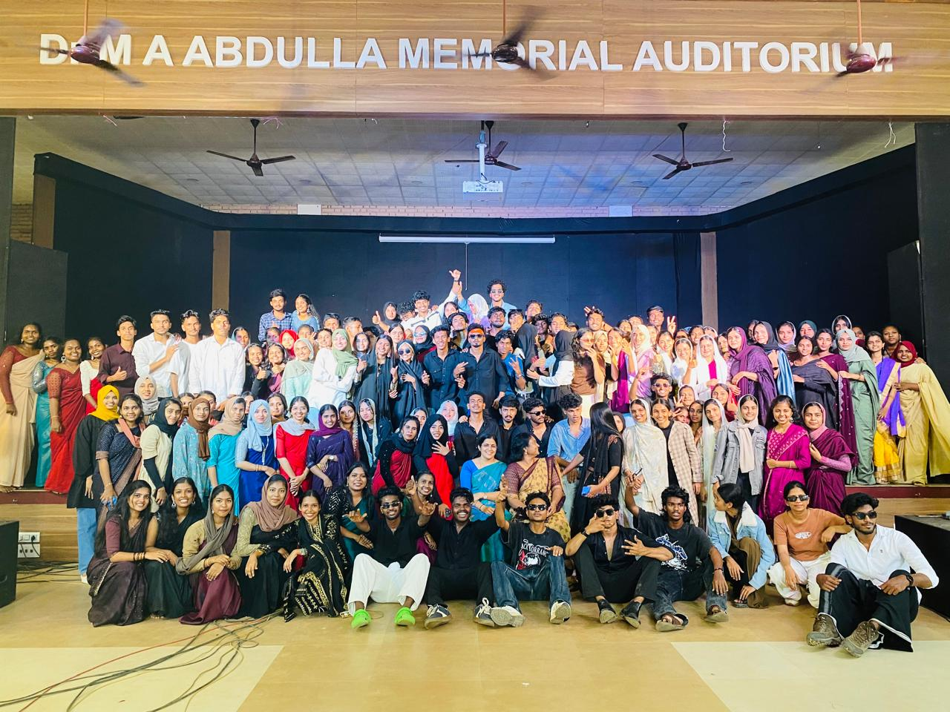

Conducted union Budget discussion and presentation
On 03/02/2025 a session was conducted to discuss and present the Union Budget for the year 2025. The session aimed to provide an in-depth understanding of the key provisions and economic implications of the budget. Objective the session aimed to provide an in-depth understanding of the key provisions and economic implications of the budget

Objective
The session aimed to provide an in-depth understanding of the key provisions and economic implications of the budget

Report
The presentation, which was conducted by Dr. Sony TL and Dr. KP Sumedhan, with panelists Dr. Sanand Sadanand and Saidalavi VP, covered a number of budgetary topics, including funding for important areas like military, infrastructure, healthcare, and education. The main concerns about the budget and farm sector were given to Shifana CP by IBA Economics. The pupils took an active part in the conversation. A detailed presentation of the budget's highlights was given, with particular attention paid to government expenditure, suggested tax adjustments, and measures meant to increase employment and economic growth.
Impact
After the presentation, there was a debate during which participants actively examined how the budget would affect various economic sectors. Participants brought up important issues about long-term economic sustainability, fiscal accountability, and money allocation. Divergent viewpoints on the suggested reforms and their possible effects were also discussed.

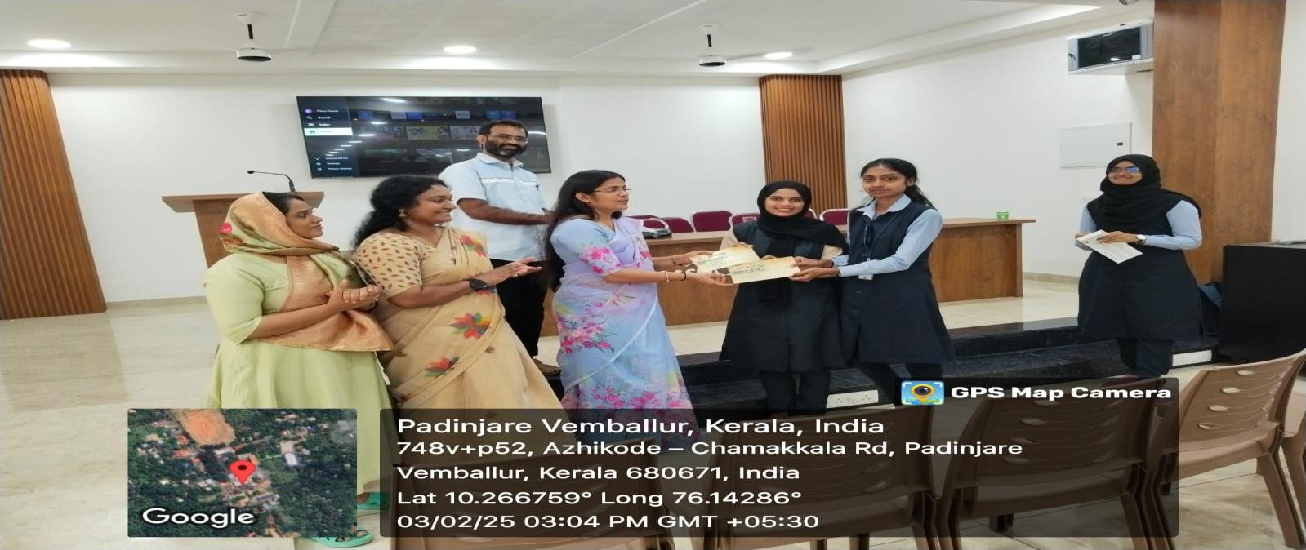

Conclusion:
The Department of Economics at MES Asmabi College, P. Vemballur, has arranged a variety of academic debates and extracurricular activities that have significantly enhanced the students' learning experience. They actively participate in numerous programmes run by the department of economics.
Furthermore, MA Economics students' participation in environmental programs, arts, paper pen competitions, and other activities demonstrates their overall development and commitment to academic and extracurricular success. These activities have not only extended the students' academic perspectives, but also aided their personal and professional development. To summarize, the Department's efforts in organizing such events and encouraging student engagement have had a significant influence in improving the educational experience and preparing students for future difficulties

Sd/- Sd/-
HoD ClassTutor

.

