M E S ASMABI COLLEGE, P. VEMBALLUR

DEPARTMENT OF ECONOMICS
II BA ECONOMICS HONOURS

Tutor : Dr.Shyla Hameed

I semester Classes started on 10/07/2024.
Total Number of students in the Class: 51 (Boys 18, Girls 33)
Class representatives:Archa Shiju and Avinash Pk
Conducted union Budget discussion and presentation
On 03/02/2025 a session was conducted to discuss and present the Union Budget for the year 2025. The session aimed to provide an in-depth understanding of the key provisions and economic implications of the budget.
Objective
The session aimed to provide an in-depth understanding of the key provisions and economic implications of the budget
The presentation, led by Dr Sony TL and Dr KP Sumedhan, Dr Sanand Sadanand, Saidalavi VP were the panellist, the session covered various aspects of the budget, including allocations for key sectors such as healthcare, education, infrastructure, and defense. From IBA Economics Shifana CP were presented the key issues of the Budget and agriculture sector. The students were actively participated in the discussion. The highlights of the budget were presented in detail, focusing on government spending, proposed tax changes, and policies aimed at boosting economic growth and employment.
Impact
Following the presentation, a discussion session was held where attendees actively engaged in analyzing the potential impacts of the budget on different sectors of the economy. Participants raised pertinent questions about the distribution of funds, fiscal responsibility, and long-term economic sustainability. The discussion also included varying perspectives on the proposed reforms and their potential outcomes.
The session concluded with a summary of the key takeaways, emphasizing the importance of understanding the budget’s broader economic implications and its role in shaping the nation's future. Overall, the Union Budget discussion and presentation proved to be an insightful and educational event, fostering informed dialogue on national economic policies. The Department of Economics in MES Asmabi College P. Vemballur organized different academic discussions and extra-curricular activities. The student of IBA Economics actively participated in IEDC programmes, arts and sports events conducted by the college and the department.
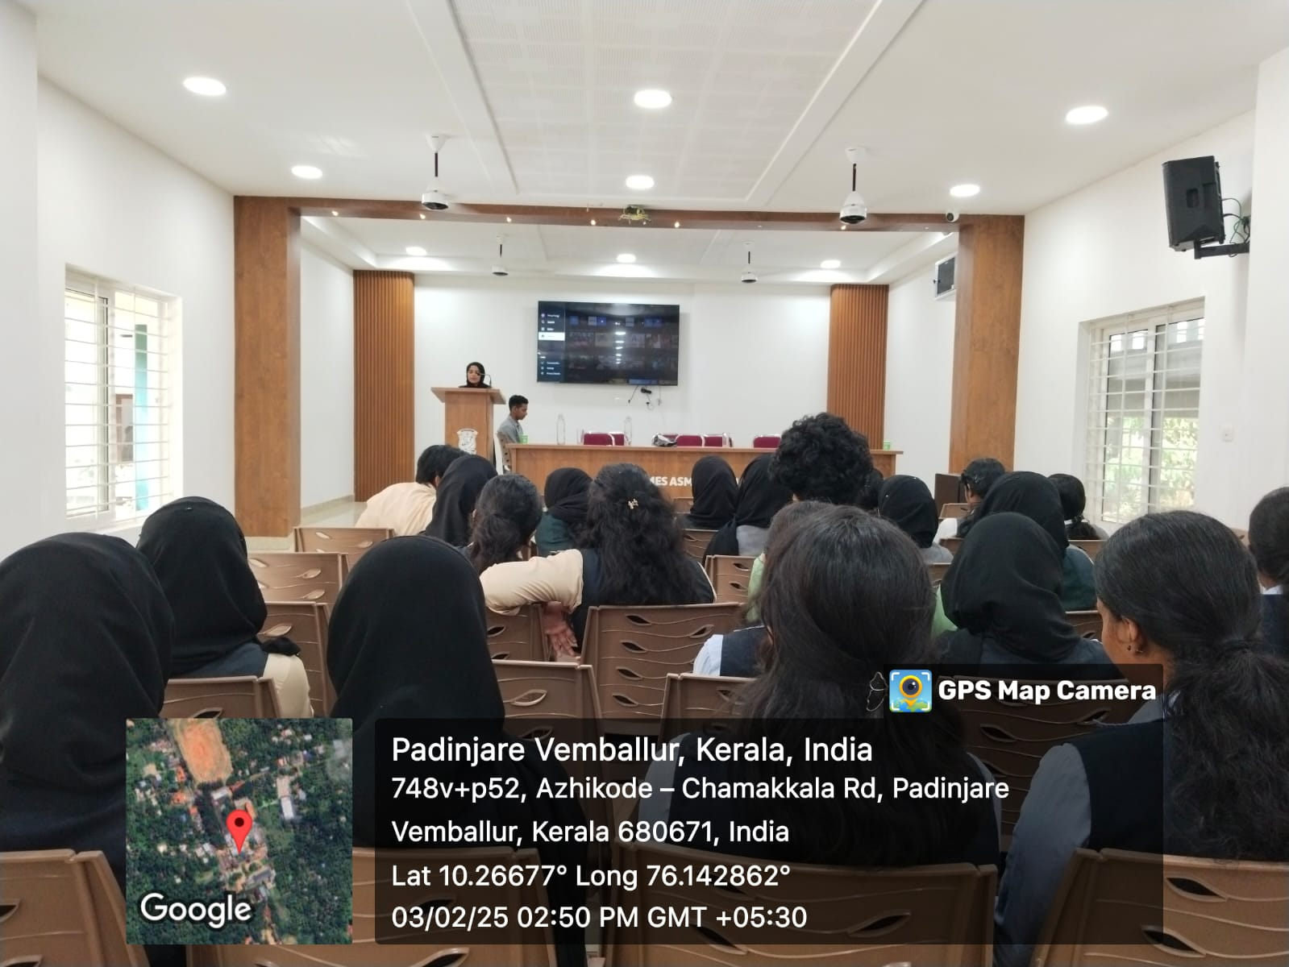

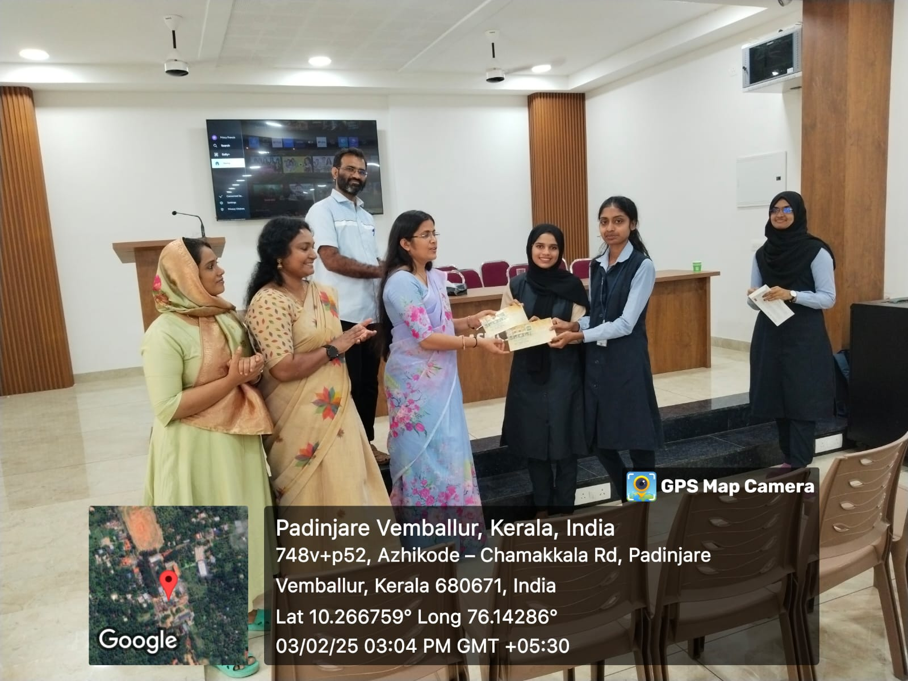
Sports Achievements

Conclusion:
The Union Budget discussion and presentation provided a platform for students to engage with the economic policies that shape the nation's future. With active participation from students and insightful contributions from the panelists, the session provided a comprehensive understanding of the budget’s impact on various sectors, fostering informed discussions on national economic priorities.
Additionally, the involvement of IBA Economics students in IEDC programmes, arts, and sports events further exemplifies their holistic development and commitment to both academic and extracurricular excellence. These activities have not only broadened the students' academic perspectives but also contributed to their personal and professional growth.
In conclusion, the efforts of the Department in organizing such events and fostering student participation have been highly impactful in enhancing the educational experience and preparing students for future challenges.

Sd/- Sd/-
HoD Class Tutor

------------------------

