MES ASMABI COLLEGE
DEPARTMENT OF ECONOMICS

Residential Camp at KILA

Introduction
As part of the institutional visit programme, a two-day residential camp was organized at the Kerala Institute of Local Administration (KILA) from 27th February to 28th February 2025 by the Department of Economics, MES Asmabi College. The objective of the camp was to provide students with practical insights into local governance, policy-making, and administrative functions.

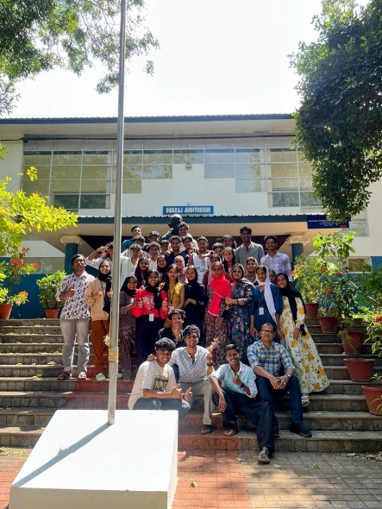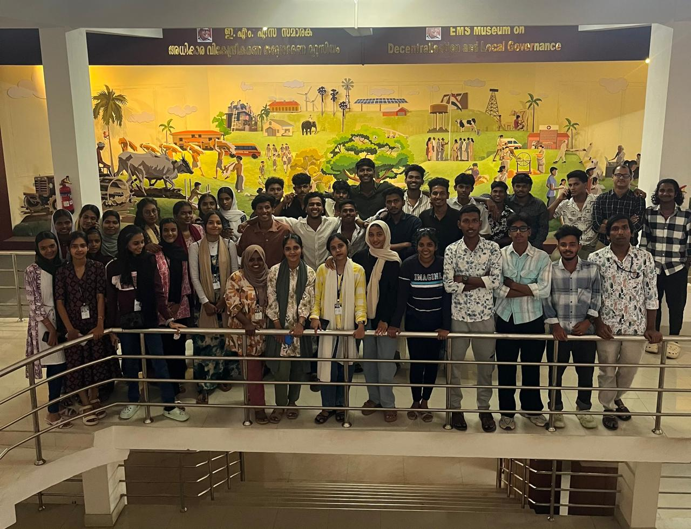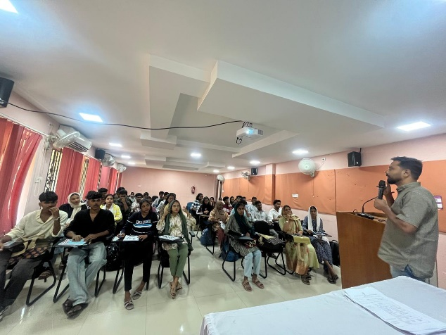

Activities and Sessions
The camp featured a series of lectures, interactive discussions, and field visits aimed at enhancing students' understanding of governance and development planning. Key activities included:
- Orientation Session: An introductory session on the role and functions of KILA in local governance.
- Expert Lectures: Sessions by policy experts and administrators on decentralization, participatory governance, and sustainable development.
- Field Visit: A visit to nearby panchayats to observe real-time governance and community participation.
- Workshops: Group activities focusing on governance challenges and policy formulation.
- Interactive Discussions: Q&A sessions with officials, enabling students to clarify doubts and gain deeper insights.

Key Takeaways
The residential camp provided students with an enriching experience by:
- Offering a comprehensive understanding of the functioning of local self-governments.
- Encouraging participatory learning through direct engagement with governance mechanisms.
- Developing critical thinking and problem-solving skills related to policy-making and administration.

