Department of Economics, MES Asmabi College
Debate on Government Action on Wayanad Landslide Enough or Not
Date and time; 21/3/2025
Venue: Department of Economics
As part of the activities organized by the Debate Club, MES ASMABI College, P Vemballur, conducted a debate on Economics department, on the topic on Government Action on Wayanad Landslide Enough or Not on 21/3/2025. The event aimed to raise awareness about the harmful effects of drug use and promote healthy lifestyles among students. The debate witnessed enthusiastic participation from 57 students from various departments, showcasing their passion and commitment to the cause. The participants presented their views on the importance of living a drug-free life, highlighting the physical, mental, and social benefits of staying away from drugs
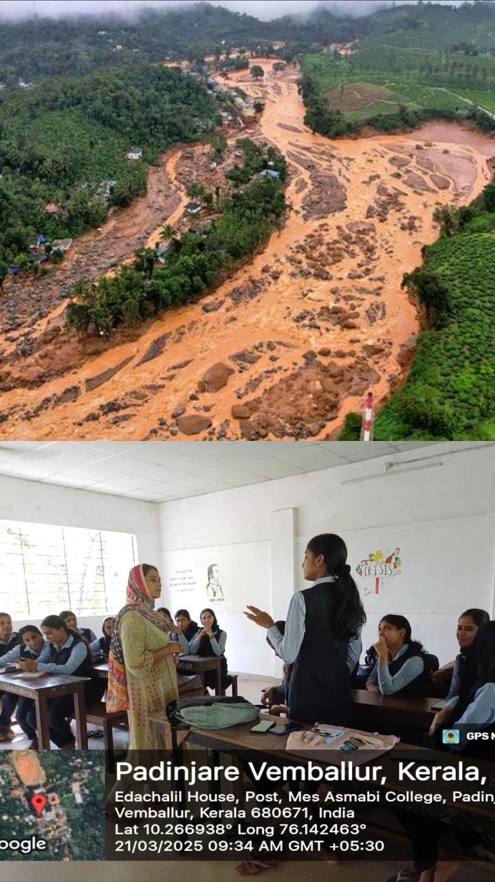
The event was successfully coordinated under the guidance of Dr. Jasna, the Joint Coordinator, who played a pivotal role in organizing the debate and ensuring its smooth execution.The debate not only provided a platform for students to express their opinions but also fostered a deeper understanding of the negative consequences of drug addiction and the importance of leading a healthy, drug-free life.
The event concluded on a positive note, with participants gaining valuable insights and pledging to spread the message of living a life free from drugs.

