Department of Economics, MES Asmabi College
Hands on Training on data Analysis

The Department of Economics at MES Asmabi College, P.Vemballur, organized a workshop on Project Preparation and Execution on 19/02/2025 . The workshop aimed to equip final-year UG students with the skills and knowledge needed to prepare and execute projects effectively. Dr. Jasna N.M, Assistant Professor, Department of Economics, MES Asmabi College, was the resource person for the workshop. She shared her expertise and guided students through the process of project preparation and execution.The workshop was coordinated by Shanilkumar, Faculty, and Department of Economics.
A total of 58 final-year UG students attended the workshop and actively participated in the discussions. The workshop covered topics such as project planning, data collection, data analysis, and report writing. Dr. Jasna emphasized the importance of proper planning, execution, and presentation of projects.
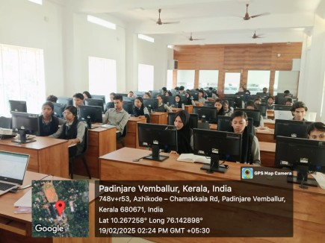
The students found the workshop highly informative and interactive. They appreciated the opportunity to learn from Dr. Jasna's experience and expertise.

Department of Economics, MES Asmabi College
Debate on "Life is better Without Drugs"
Highlights
Date and time; 18/7/2025
Venue: Department of Economics
Agenda: To raise awareness about the harmful effects
Coordinator: Dr.Saidalavi
Joint Coordinator Dr.Jasna NM
Report of the Programme
As part of the activities organized by the Debate Club, MES ASMABI College, P Vemballur, conducted a debate on Economics department, on the topic "Life is Better Without Drugs "on 18/7/2025. The event aimed to raise awareness about the harmful effects of drug use and promote healthy lifestyles among students.The debate witnessed enthusiastic participation from 57 students from various departments, showcasing their passion and commitment to the cause. The participants presented their views on the importance of living a drug-free life, highlighting the physical, mental, and social benefits of staying away from drugs.
The event was successfully coordinated under the guidance of Dr. Jasna, the Joint Coordinator, who played a pivotal role in organizing the debate and ensuring its smooth execution.The debate not only provided a platform for students to express their opinions but also fostered a deeper understanding of the negative consequences of drug addiction and the importance of leading a healthy, drug-free life.
The event concluded on a positive note, with participants gaining valuable insights and pledging to spread the message of living a life free from drugs.
Outcomes
Increased Awareness: The debate helped raise awareness among students regarding the harmful effects of drug abuse on physical health, mental well-being, and societal dynamics. Both sides presented compelling arguments, leading to a well-rounded understanding of the issue.
Promotion of a Healthy Lifestyle: The proponents of the motion effectively conveyed the message that living a drug-free life can lead to improved health, productivity, and a better quality of life. This encouraged students to consider drug-free living as a more viable option for their future.

