Department of Economics, MES Asmabi College
Paper Presentation at Annual Students Conference

Two of our PG students, Amrutha and Khadeeja, made us proud by presenting a paper titled "AI's Role in Social Cohesion: Intensifying Gaps" at the Annual Students Conference held at Sree Kerala Varma College, Thrissur.
The conference, which was held on 17/12/2024, brought together students from various colleges and universities across the state. The event provided a platform for students to showcase their research skills, critical thinking, and presentation abilities.
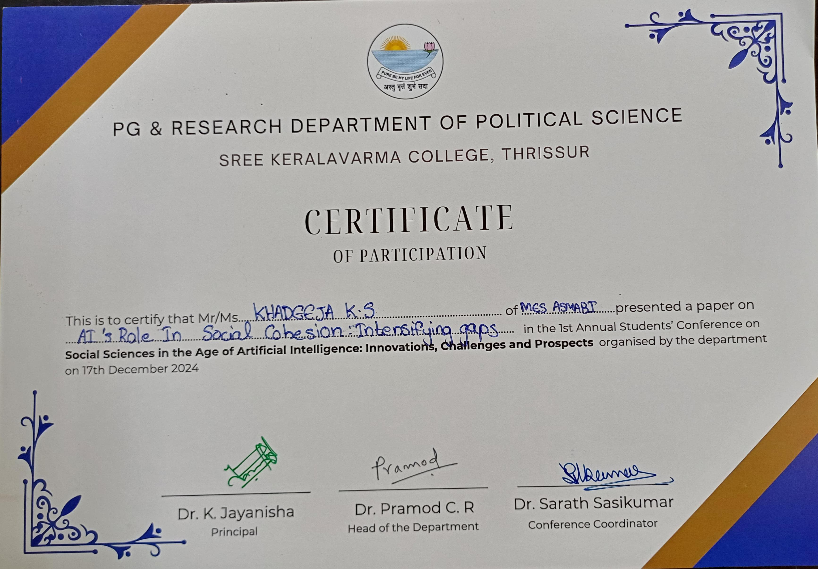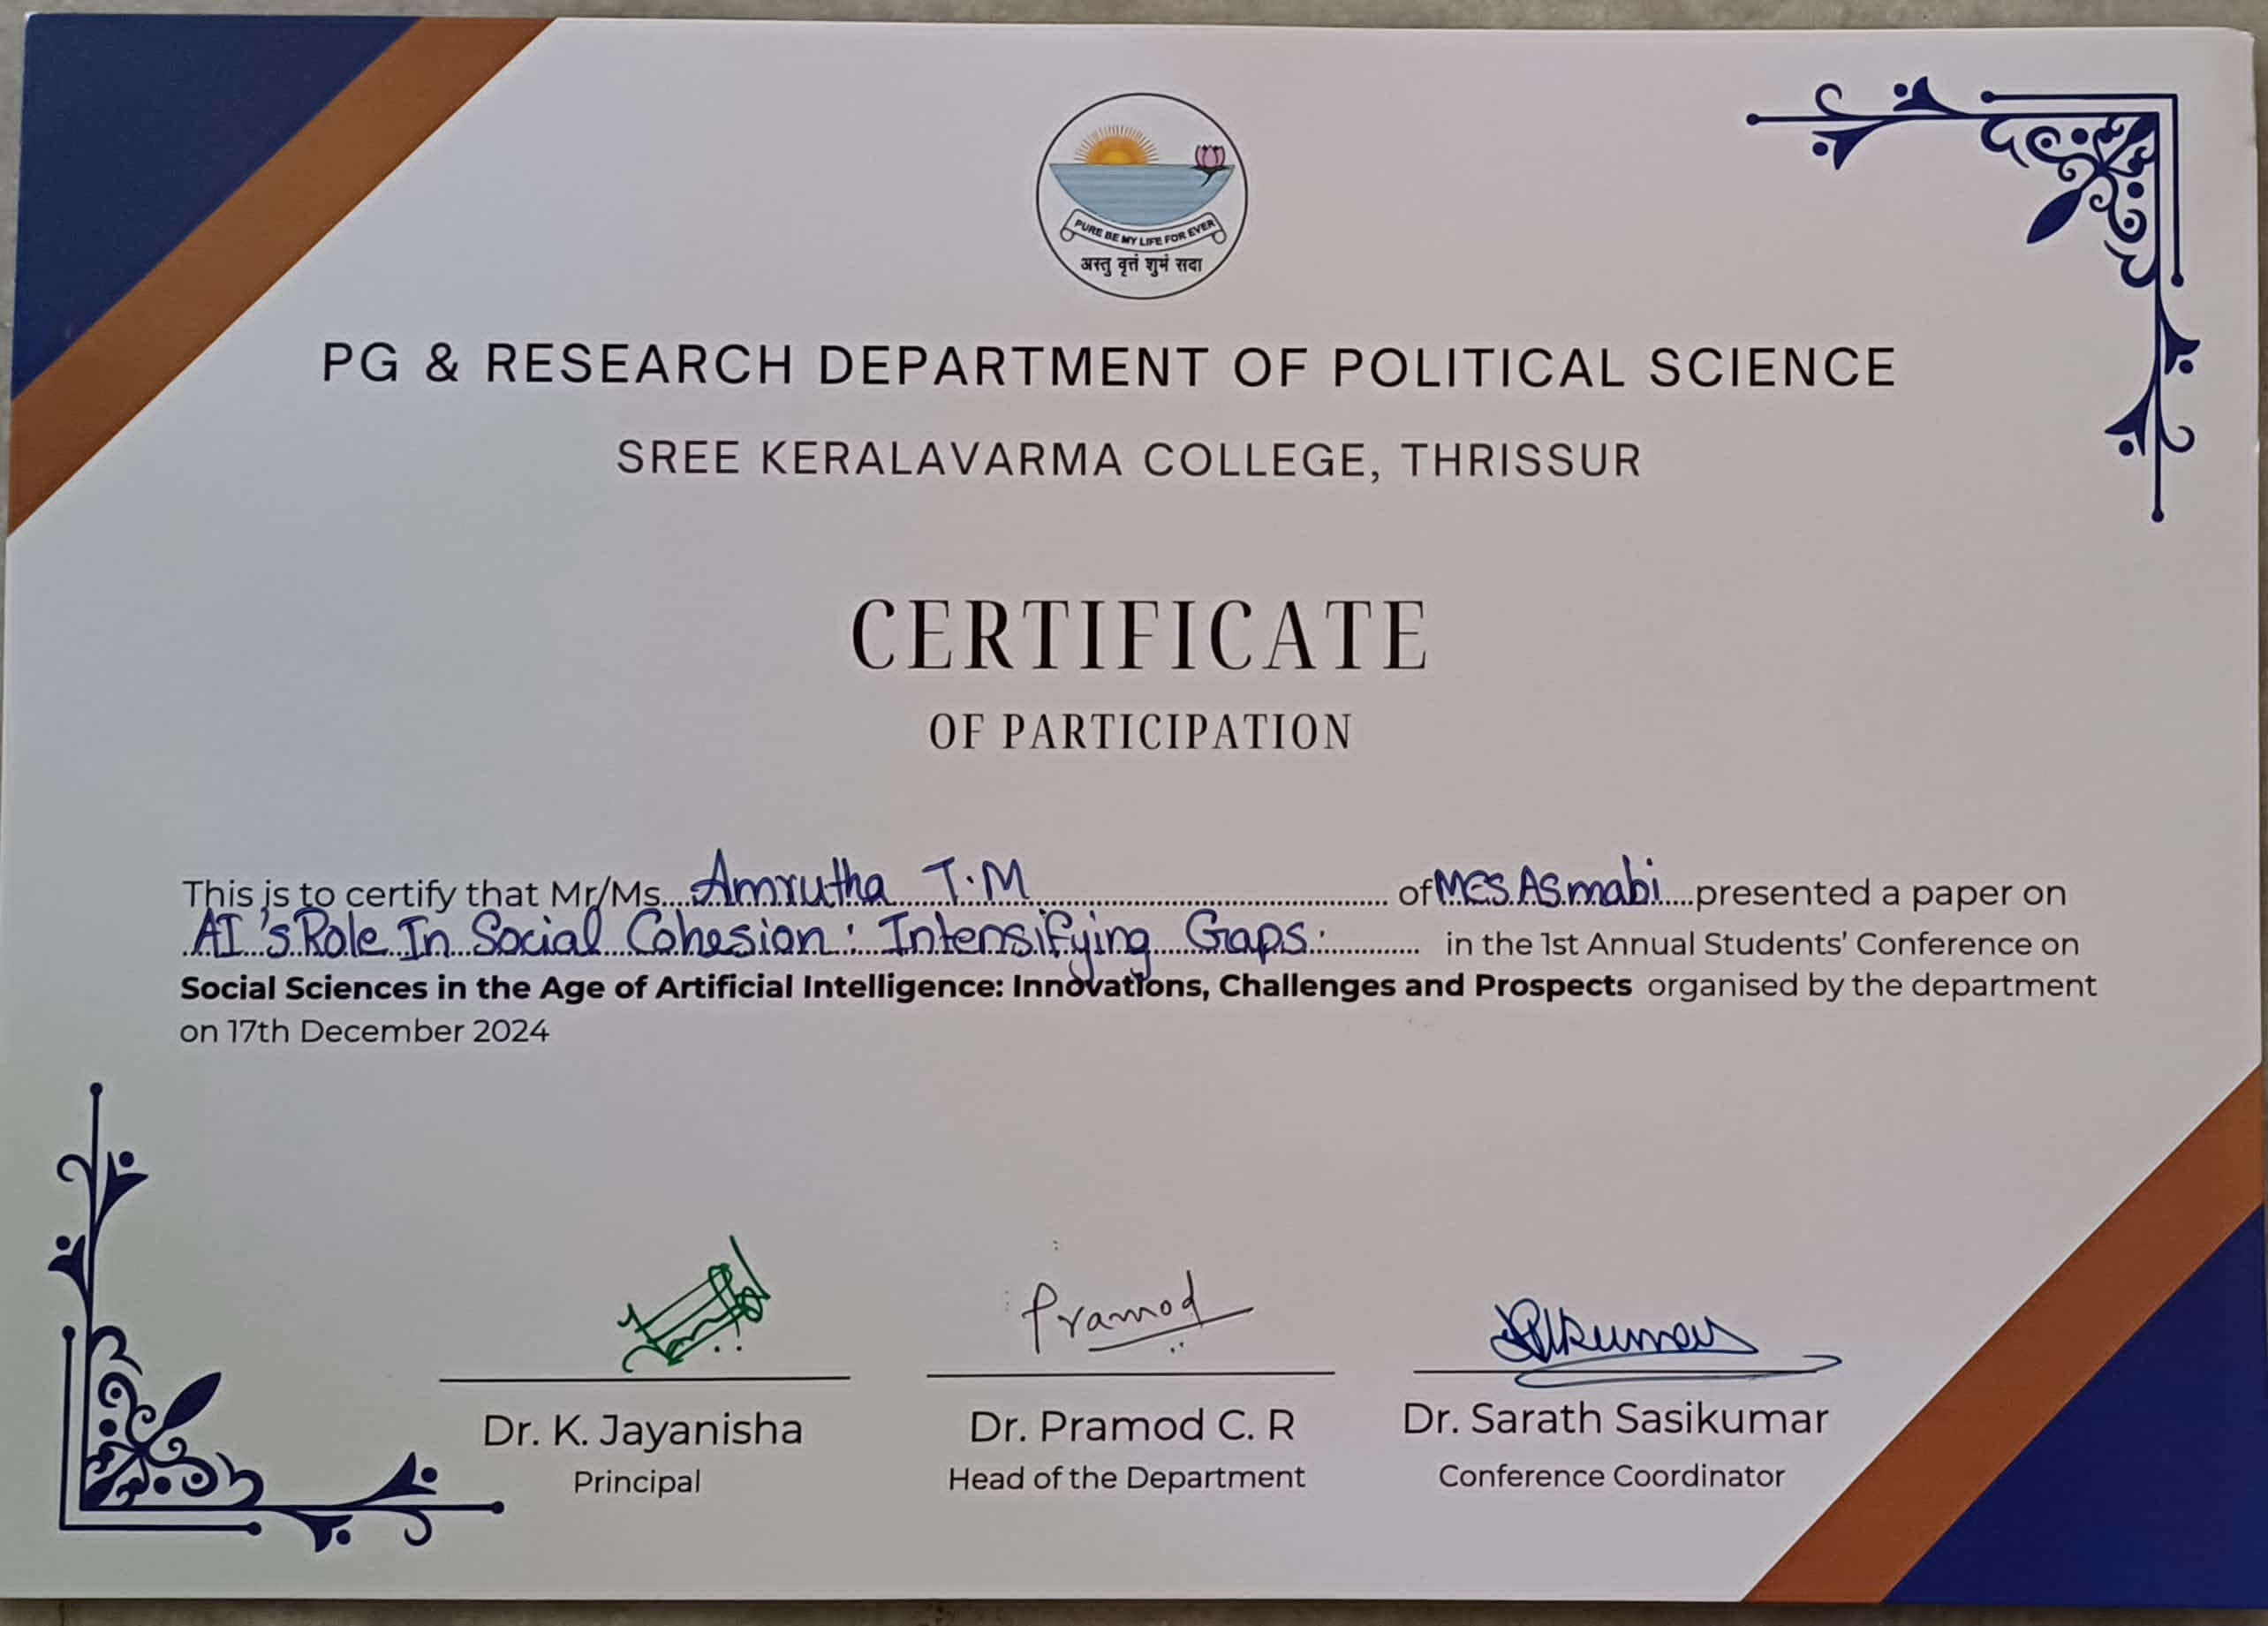
Amrutha and Khadeeja's paper explored the impact of Artificial Intelligence (AI) on social cohesion, highlighting how AI can exacerbate existing social gaps. Their presentation was well-received by the audience and appreciated by the judges for its originality, depth, and relevance to contemporary societal issues.
This achievement demonstrates the academic excellence and research capabilities of our PG students. It also reflects the department's commitment to fostering a research-oriented culture and providing opportunities for students to engage with academic conferences and seminars.
We extend our warmest congratulations to Amrutha and Khadeeja on their outstanding achievement. We also appreciate the efforts of our faculty members who guided and supported them throughout the process.

