Report on Industrial Visit
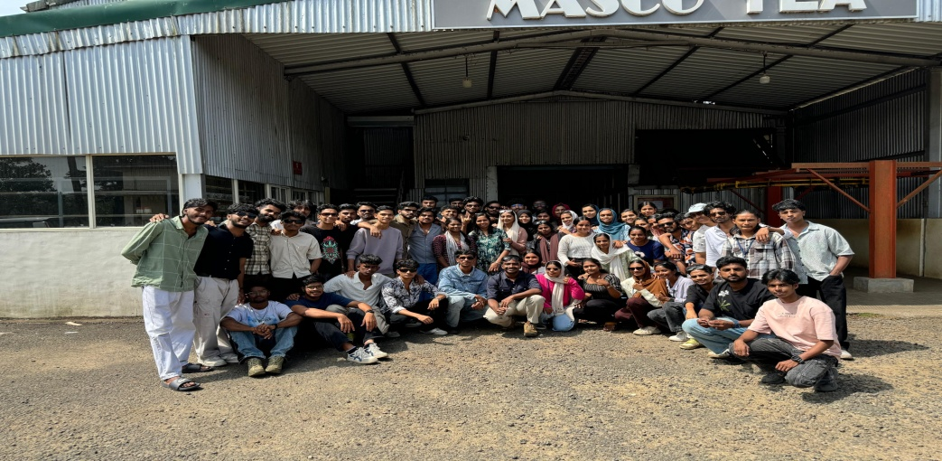
The industrial visit to MASCO TEA FACTORY in Vagamon by Second year BCom Finance Students on November 22, 2024 With 54 students and Accompanied by 2 Teachers provided a valuable firsthand experience of tea processing, revealing the intricate steps involved in transforming freshly plucked leaves into finished tea. The observation of withering, rolling, oxidation, drying, and sorting processes highlighted the precision required for quality tea production, while the grading demonstration illustrated the criteria used to differentiate tea varieties based on leaf size and quality; this visit effectively bridged the gap between theoretical understanding and practical application, emphasizing the importance of controlled environments and meticulous procedures within the tea manufacturing industry.

