Report on Cross Age Teaching: Teacher’s Day Initiative
Organized by:
Research Department of Commerce, MES Asmabi College
Date:
5 September 2024
1. Introduction
On the occasion of Teacher's Day 2024, the Research Department of Commerce at MES Asmabi College conducted a unique and engaging event titled "Cross Age Teaching". The program aimed to promote collaborative learning and knowledge exchange between students of different academic levels, fostering a deeper understanding of subject matter and enhancing peer-learning strategies.
2. Objectives of the Program
The primary objectives of the Cross Age Teaching initiative were:
- To encourage peer learning by allowing senior students to engage in teaching junior students.
- To promote a collaborative academic environment where students actively participate in teaching and learning processes.
- To instill confidence and improve communication skills in students by giving them a platform to teach others.
- To honor the spirit of Teacher’s Day by recognizing the significance of teaching in personal and academic growth.
3. Event Overview
In this initiative, First-year M.Com students took on the role of teachers, conducting sessions for Second-year B.Com students. The program was structured to promote inter-level academic collaboration, where senior students from the Master’s program taught concepts to undergraduate students in a comfortable, peer-driven setting.
Key Highlights:
- First-year M.Com students prepared lesson plans and engaged with the second-year B.Com students through interactive sessions.
- These classes were held in classrooms, creating an informal and conducive learning environment where both seniors and juniors could exchange ideas.
- The initiative emphasized active learning techniques, providing an alternative approach to the traditional teacher-led classroom.

4. Organizational Support
The program was organized under the guidance of the following leaders:
- Dr. Reena Mohamed – Principal, MES Asmabi College
- Smt. Chithra P – Head of the Department, Commerce
- Dr. Safiya KM – Program Coordinator
Their support and leadership ensured the smooth execution of the program, highlighting the institution's commitment to innovative teaching methods and student engagement.
5. Impact on Participants
For First-year M.Com Students:
- The M.Com students experienced a unique opportunity to step into a teaching role, giving them a sense of responsibility and ownership over their learning.
- They developed essential skills such as communication, leadership, and confidence while delivering lectures to their juniors.
For Second-year B.Com Students:
- The B.Com students found the experience enriching as they received knowledge from their seniors in a comfortable and interactive environment.
- The initiative bridged the gap between different academic levels within the department, fostering teamwork and a sense of academic community.
6. Conclusion
The Cross Age Teaching initiative conducted by the Research Department of Commerce was a successful and enriching experience for all participants. By empowering First-year M.Com students to teach Second-year B.Com students, the program not only honored the spirit of Teacher's Day but also fostered a collaborative and dynamic academic environment. This initiative reflects the college’s commitment to innovative learning strategies that extend beyond traditional teaching methods.

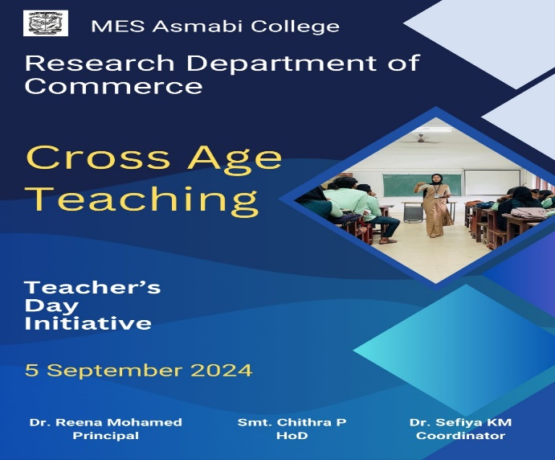 | 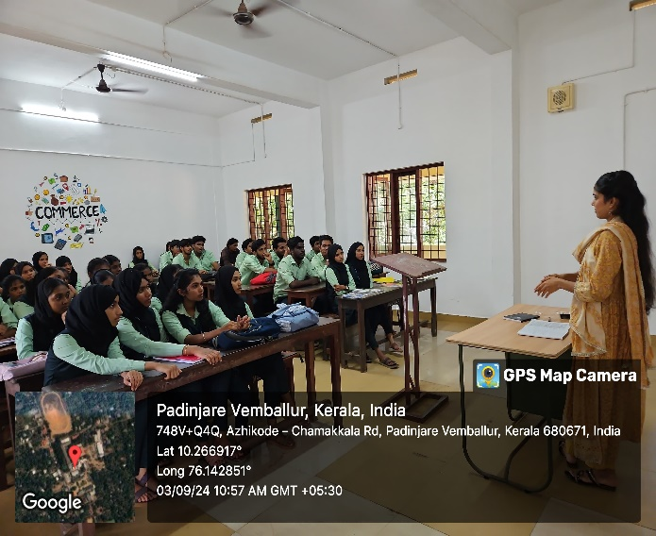
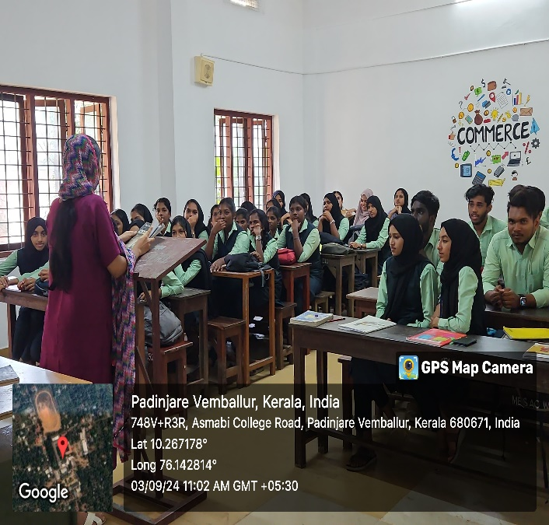 | 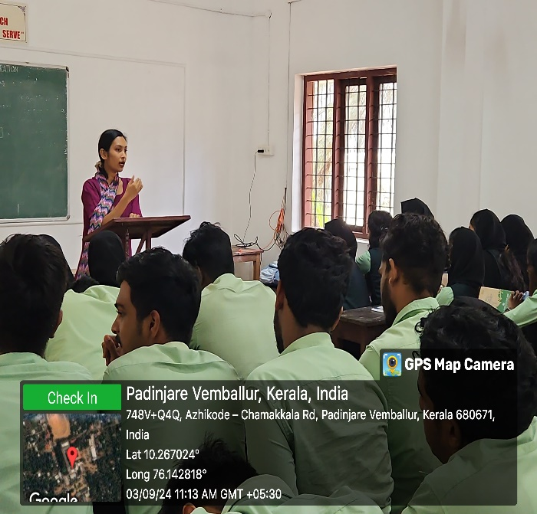
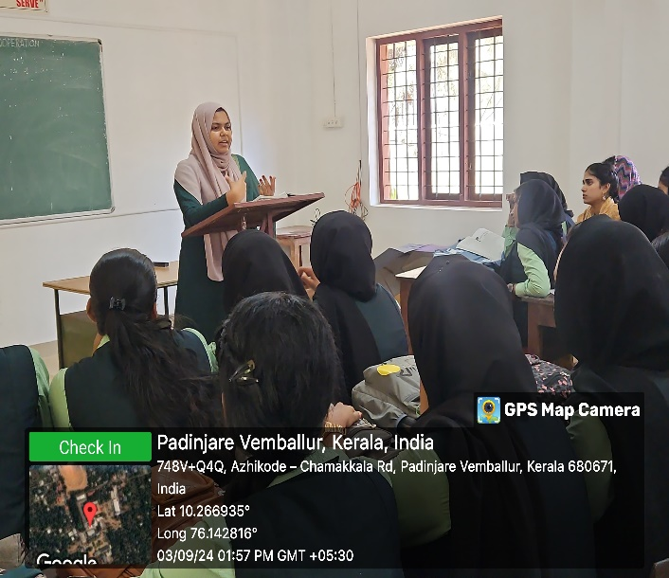 | 