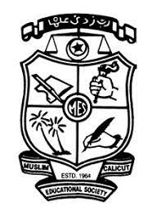
MES ASMABI COLLEG, P.VEMBALLUR
FINE ARTS CLUB
NAAC CULTURAL FEST
21/08/2024
The Fine Arts Club of MES Asmabi College hosted a remarkable cultural fest titled "Manithan" on the evening of 21st August 2024. The event was designed to portray the evolutionary journey of humankind, highlighting significant discoveries and inventions that have shaped human civilization. The program successfully captured the dual impact of human progress on Earth, exploring both the positive advancements and the accompanying challenges.
The central theme of "Manithan" revolved around the evolution of mankind, beginning from the primitive age to the modern technological era. The presentation illustrated key milestones such as the discovery of fire, the invention of the wheel, the agricultural revolution, the industrial age, and the digital revolution. Each segment of the program was meticulously designed to emphasize how these advancements have contributed to human development while also reflecting on their environmental and societal impacts.
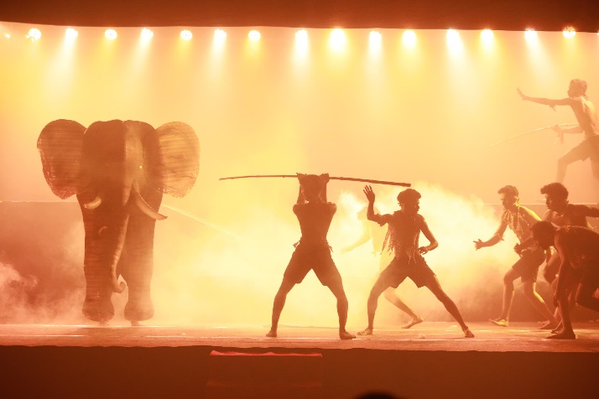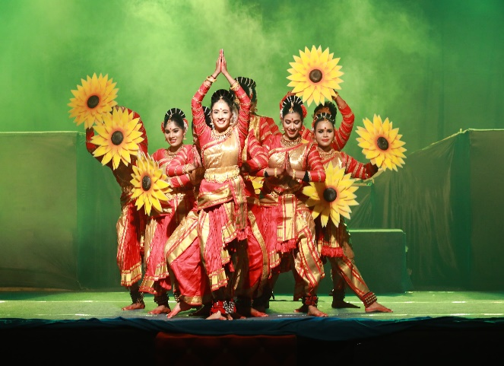
The NAAC peer team members, who were present to evaluate the institution, extended special appreciation for the conceptual depth and execution of "Manithan." They lauded the creative approach taken by the Fine Arts Club to convey a profound message about human progress and its implications. The peer team noted the students' commitment, creativity, and the relevance of the program's message in today's context.
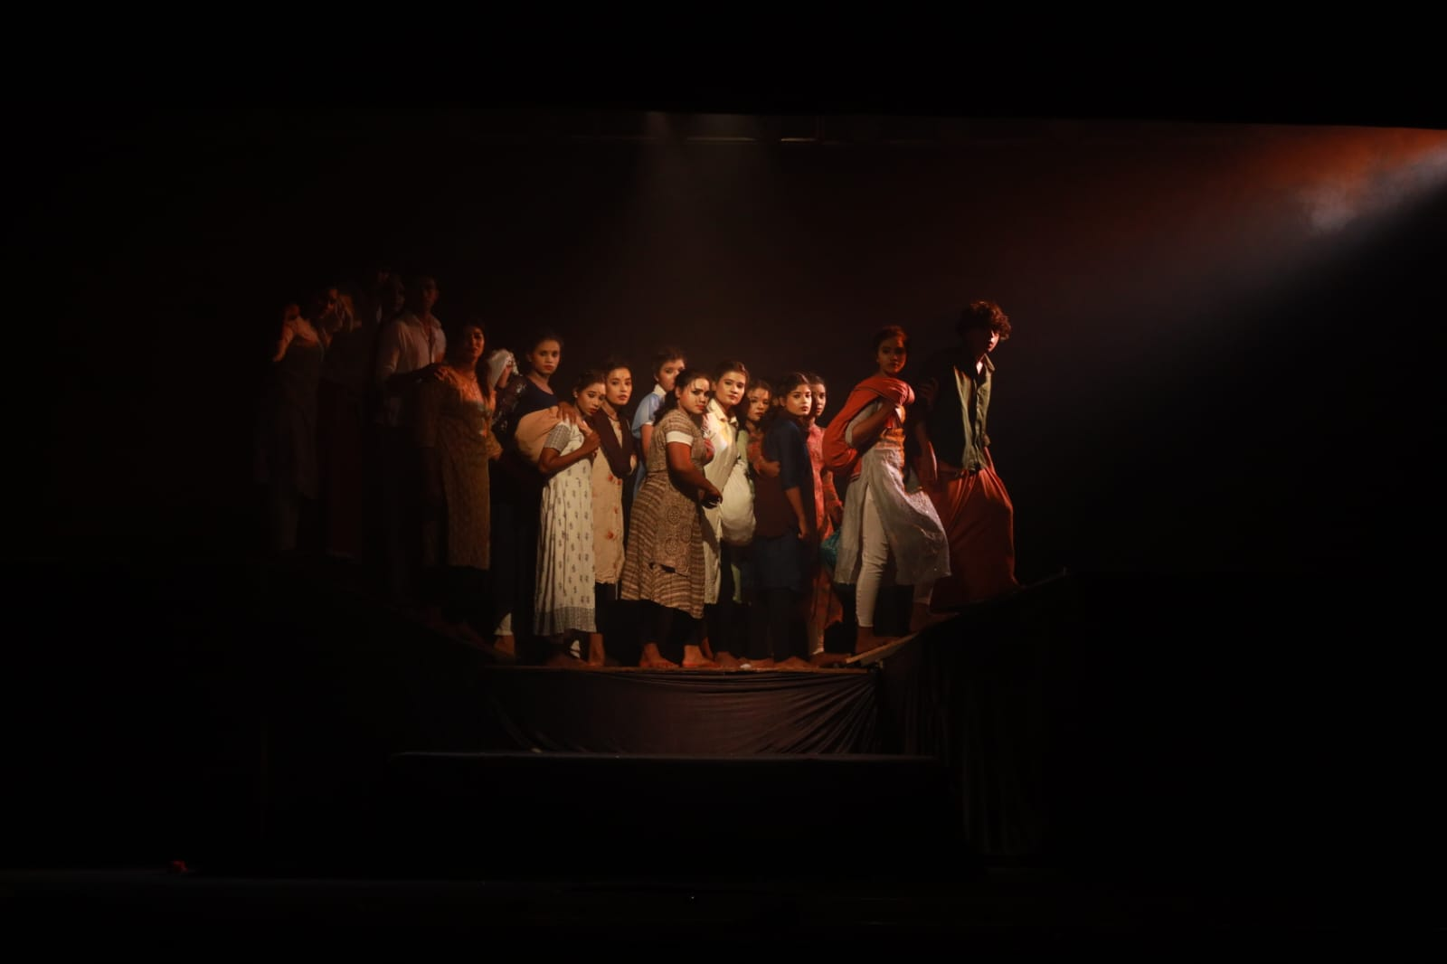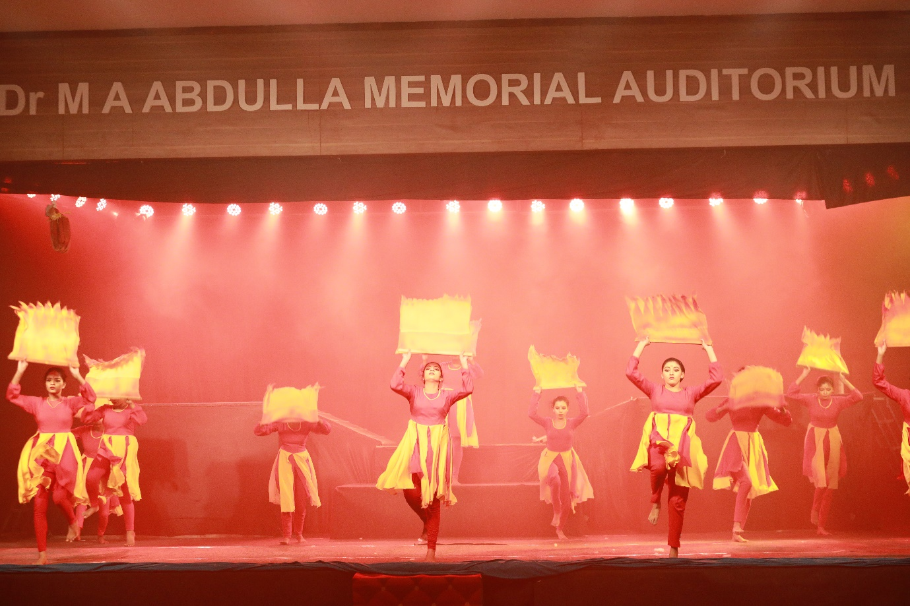
The "Manithan" cultural fest was not only a celebration of artistic talent but also a thought-provoking event that encouraged reflection on humanity's journey and its impact on Earth. The program successfully blended education with entertainment, leaving a lasting impression on the audience and garnering commendation from esteemed guests. This fest stands as a testament to the Fine Arts Club's dedication to promoting meaningful cultural expressions.

