MES ASMABI COLLEGE, P.VEMBALLUR
FINE ARTS CLUB
Muhammed Rafi commemoration
31/07/2024
The Fine Arts Club of MES Asmabi College organized a poignant commemoration event in
honor of the legendary playback singer Mohammed Rafi on July 31, 2024. The program,
inaugurated by Dr. Reena Muhammed, Principal of the college, was a heartfelt tribute to
one of India's most iconic voices. Dr. Dhanya K, the Fine Arts Coordinator of the college,
extended a warm welcome to the gathered audience, highlighting the enduring legacy and
influence of Mohammed Rafi in the realm of Indian music. Her opening remarks set the stage
for an evening dedicated to celebrating Rafi's contributions to the world of music.

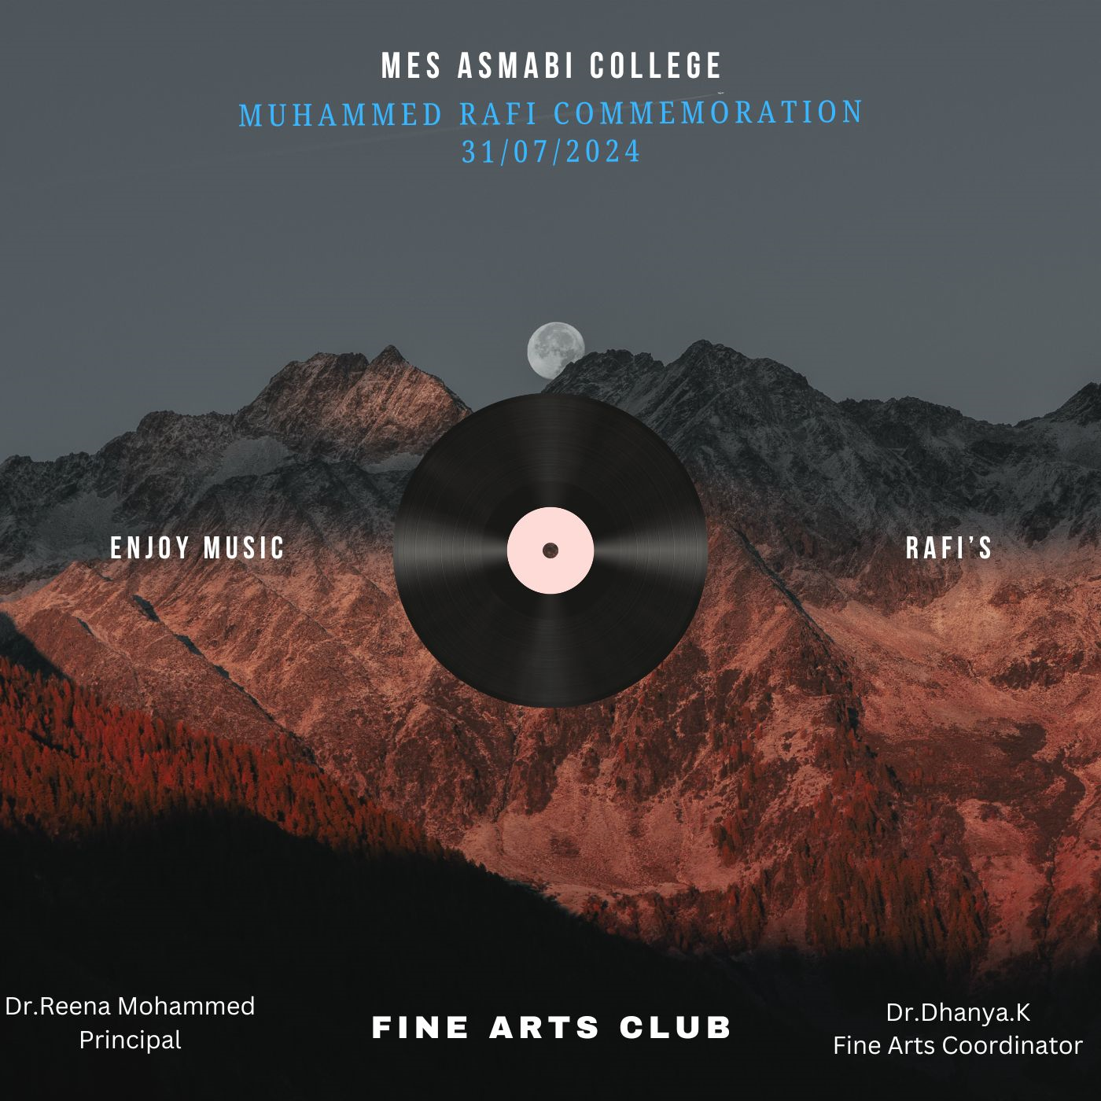

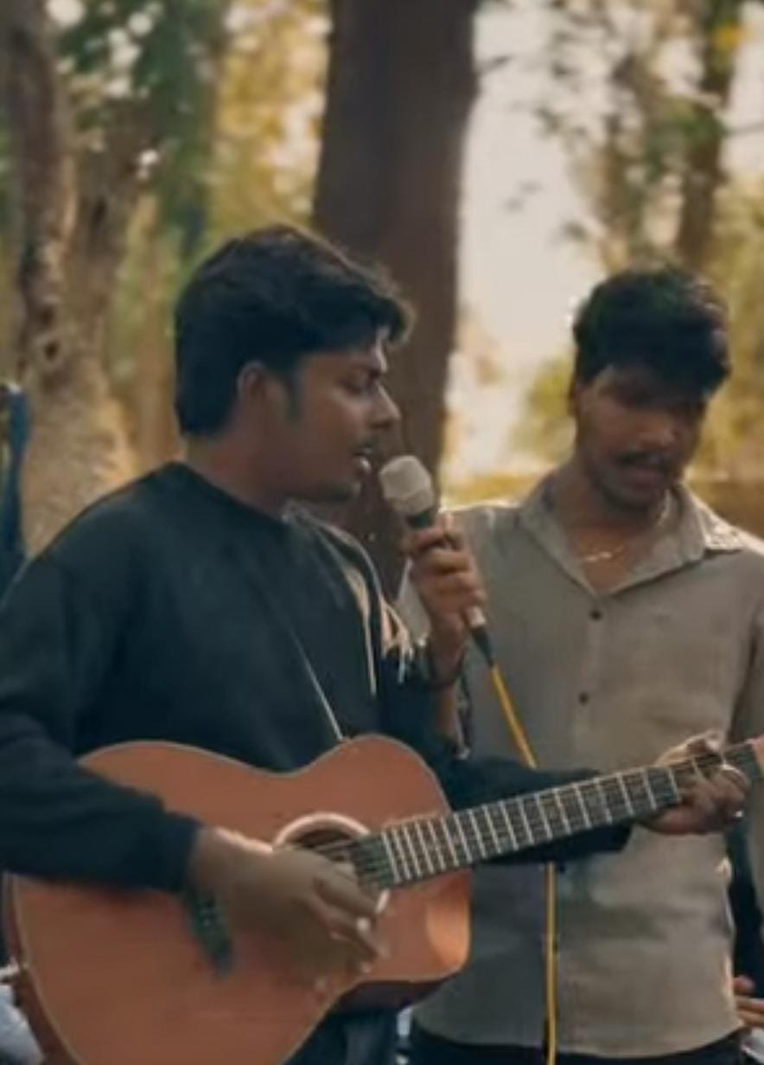
The event featured soul-stirring renditions of Rafi's classic songs performed by talented
students and faculty members. From melodious solos to captivating group performances, each
rendition captured the essence of Rafi's unmatched versatility and emotive power in singing.

