MES ASMABI COLLEGE, P.VEMBALLUR
FINE ARTS CLUB
DIGNITO-- STATE-LEVEL DANCE COMPETITION
The dance team of MES Asmabi College achieved a remarkable victory by securing the Third Prize at the Dignito State-Level Dance Competition, organized by D Paul Institute of Science and Technology on 01/11/ 2024. This prestigious competition witnessed participation from various colleges across the state, making the achievement even more significant.

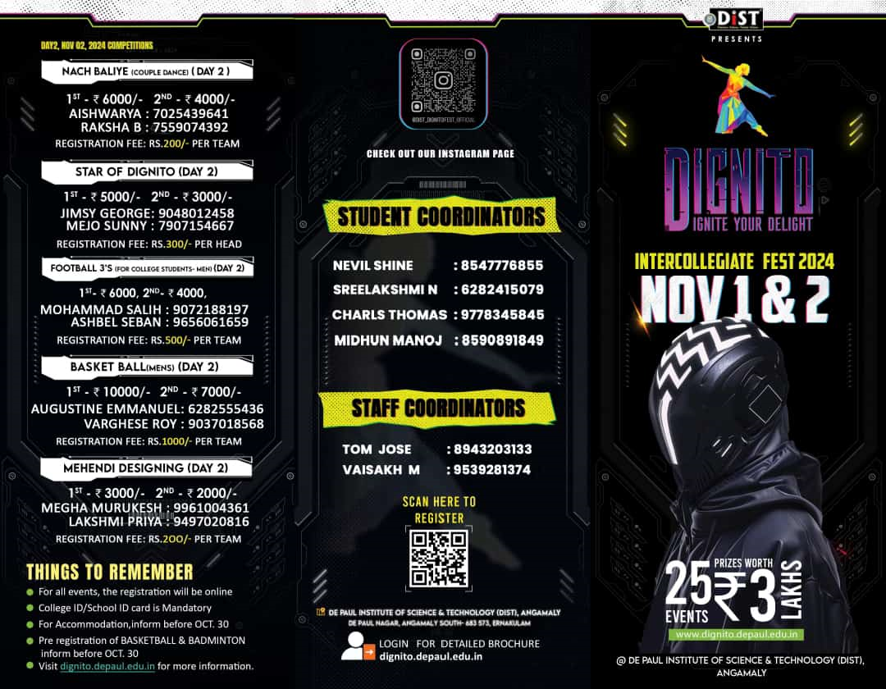

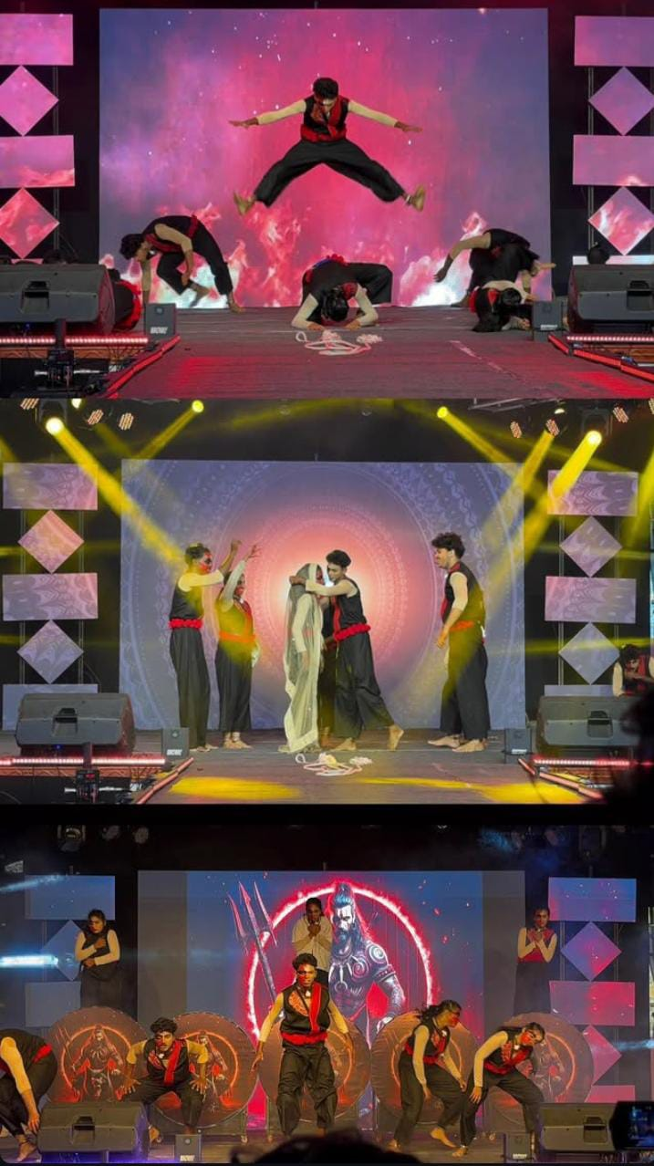

The exceptional performance by the MES Asmabi College dance team stood out among the competitors. Their dedication, synchronized movements, and captivating expressions left a lasting impression on both the judges and the audience.
This victory is a testament to the hard work and commitment of the dance team, as well as the unwavering support from the Fine Arts Club and college faculty. The achievement has brought immense pride to MES Asmabi College, further strengthening its reputation in the field of performing arts.
The college extends heartfelt congratulations to the dance team for their outstanding performance and looks forward to more such accomplishments in the future.

