REPORT OF STUDY TOUR-S4 MCOM-FINANCE

Organized by: Research Department of Commerce, MES Asmabi College,P Vemballur
Destination: Munnar and Vattavada
Co-ordinator & Tutor: Smt Thanzeela Ebrahim K
Date: 15th January 2024
Introduction
The Smester Four M Com Finance students of MES Asmabi College embarked on a memorable trip to the scenic destinations of Munnar and Vattavada. Guided by our esteemed tutor, Smt Thanzeela Ebrahim K, the trip combined exploration, learning, and team bonding. The serene landscapes of Munnar and Vattavada offered a refreshing escape and a chance to appreciate the natural beauty of Kerala.

Schedule
Day 1: Journey Begins
8:00 PM: Departure from MES Asmabi College.
9:00 PM: Movie screening.
12:00 AM: Official start of the trip journey.

Day 2: Exploring Munnar and Vattavada
1:00 AM: Short stop at Airport Road.
5:00 AM: Freshen up.
6:30 AM: Breakfast – Traditional Kerala dishes (Noolappam, Palappam, Egg Roast, Veg Curry).
8:30 AM: Visit to Vattavada Strawberry Farm – Students experienced strawberry cultivation and the serene charm of this picturesque farmland.
11:00 AM: Arrival at a Munnar Hill Station – Known for its misty valleys and tea plantations.
1:00 PM: Visit to Kundala Dam – A serene spot perfect for relaxation and group discussions.
2:00 PM: Lunch at Echo Point – Enjoyed delicious chicken biryani amid scenic surroundings.
3:00 PM: Sight seeing at Echo Point – Famous for its natural echo phenomenon and breathtaking views.
4:00 PM: Local shopping – Students explored and purchased local handicrafts and souvenirs.
4:30 PM: Visit to Mattupetti Dam – Another iconic spot with calm waters and surrounding greenery.
5:30 PM: Stroll through the Rose Garden – Admired colorful blooms and engaged in photography.
8:00 PM: Campfire activity – Bonding moments with music and games.
9:00 PM: Dinner – A lavish spread including Al Fahm, Ghee Rice, Chapathi, Porotta, and Kubboos.
10:00 PM: Return journey to MES Asmabi College.

Features of the Destination
Munnar
Known as the “Kashmir of South India,” Munnar is a hill station famous for its tea plantations, rolling hills, and pleasant climate.
Key Attractions:
Kundala Dam: A picturesque spot for boating and photography, surrounded by lush greenery.
Mattupetti Dam: Offers a serene atmosphere and panoramic views, perfect for relaxation.
Rose Garden: A beautifully maintained garden showcasing a variety of vibrant flowers.
Vattavada
Located near Munnar, Vattavada is a less-crowded destination known for its organic farming and pleasant weather.
Key Attractions:
Strawberry Farms: Visitors can experience strawberry cultivation and even pick fresh strawberries.
Hill Station Views: Spectacular views of terraced fields and lush landscapes.
Eco Point: A serene spot to connect with nature, surrounded by misty hills.
Activities & Experiences
Campfire: An engaging session where students bonded over music and conversations under the stars.
Shopping: Local handicrafts and souvenirs from Echo Point and nearby areas.
Photography: Capturing the breathtaking beauty of Munnar and Vattavada.
Highlights of the Trip
1. A perfect blend of education and leisure.
2. Group activities like campfire and sightseeing fostered teamwork.
3. Insight into local agriculture and culture at Vattavada.
4. Memorable scenic spots ideal for relaxation and photography.
Conclusion
The trip to Munnar and Vattavada was an enriching experience that provided students with a much-needed break and an opportunity to explore the beauty of nature. The support and guidance of Smt Thanzeela Ebrahim K made the journey even more meaningful. This memorable outing strengthened bonds among students while fostering appreciation for Kerala’s natural heritage.
Links: https://www.instagram.com/reel/DFqUAQozZi9/?igsh=MTFybmNxenNpcmQxMw==
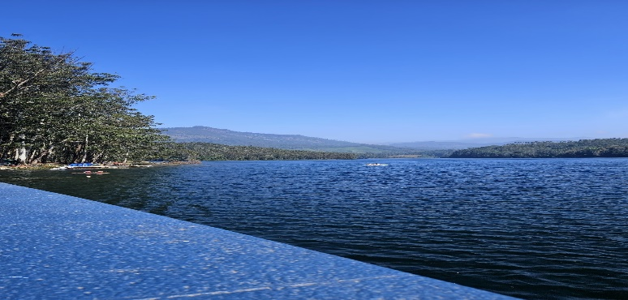
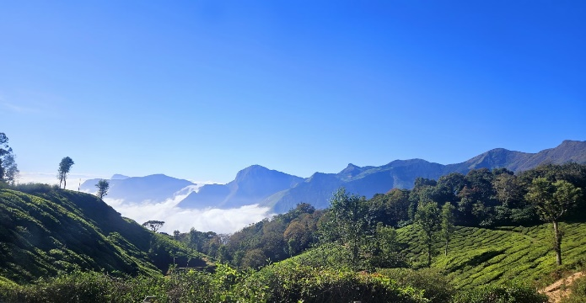
Photo Galery
