WORKSHOP REPORT: MASTERING EXCEL : DATA ANALYSIS AND VISUALIZATION

Date: 10th March 2025
Time: 10:00 am
Number of Participants: 23

Welcome Address:
The workshop commenced with a warm welcome address by Thanzeela Ebrahim K, Assistant Professor of Commerce & Co-ordinator , who set the tone for the engaging sessions to follow.
Presidential Address:
Dr. Reena Mohammed P M, Principal, delivered the presidential address, highlighting the significance of data analysis and validation in various fields. She encouraged participants to make the most of the workshop and enhance their Excel skills.
Feliciatation:
The workshop was felicitated by Chithra P, Assistant Professor & Head,Research Department of Commerce, and Dr. Amitha Bachan K H, IQAC Co-ordinator. They appreciated the initiative and emphasized the relevance of Excel skills in academic and professional pursuits.
Resource Person:
Smt. Thanzeela Ebrahim K, Assistant Professor of Commerce, was the resource person for the workshop. She shared her expertise on mastering Excel, focusing on data analysis and validation.
Workshop Overview:
The workshop provided hands-on training on Excel, covering topics such as:
- Data analysis techniques
- Excel formulas and functions
- Data visualization best practices
Vote of Thanks:
The vote of thanks was delivered by Ms Fathima Parveen,Student of II MCom Finance.
Certificate Distribution:
All participants were issued certificates by Smt. Thanzeela Ebrahim K, acknowledging their successful completion of the workshop.

Conclusion:
The workshop on Mastering Excel - Data Analysis and Visualisation was a resounding success, providing participants with valuable insights and practical skills. The organizers extend their gratitude to the participants, dignitaries, and faculty members for their support and enthusiasm.
Recommendations:
Based on the feedback and outcomes, the organizers recommend conducting similar workshops in the future, focusing on advanced Excel topics and other data analysis tools.
Event Brochure:
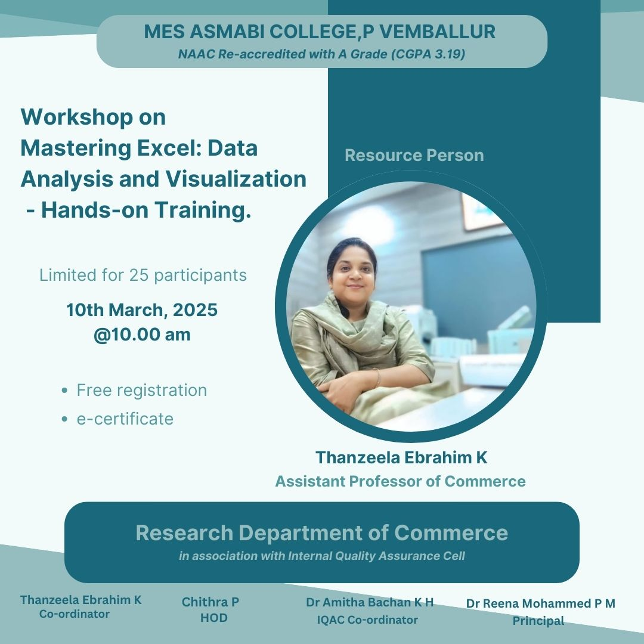
Photographs of the event:
