Anti-Drug Awareness Programme for Parents and Students
Date: March 12, 2025
Time: 10:30 AM
Venue: Seminar Hall, MES Asmabi College, P. Vemballur
Organised by: College Protection Group & NSS Units 53 & 95, MES Asmabi College
An impactful awareness session titled “Anti-Drug Awareness for Parents and Students” was conducted on March 12, 2025, at 10:30 AM in the Seminar Hall of MES Asmabi College, P. Vemballur. The programme was jointly organized by the College Protection Group and NSS Units 53 & 95 to sensitize students and parents about the grave issue of drug abuse and society's collective role in preventing it.
The session featured two esteemed resource persons:
- Mr. Shaji M K, Circle Inspector of Police, Mathilakam Station, who addressed the legal implications and enforcement strategies associated with drug abuse and trafficking. He highlighted real-life incidents and offered practical guidance to identify early warning signs and report drug-related activities.
- Dr. Monsy Edward, Clinical Psychologist, Jubilee Mission Hospital, who provided insights into the psychological impact of drug abuse, addiction cycles, and the importance of emotional and mental well-being. His session focused on preventive mental health strategies and the role of families and institutions in rehabilitation and support.
The programme witnessed active participation from both students and parents, sparking an interactive environment where attendees openly discussed concerns, posed questions, and received practical suggestions from the resource persons. The event served as a timely intervention to strengthen the college’s commitment to building a drug-free campus and community.
The session concluded with a vote of thanks and a collective pledge to uphold awareness and vigilance against the menace of drug abuse.

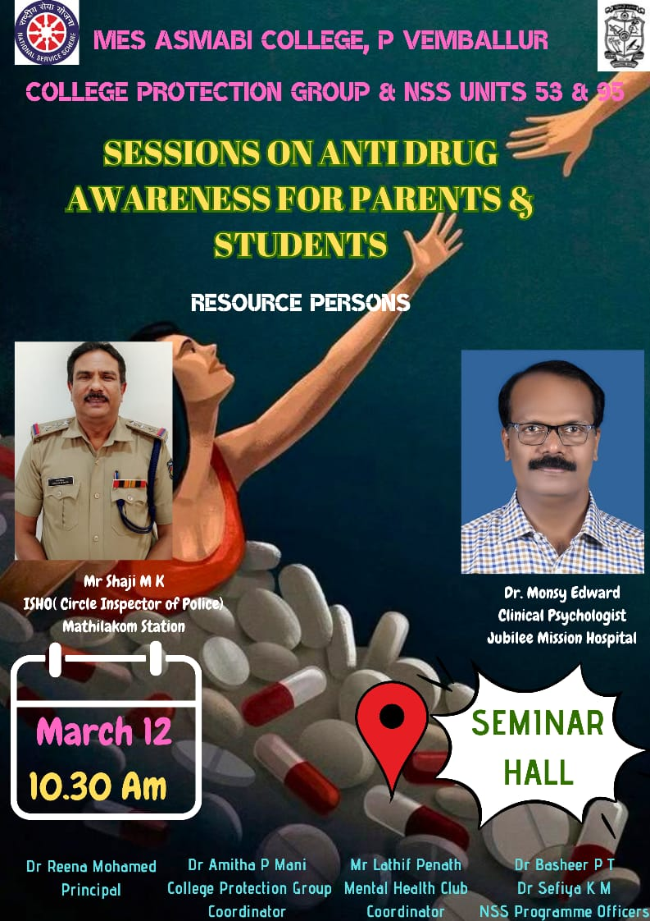
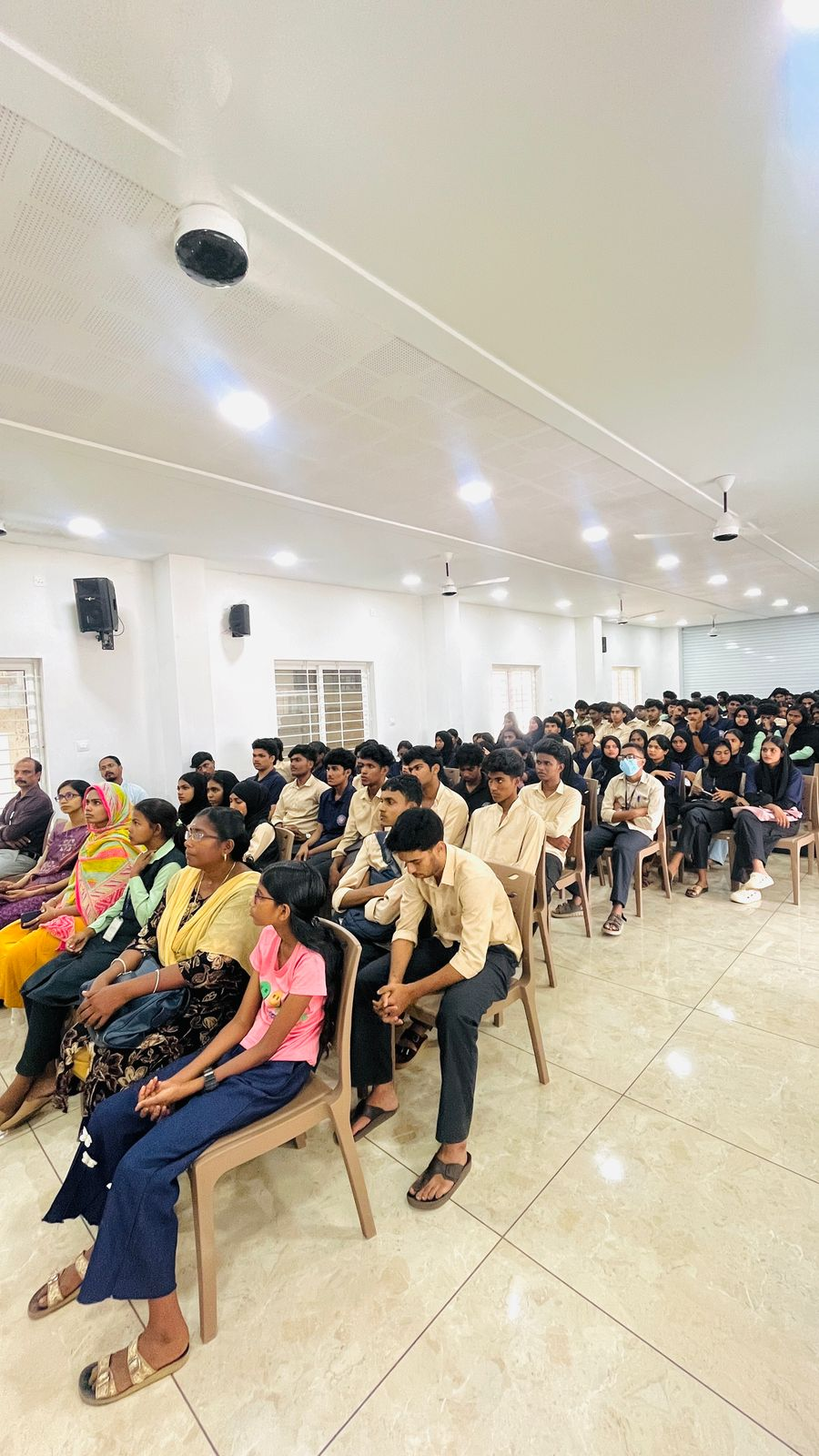 | 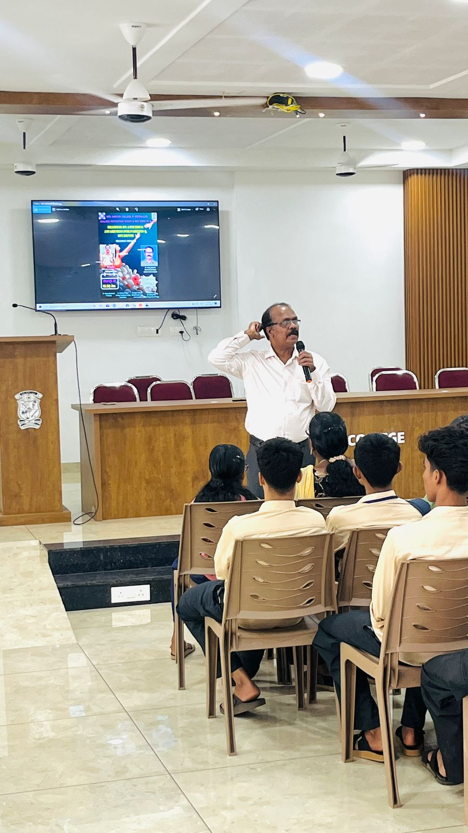
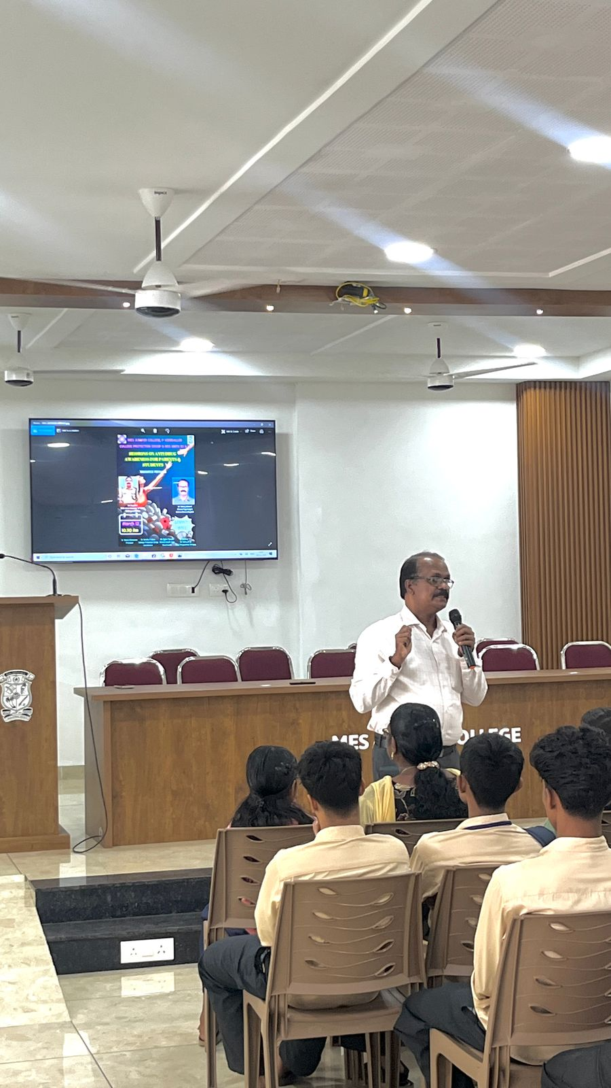 | 