Report on the NSS Induction Programme
Date: 21st February 2025
Time: 9:30 AM to 12:30 PM
Venue: New Seminar Hall
Organized by: NSS Units 53 & 95, MES Asmabi College, P. Vemballur
To welcome and orient new volunteers into the spirit of service, NSS Units 53 & 95 of MES Asmabi College, P. Vemballur, organized an NSS Induction Programme on 21st February 2025 at the New Seminar Hall. The session aimed to familiarize the volunteers with the objectives, activities, and responsibilities of being an NSS member.
The induction program was graced by Sameera M. P., Assistant Professor, Government College, Nilambur, who served as the resource person. As an award-winning Program Officer, having received the Best Program Officer Award (University of Calicut) for 2016-17 and 2018-19 and the State Award (2018-19), her insights and experiences were invaluable in inspiring the students.
During the session, she elaborated on the core values of NSS, the significance of community service, and the impact of volunteerism on personal and societal development. The interactive session helped new volunteers understand their role in contributing to social change and developing leadership and teamwork skills. The event concluded with an interactive Q&A session, where volunteers actively participated and clarified their doubts about NSS activities and initiatives.
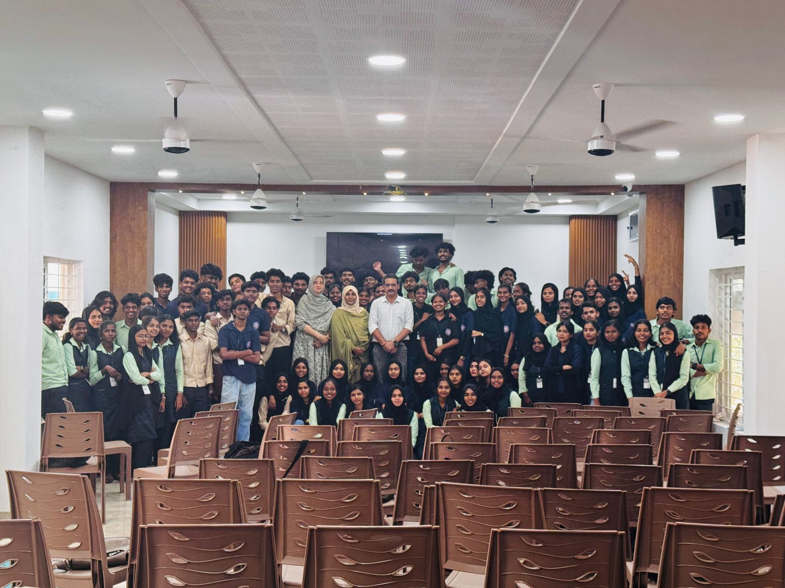
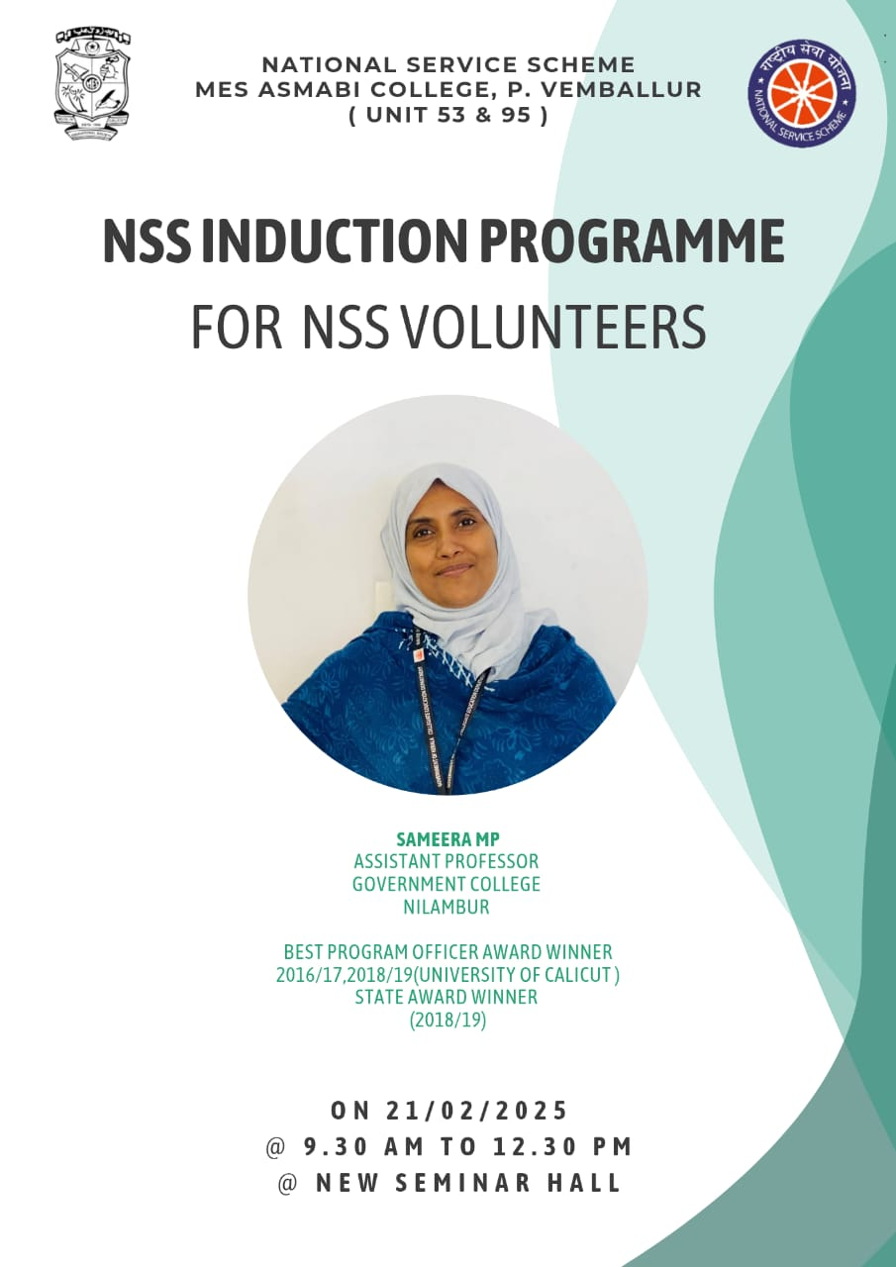

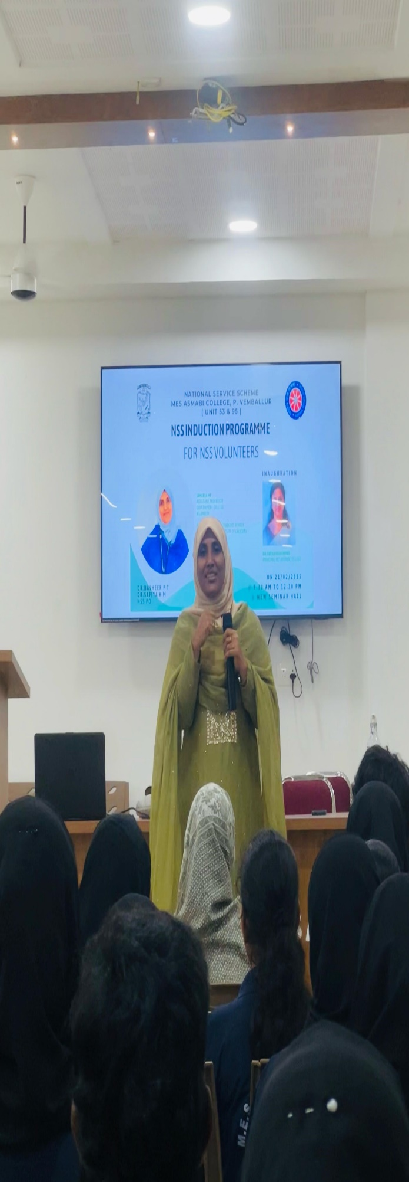 | 