Report on the Pain and Palliative Three-Day Volunteer Training
Title: Pain and Palliative: Three-Day Volunteer Training
Date of Participation: 17th February 2025
Organized by: Sreenarayanapuram Panchayath in association with Family Health Centre, P. Vemballur
Participants: 25 NSS Volunteers from Units 53 & 95, MES Asmabi College, P. Vemballur
The Pain and Palliative: Three-Day Volunteer Training program was organized by Sreenarayanapuram Panchayath in collaboration with Family Health Centre, P. Vemballur to provide essential training on palliative care and volunteer services. The initiative aimed to equip volunteers with the knowledge and skills required to support individuals in need of palliative care, emphasizing the importance of empathy, caregiving techniques, and community service.
A total of 25 NSS volunteers from Units 53 & 95 of MES Asmabi College, P. Vemballur actively participated in the training session on 17th February 2025. During the session, experts in the field of palliative care provided insights into the principles of pain management, psychological support, and the role of volunteers in assisting patients and their families. The training also included practical demonstrations on handling patients with dignity and respect.
The session fostered a sense of responsibility among the volunteers and strengthened their commitment to community service. Participants expressed their gratitude for the opportunity to be part of such a meaningful initiative. They acknowledged the significance of palliative care in improving the quality of life for those in need.
The event concluded with an interactive session where volunteers shared their reflections and pledged to actively contribute to palliative care services in their communities. The initiative was a step forward in enhancing social responsibility and fostering a culture of compassionate care among the youth.
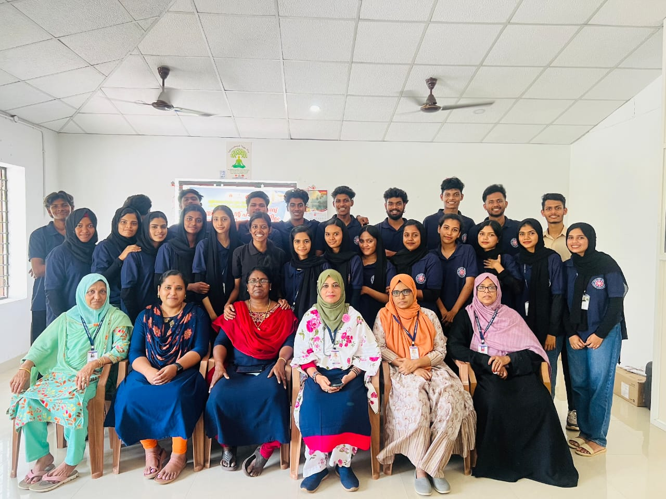
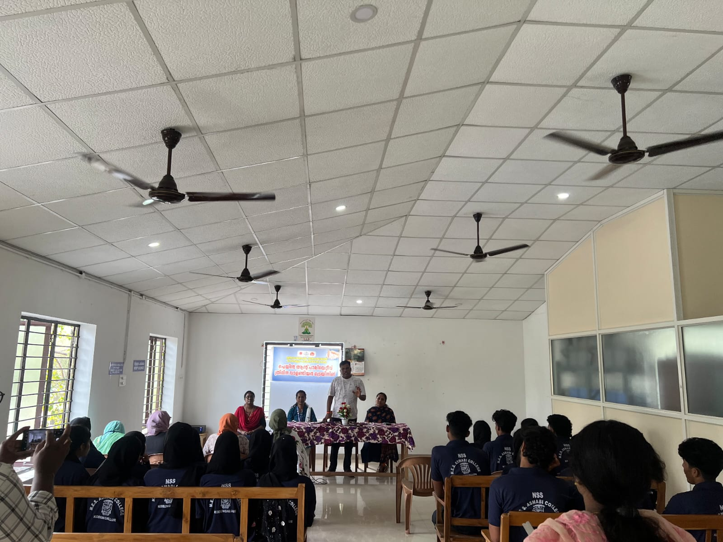
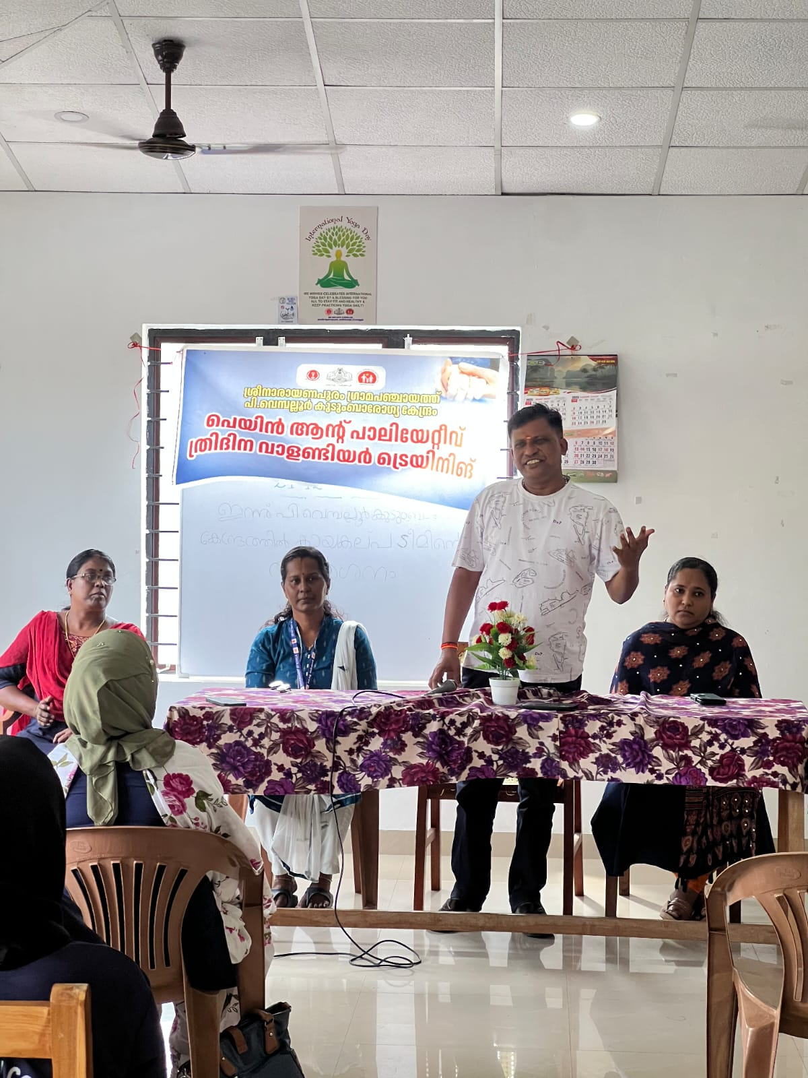 | 