Report on the Awareness Programme on Eradicating Dowry
Title: Eradicating Dowry: The Role of Education and Student Movements
Date & Time: 12th (Wednesday), 2:00 PM
Organized by: NSS Unit 53 & 95, MES Asmabi College, P. Vemballur, in collaboration with the Internal Compliance Committee
In Association With: District Legal Service Authority, Thrissur & Taluk Legal Service Committee, Kodungallur
Guest Speaker: Adv. Simi P.P., Panel Lawyer, TLSC Kodungallur
In collaboration with the Internal Compliance Committee, the National Service Scheme (NSS) units of MES Asmabi College, P. Vemballur, organized an awareness programme on the topic "Eradicating Dowry: The Role of Education and Student Movements." The event, conducted in association with the District Legal Service Authority, Thrissur, and the Taluk Legal Service Committee, Kodungallur, aimed at sensitising students about the pressing issue of dowry and the critical role of education and student activism in eradicating this social evil.
The keynote address was delivered by Adv. Simi P.P., Panel Lawyer, TLSC Kodungallur, elaborated on the legal framework surrounding dowry prohibition, the rights of women, and the importance of legal awareness in tackling dowry-related issues. She emphasized the role of youth in challenging societal norms and fostering a culture of gender equality and empowerment.
The session was interactive, with students actively engaging in discussions and sharing their perspectives on the role of education in preventing dowry practices. The event also highlighted the importance of student-led initiatives in promoting social change and ensuring that educational institutions remain strongholds against gender-based discrimination.
The programme concluded with a call to action, urging students to take a stand against dowry practices and become advocates for change within their communities. The NSS Program Officer extended gratitude to the guest speaker and all participants for their enthusiastic involvement in making the event a success.
This initiative reinforced the commitment of MES Asmabi College to promoting gender justice and empowering students with the knowledge and awareness necessary to build a more equitable society.
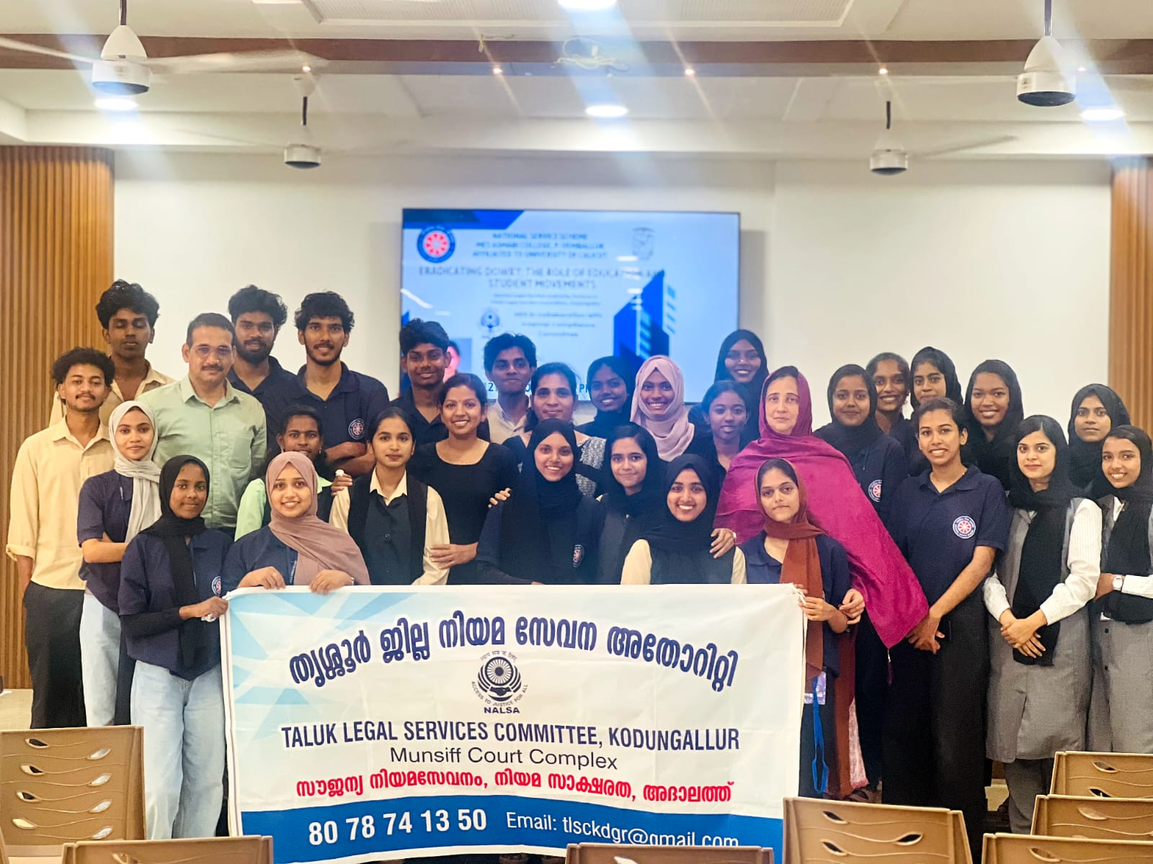
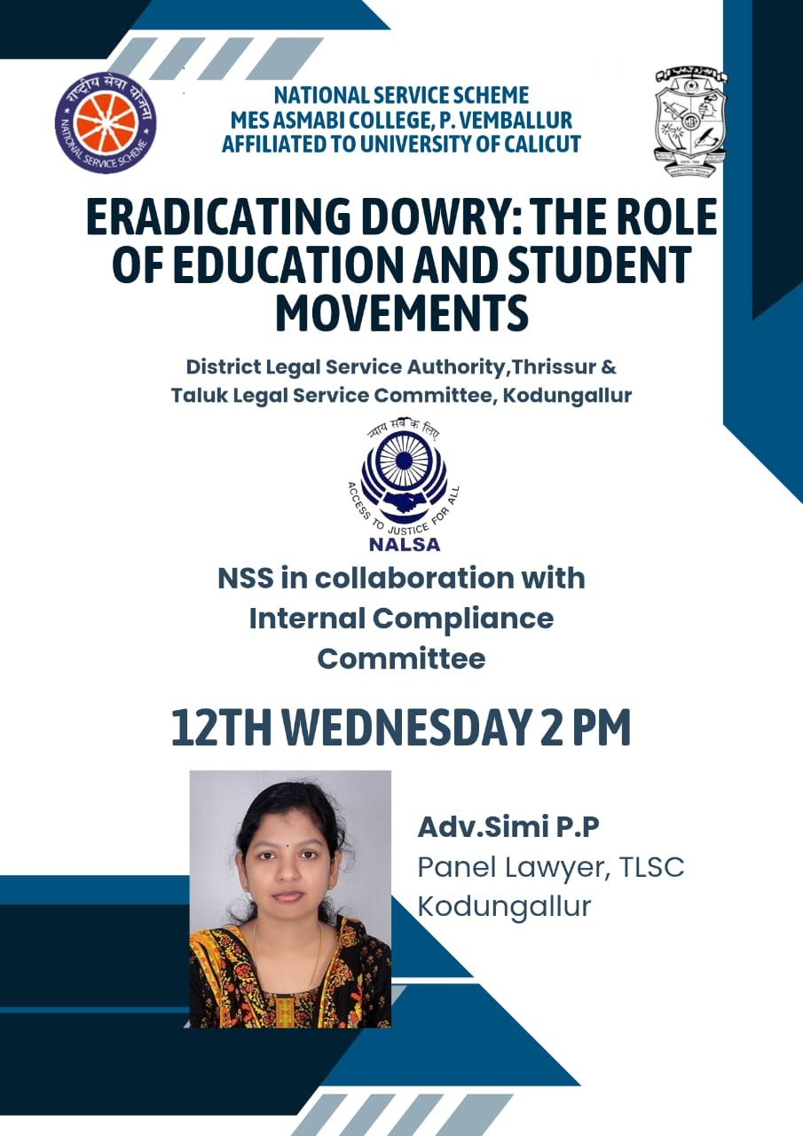

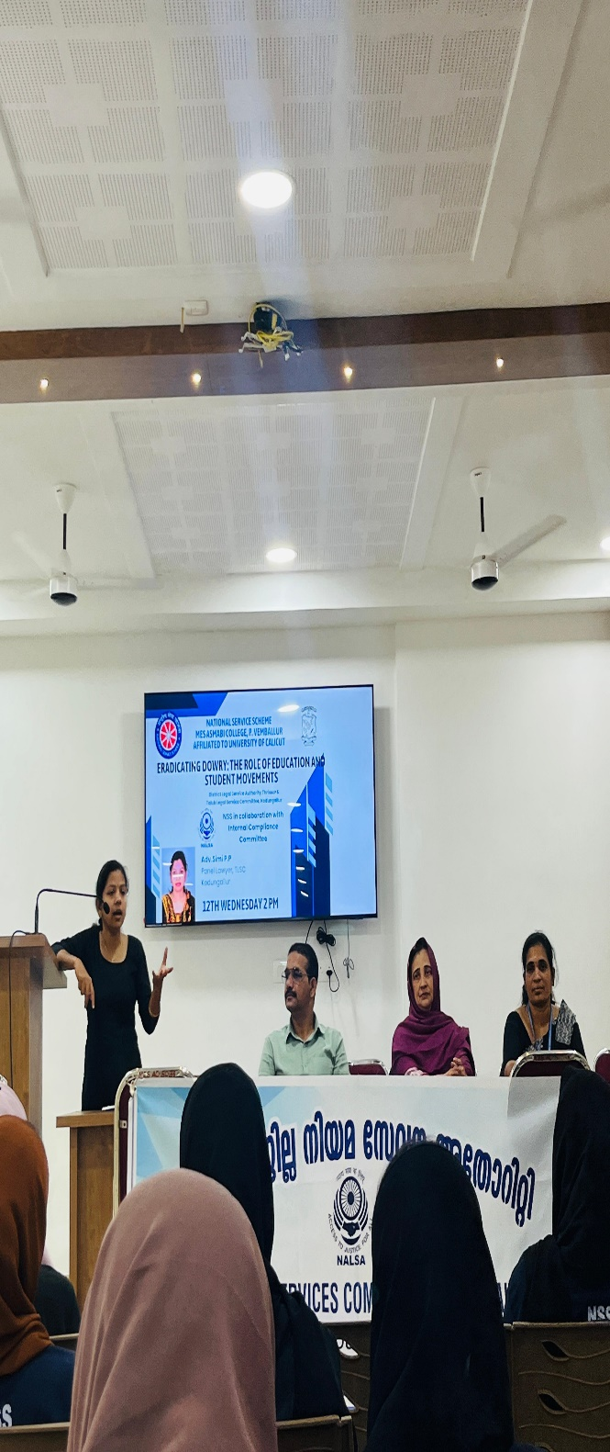 | 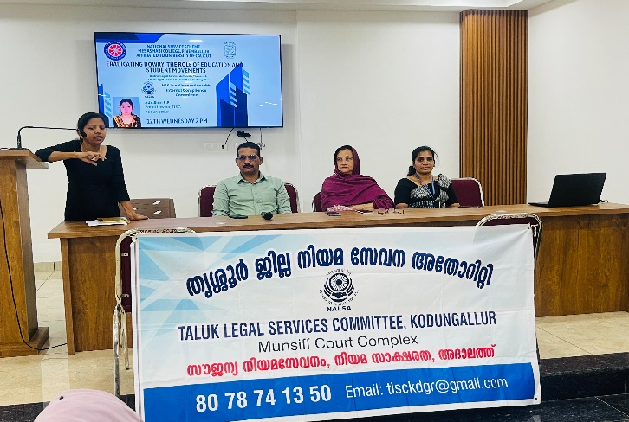
 | 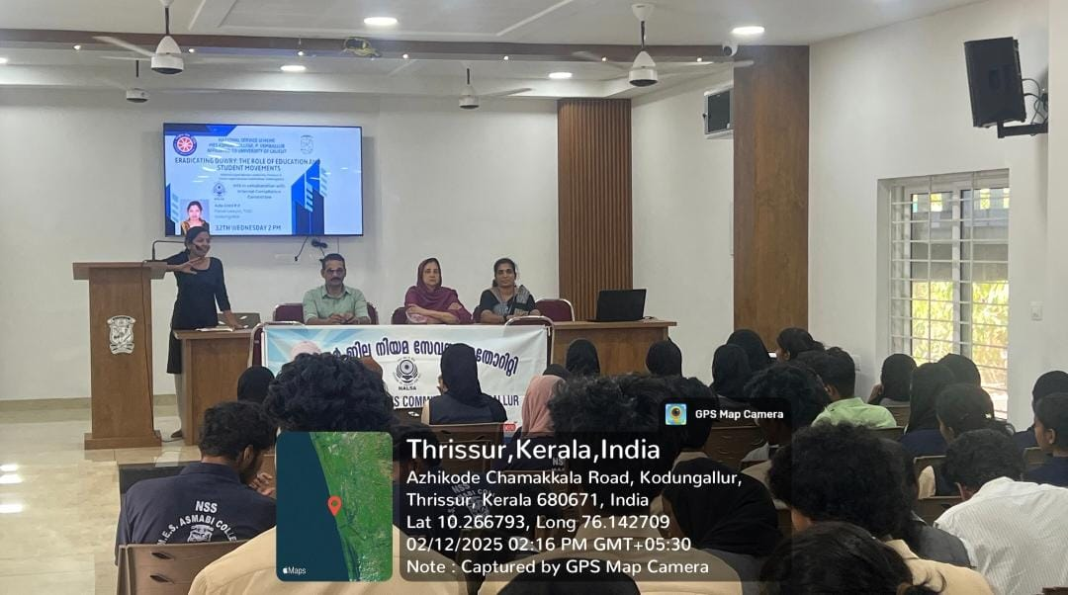
 | 