Report on the Observance of Palliative Care Day
Title: Satisfied Care is Everyone's Right (സംപ്തൃത പരിചരണം എല്ലാവരുടെയും അവകാശം)
Date: 15th January 2025
Organized by: NSS Units 53 & 95, MES Asmabi College, in collaboration with Primary Health Centre, P. Vemballur
On 15th January 2025, NSS Units 53 & 95 of MES Asmabi College, in association with the Primary Health Centre, P. Vemballur, successfully organized a program titled "Satisfied Care is Everyone's Right" to mark Palliative Care Day. The event aimed to raise awareness about the importance of palliative care and highlight the universal right to compassionate care for all individuals.
The program commenced with a rally, where NSS volunteers and other participants marched through the local community, carrying banners and placards bearing messages about the significance of palliative care. The rally effectively conveyed the message of dignity, comfort, and support for individuals requiring palliative care.
Following the rally, a pledge-taking ceremony was conducted, where all participants reaffirmed their commitment to promoting and ensuring access to palliative care for everyone. The pledge emphasized the collective responsibility of society to care for individuals with chronic or terminal illnesses, providing them with comfort and emotional support.
The event highlighted the need for greater awareness and community participation in extending palliative care services. The collaborative effort between MES Asmabi College and the Primary Health Centre, P. Vemballur, showcased the power of teamwork in advancing meaningful causes.
The program concluded with a message from the NSS Program Officer, who commended the volunteers for their active participation and urged them to continue being ambassadors of compassion and care in their communities.
This observance achieved its goal of raising awareness and inspired participants to work towards a society where satisfied care becomes a fundamental right for all.
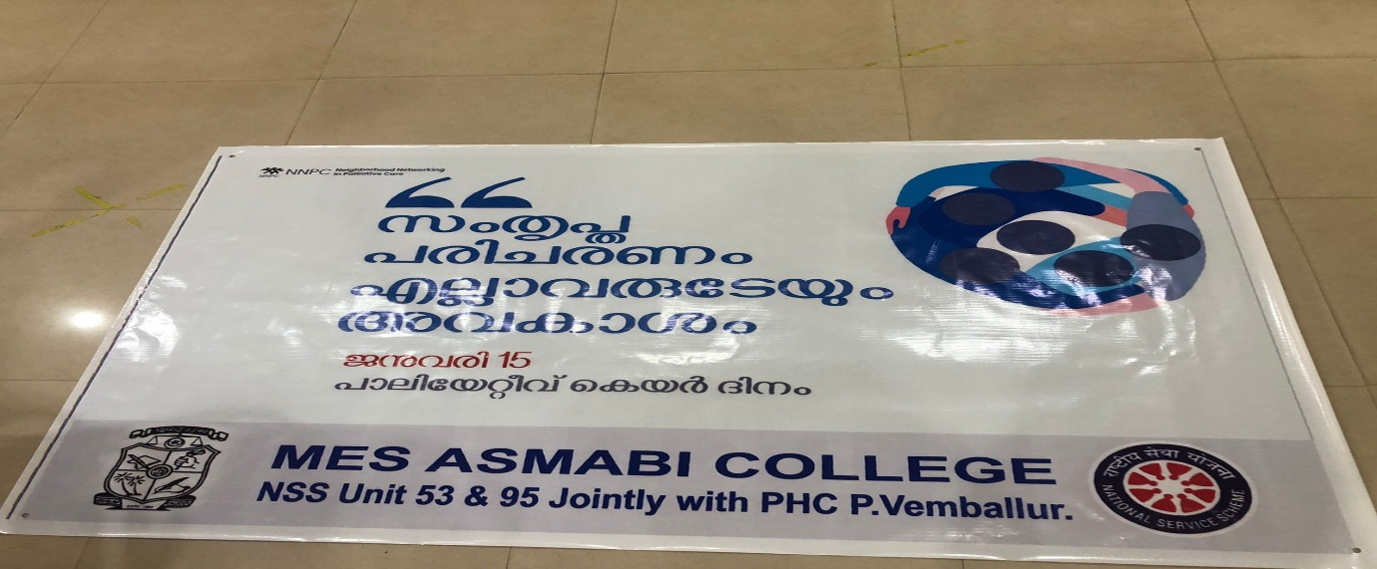
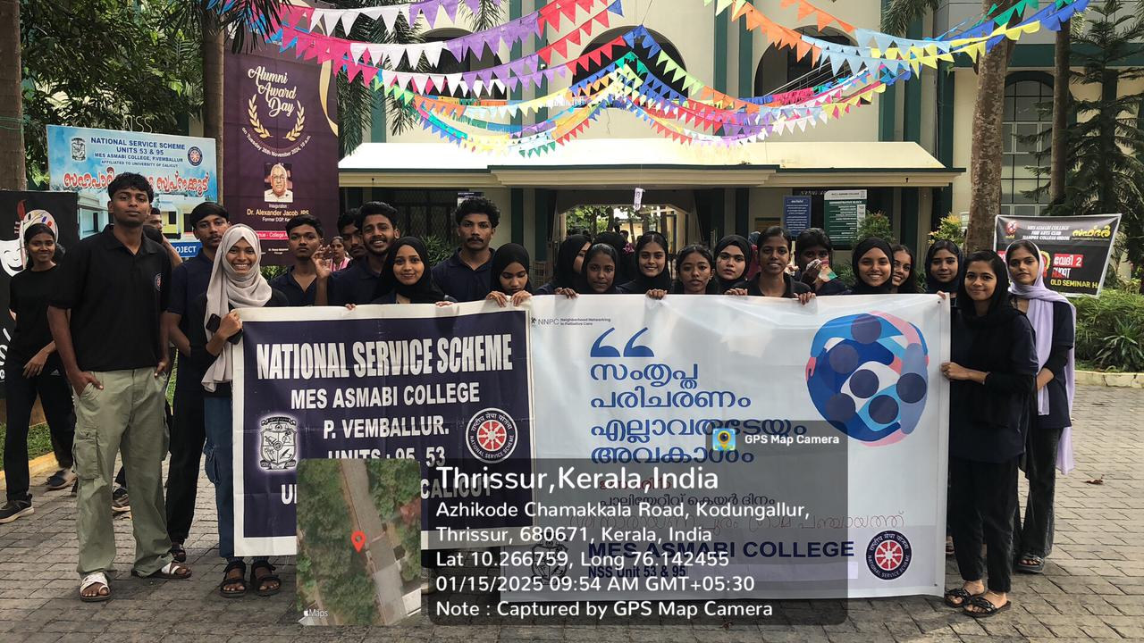
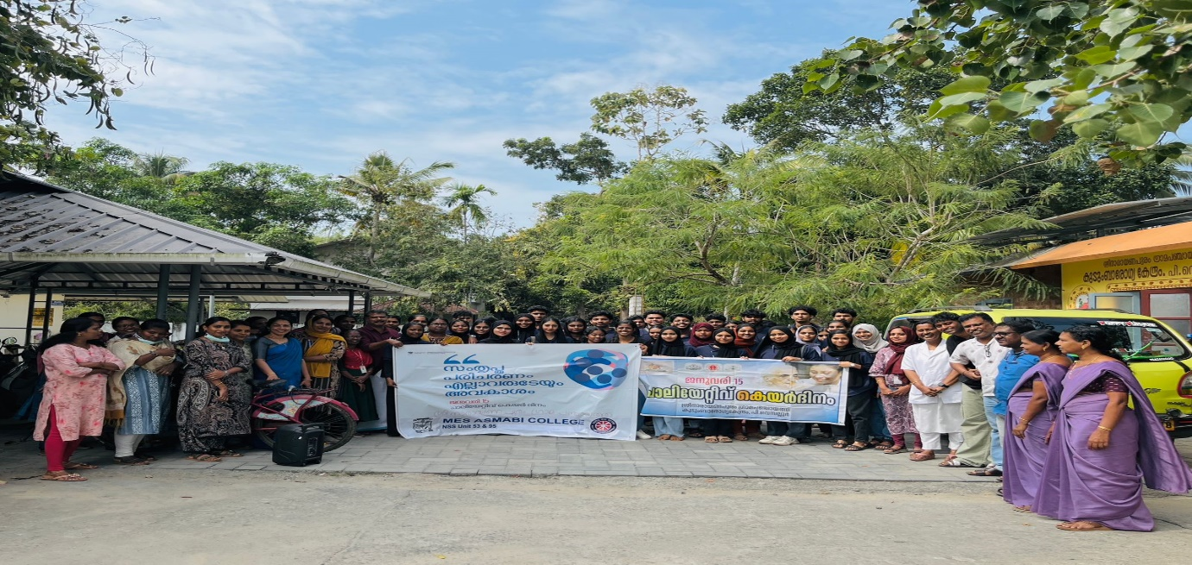
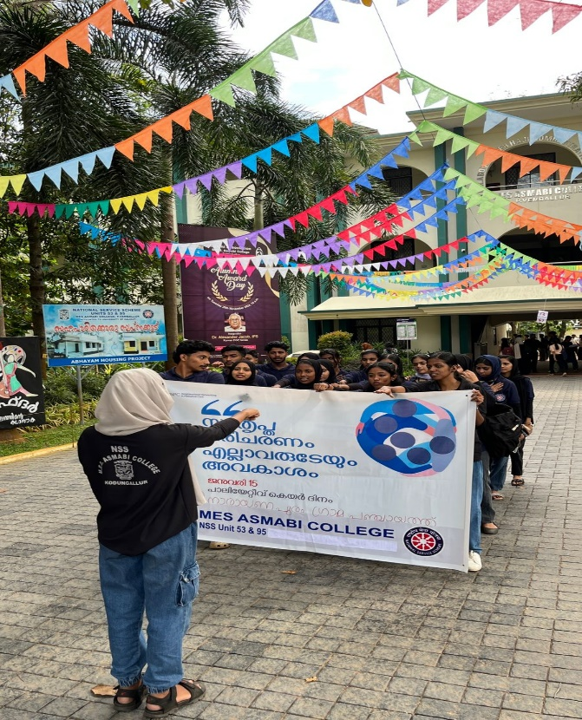 | 