Report of Christmas Fest organised by Commerce IEDC on December 13, 2024
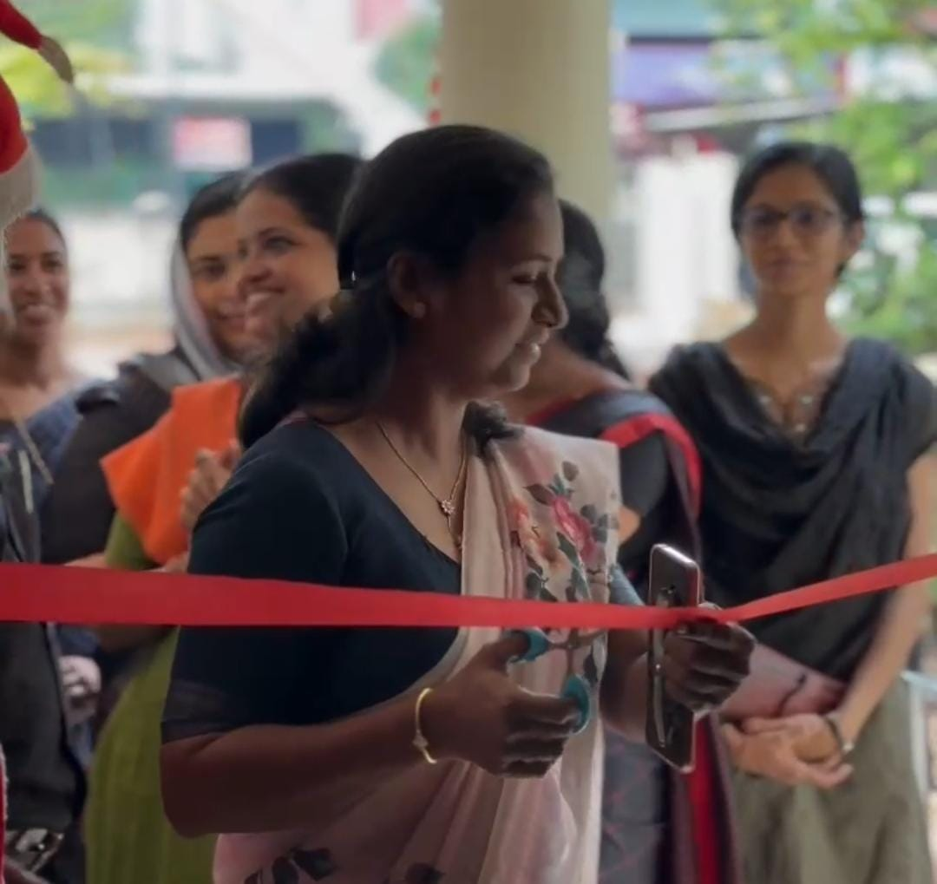
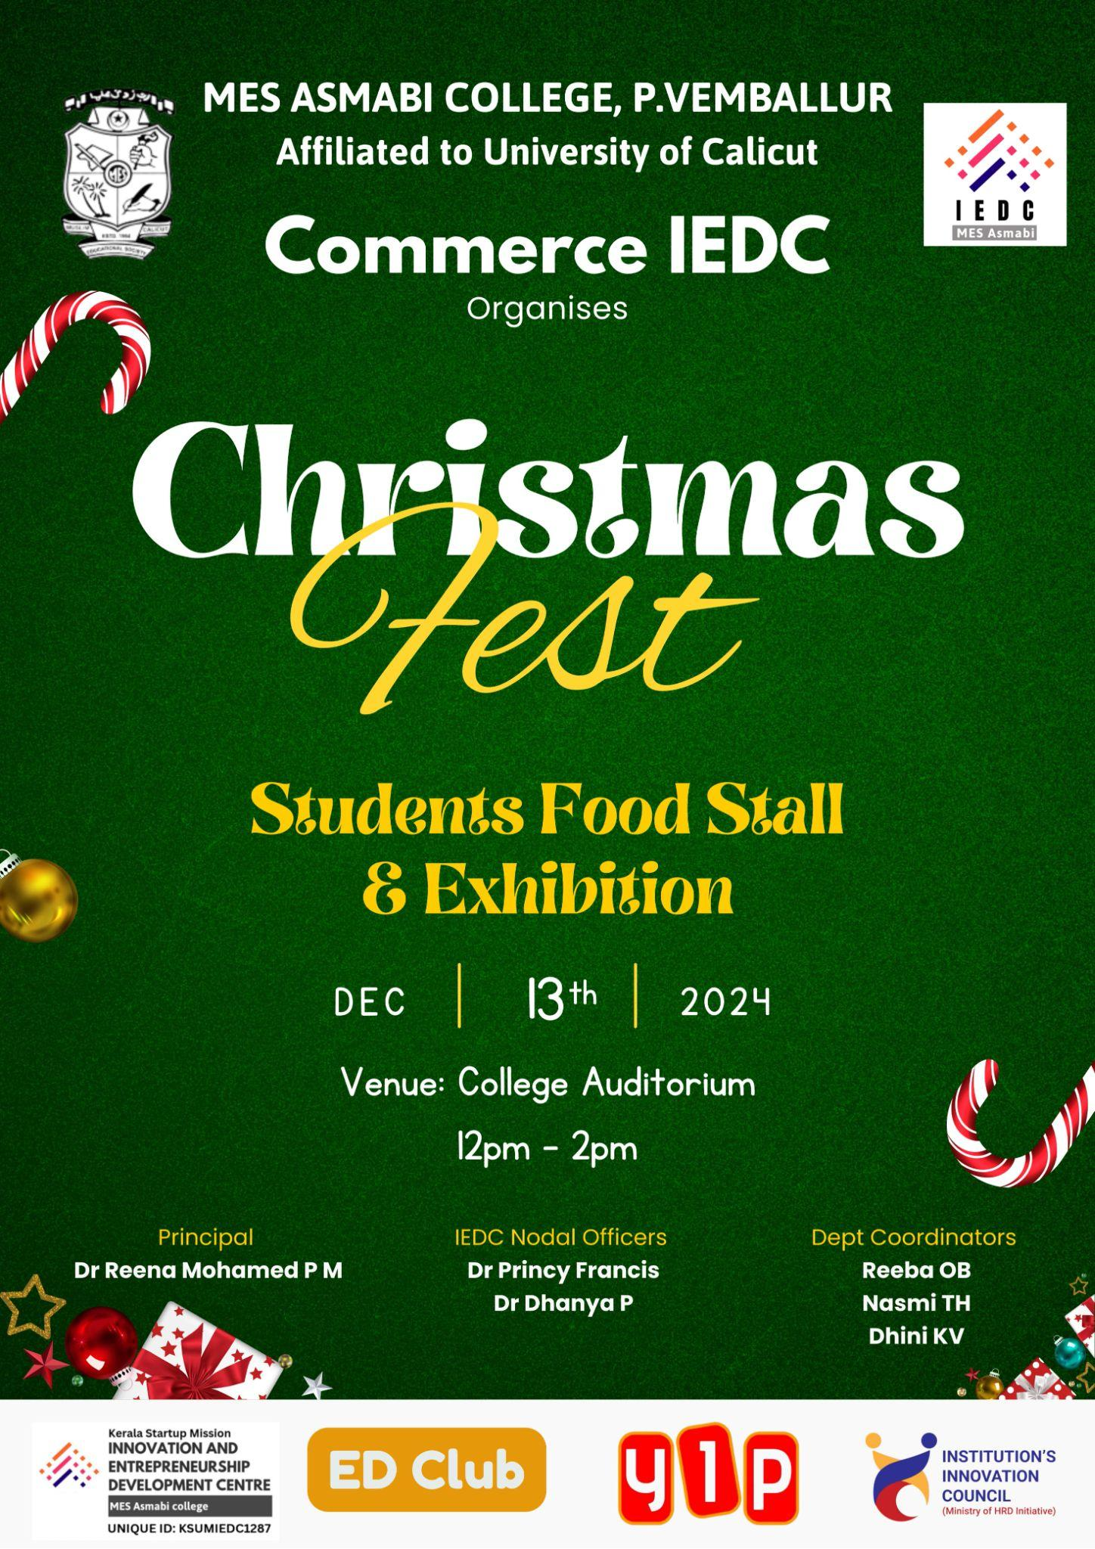
The Commerce IEDC of MES Asmabi College, P. Vemballur, successfully organized the vibrant "Christmas Fest" on December 13, 2024, at the college auditorium. This event, held under the leadership of Principal Dr. Reena Mohamed P M and IEDC Nodal Officers Dr. Princy Francis and Dr. Dhanya P, featured a Student Food Stall and Exhibition, which brought together creativity, innovation, and festive spirit. The event provided a platform for students to showcase their culinary talents and entrepreneurial skills through a variety of food stalls, offering homemade delicacies and sweets. The fest created a lively atmosphere, with Santa Claus adding charm and spreading joy among attendees, embodying the true essence of Christmas.
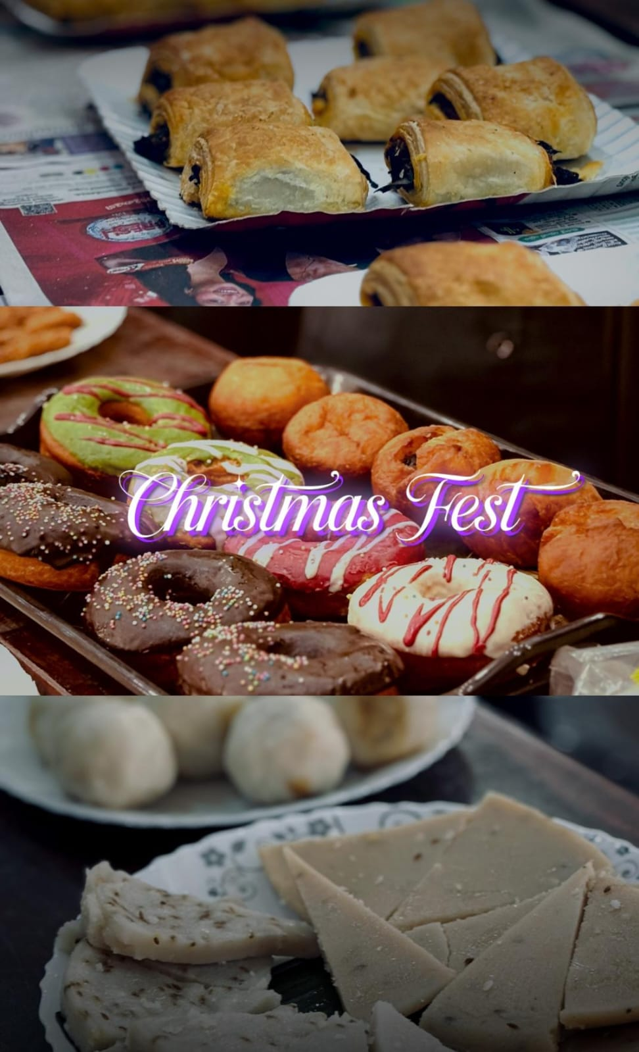
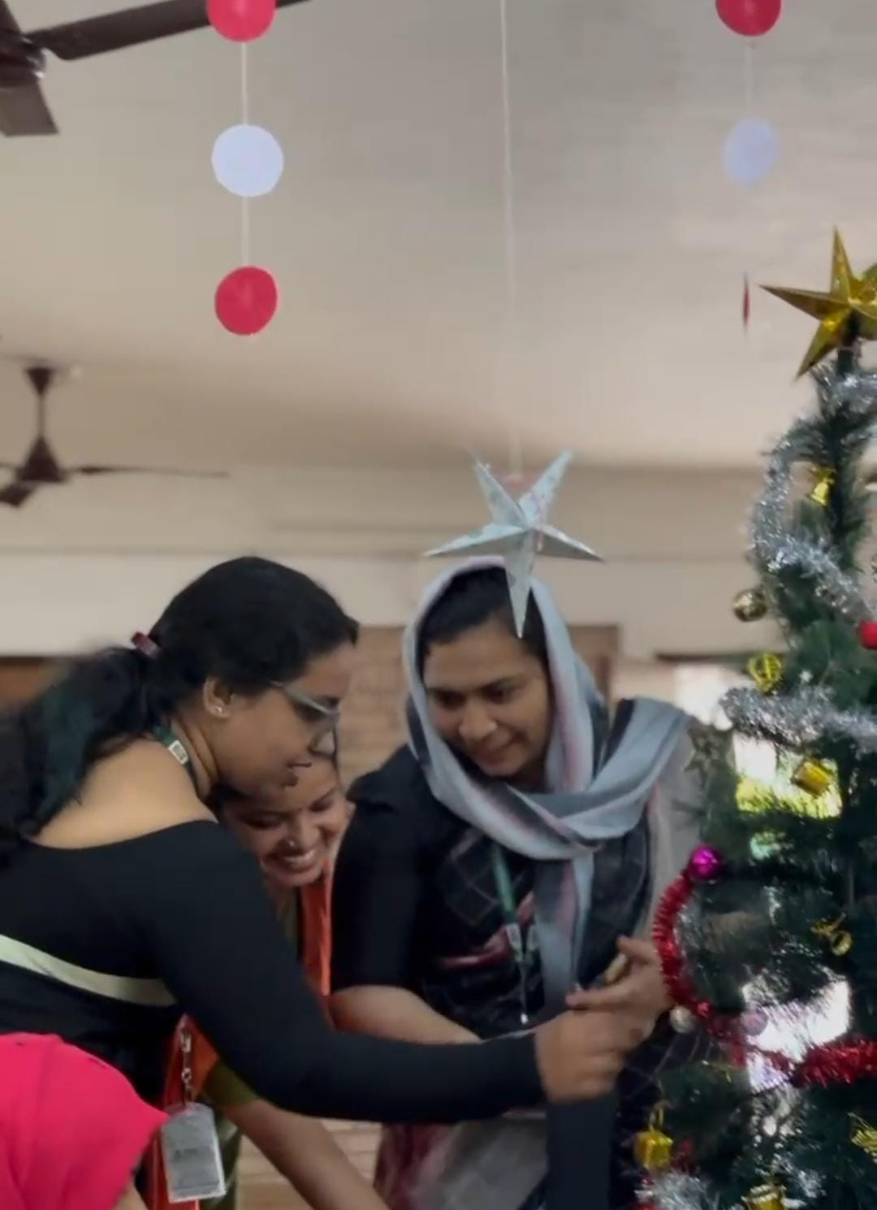
The event was well-coordinated by department coordinators Reeba OB, Nasmi TH, and Dhini KV, with enthusiastic participation from students. The colorful and festive decorations, combined with the variety of food items displayed, created a warm and inviting ambiance. The stalls attracted a significant number of visitors, encouraging a sense of teamwork and collaboration among the students. The Christmas Fest not only celebrated the holiday spirit but also fostered entrepreneurial thinking and cultural engagement, making it a memorable and impactful event for all participants.
https://www.facebook.com/reel/1175181810640862

