Seminar on "Youth for Sustainable Development"
Date: 21 December 2024
Time: 11:30 AM
Venue: Seethi Sahib Memorial High School, Azhikode
As part of the NSS Special Camping Program (December 20–26) organized by NSS Units 95 & 53 of MES Asmabi College, a “Youth for Sustainable Development” seminar was conducted on 21 December 2024 at 11:30 AM.
The session resource person was Dr. Midhun K S, Assistant Professor at Sree Krishna College, Guruvayoor. With his profound academic background and expertise in sustainability studies, Dr. Midhun provided valuable insights into the pivotal role of youth in achieving sustainable development goals (SDGs).
Key highlights of the session included:
- Understanding sustainable development and its relevance in today's world.
- The active role of youth in tackling climate change, conserving resources, and promoting social equity.
- Practical initiatives for individuals and communities to foster environmental stewardship and sustainable practices.
Dr. Midhun K S emphasized that young people are the agents of change who can shape the future through innovative ideas and community-level interventions. He inspired the NSS volunteers to take a proactive stance on sustainability challenges and to work collectively for a greener, more equitable world.
The interactive segment of the session allowed participants to discuss practical ways to integrate sustainability into their daily lives. Dr. Midhun encouraged them to lead by example and raise awareness among peers and family members about the significance of sustainable living.
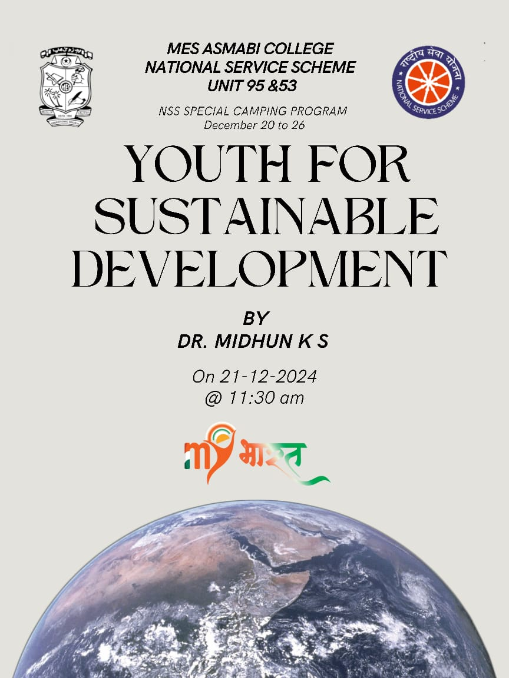
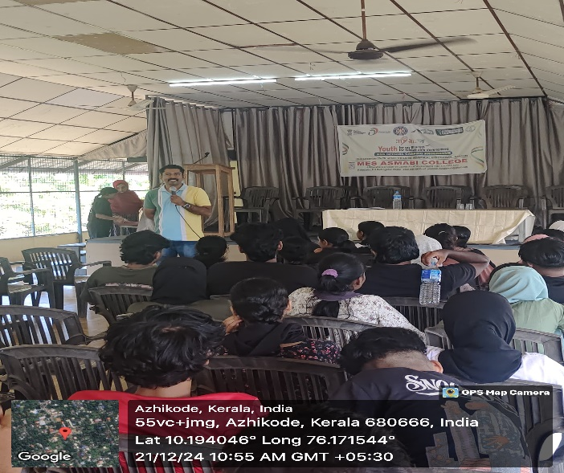 | 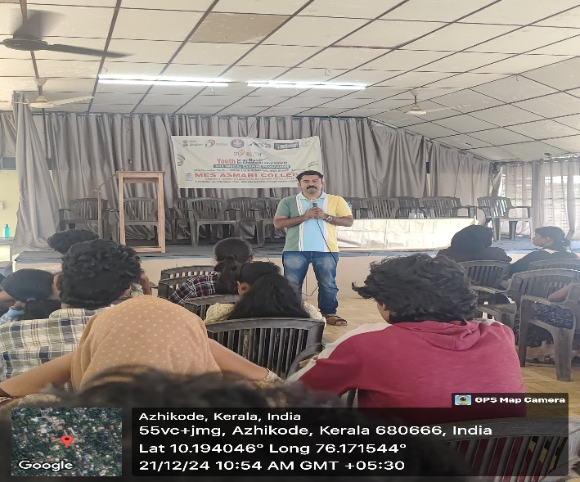
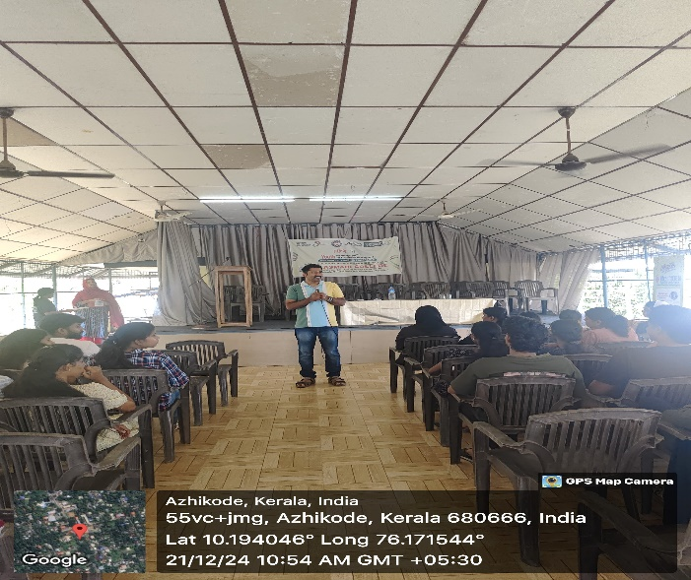 | 