Seminar on "Gender Equality..... For What and How"
NSS Unit 53 & 95, MES Asmabi College, P. Vemballur
Date: 24 December 2024
Time: 10:00 AM
Venue: Seethi Sahib Memorial High School, Azhikode
As part of the NSS Special Camping Program (December 20–26), NSS Units 53 & 95 of MES Asmabi College organized a seminar titled “Gender Equality….. For What and How” on 24 December 2024 at 10:00 AM.
The session was led by Dr. Sheeba N H, a retired Associate Professor with extensive experience as an NSS Programme Officer. Drawing from her vast knowledge and practical expertise, Dr. Sheeba delivered a thought-provoking presentation on gender equality.
The seminar explored the following key themes:
- The importance of fostering equality between genders in education, workplace, and social settings.
- Challenges faced in achieving gender parity and ways to overcome them.
- Practical steps for individuals and communities to promote inclusivity and mutual respect.
Dr. Sheeba emphasised the role of youth, particularly NSS volunteers, in breaking stereotypes and creating a society where men and women stand up for each other. She highlighted the need for collective action and grassroots-level awareness to address issues of gender discrimination.
The interactive session encouraged active participation from students, who shared their perspectives and raised pertinent questions about achieving equality in their contexts. This seminar not only educated participants on gender equality but also inspired them to contribute toward building a fair and just society.
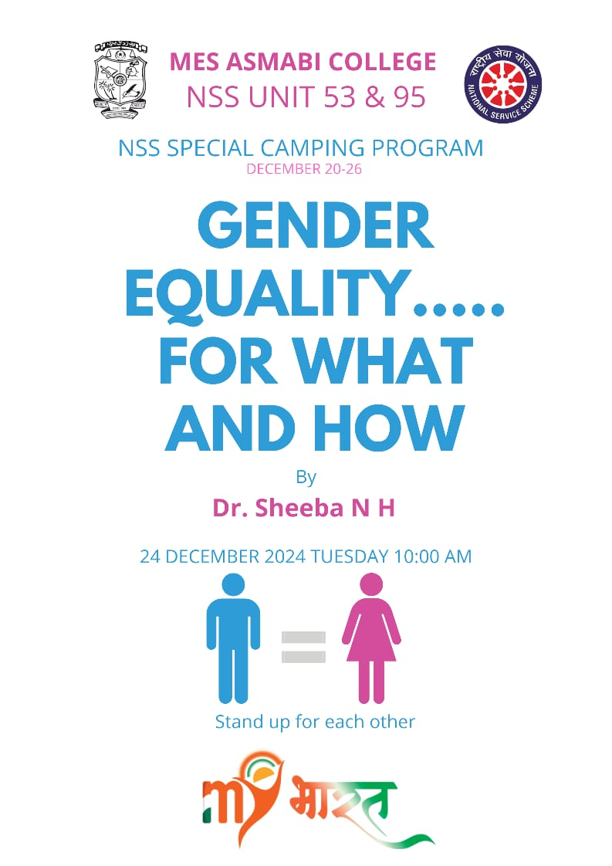
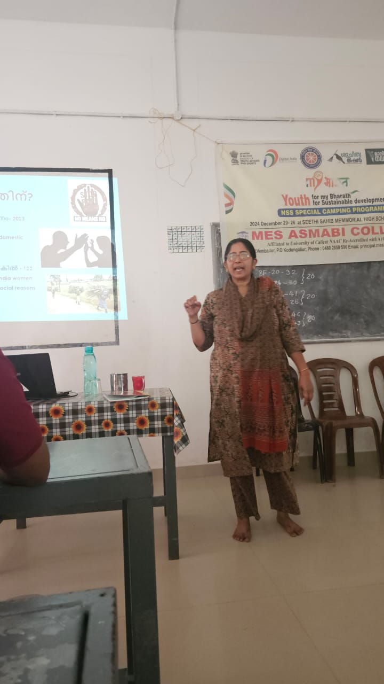 | 