Constitution Day Programme
Date: 26th November 2024
Venue: MES Asmabi College
Organised by: NSS Units 53 & 95, in association with the Parliamentary Affairs and Electoral Literacy Club
On 26th November 2024, MES Asmabi College commemorated Constitution Day with a series of meaningful events organised by the NSS Units 53 & 95, in collaboration with the Parliamentary Affairs and Electoral Literacy Club.
The programme commenced with the Revealing of the Preamble of the Constitution, emphasizing the core values enshrined in the Indian Constitution. This was followed by an insightful Talk on the Indian Constitution delivered by NSS volunteers, who highlighted its significance, fundamental rights, and duties.
The event aimed to instil constitutional awareness and reinforce the importance of democratic values among students. The active participation of the students and NSS volunteers ensured that the programme was both engaging and educational.
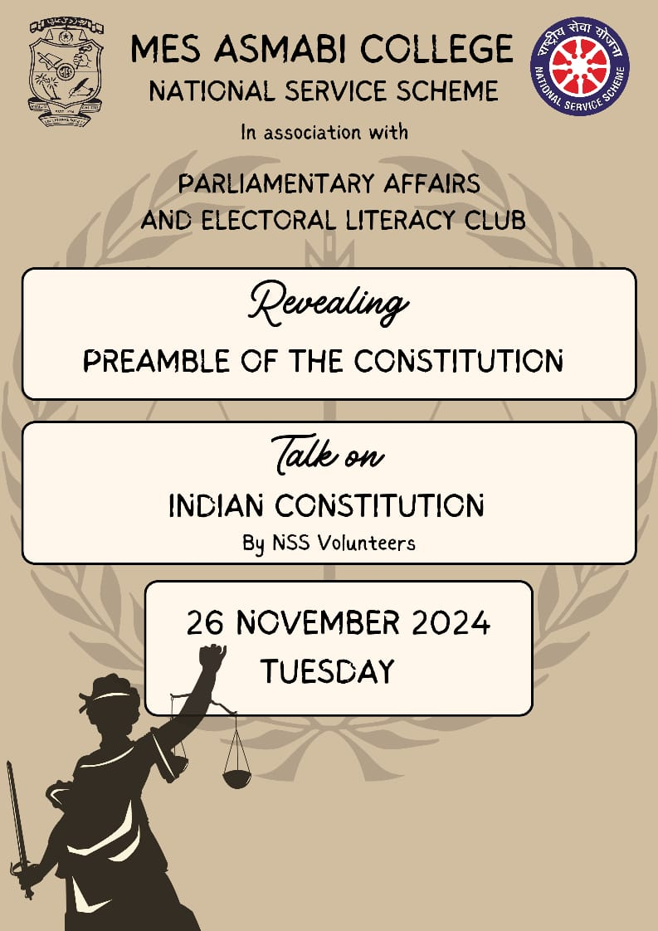
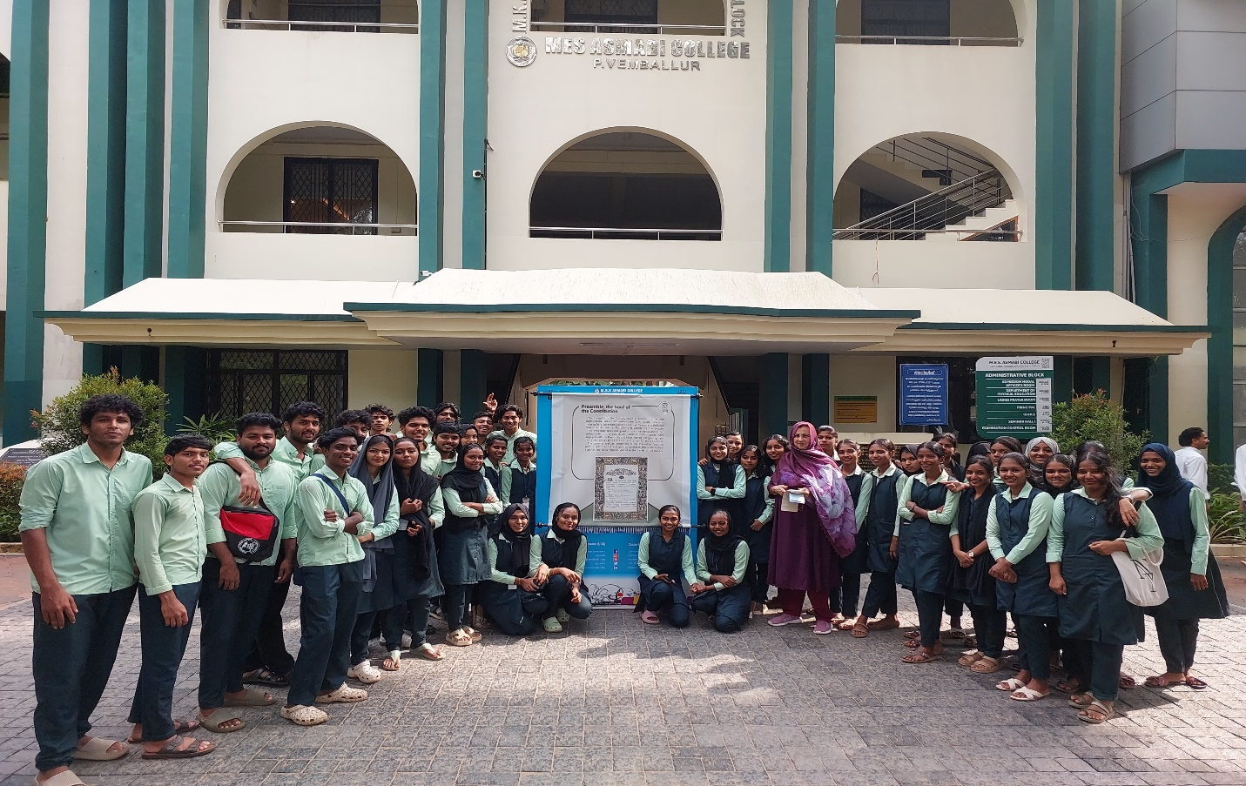
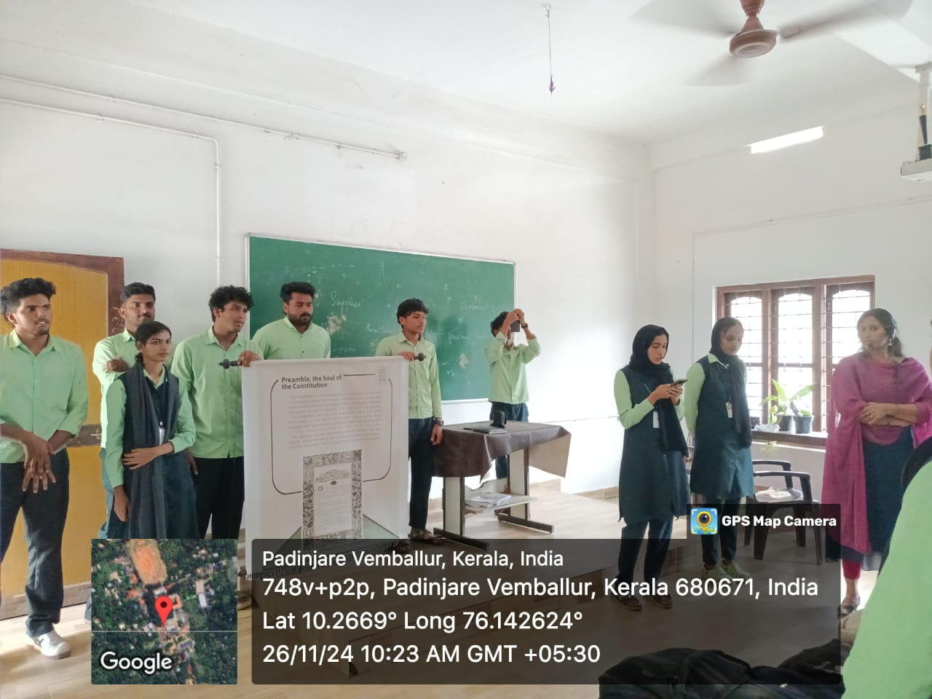 | 