Mizhivu 2024: Nature Study Camp
Dates: 14th & 15th November 2024
Venue: Vazhachal
Organized by: NSS Units 53 & 95, MES Asmabi College
Occasion: Janajatiya Gaurav Diwas 2024
As part of the celebrations for Janajatiya Gaurav Diwas 2024, NSS Units 53 & 95 of MES Asmabi College conducted a two-day nature study camp titled Mizhivu 2024 at Vazhachal on November 14th and 15th, 2024. The camp aimed to provide participants with an immersive experience in exploring the natural environment and understanding the lives of the tribal communities in the region, particularly the Kadar Community.
The programme successfully instilled a deeper appreciation for nature and the tribal heritage among the participants. It was a step forward in sensitising young minds to the interconnectedness of humanity and the environment, promoting a harmonious coexistence.
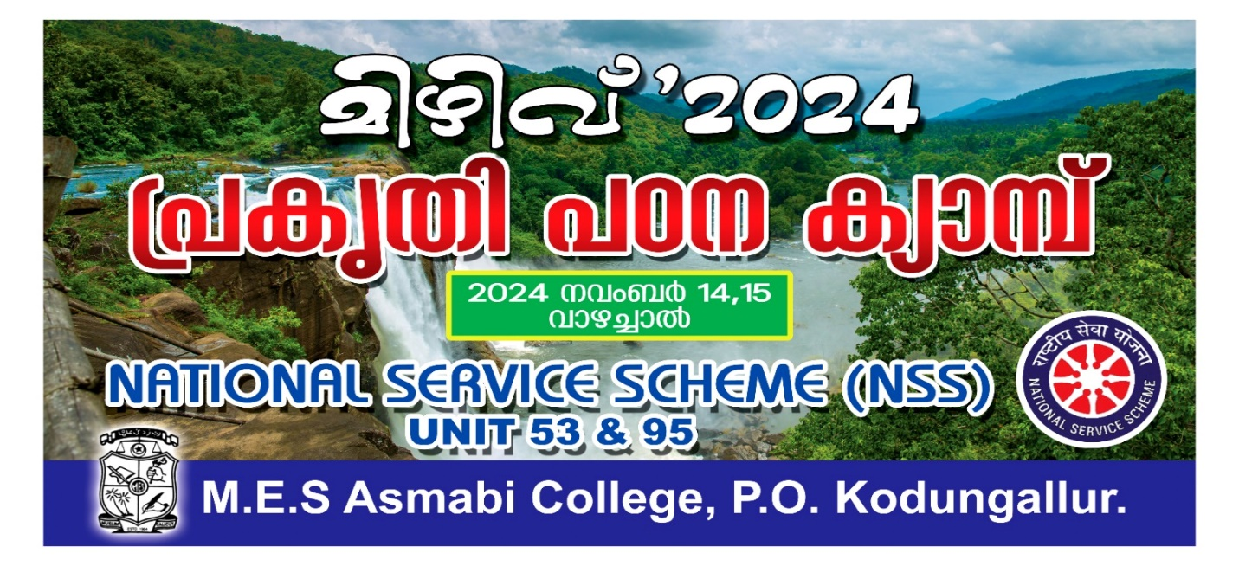

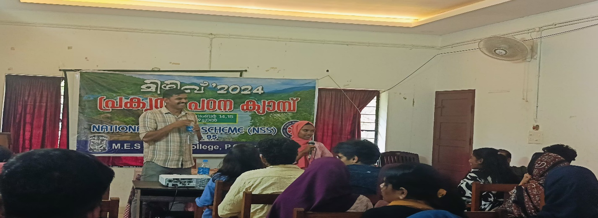
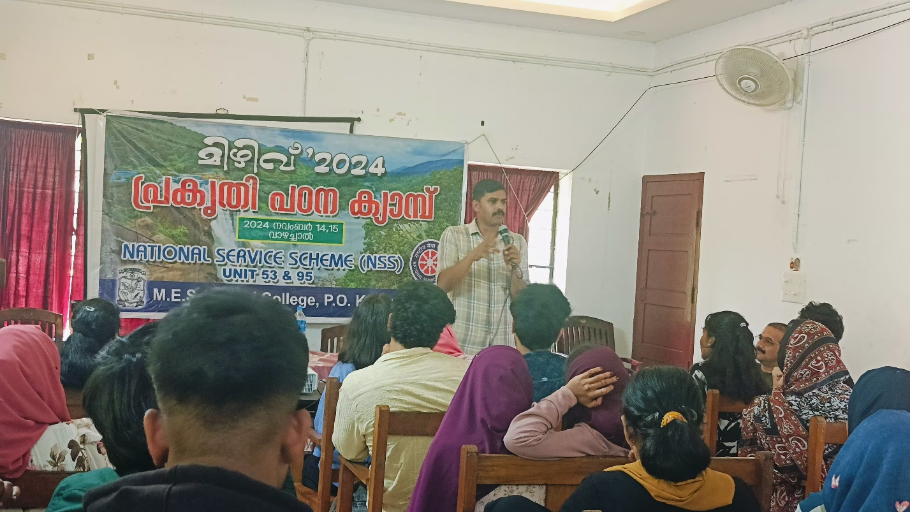
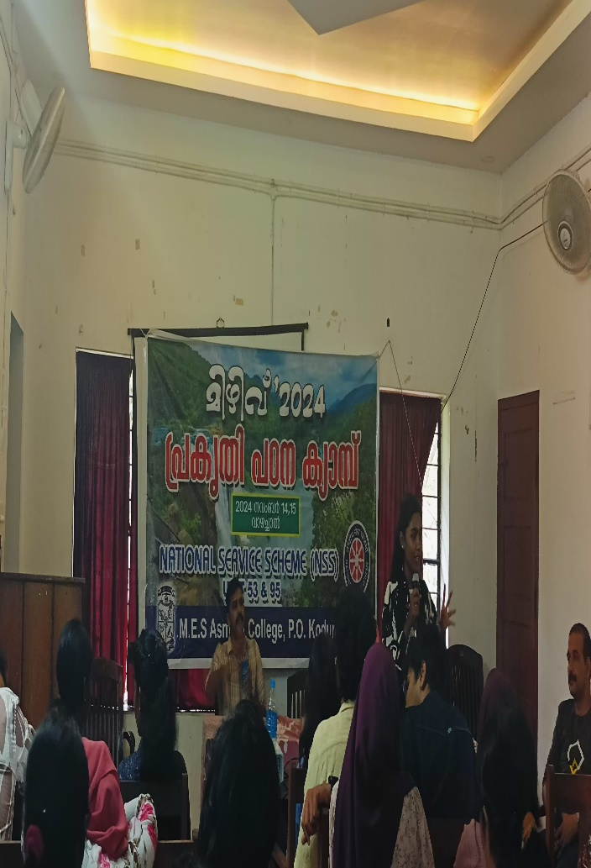 | 