Report on Children’s Day Celebration
Date: 14th November 2024
Venue: Govt. LP School, P. Vemballur
Organised by: NSS Units 53 & 95, MES Asmabi College
On 14th November 2024, in celebration of Children’s Day, NSS Units 53 & 95 of MES Asmabi College organised a joyful programme at Govt. LP School, P. Vemballur. The event was held to honour and engage with the young students, making the day memorable for them.
The event emphasised the importance of nurturing young minds and fostering a spirit of joy and community among the students. The programme was a meaningful opportunity for the NSS volunteers to connect with the younger generation and positively contribute to the community. The enthusiasm of the students and volunteers alike made the event a great success.
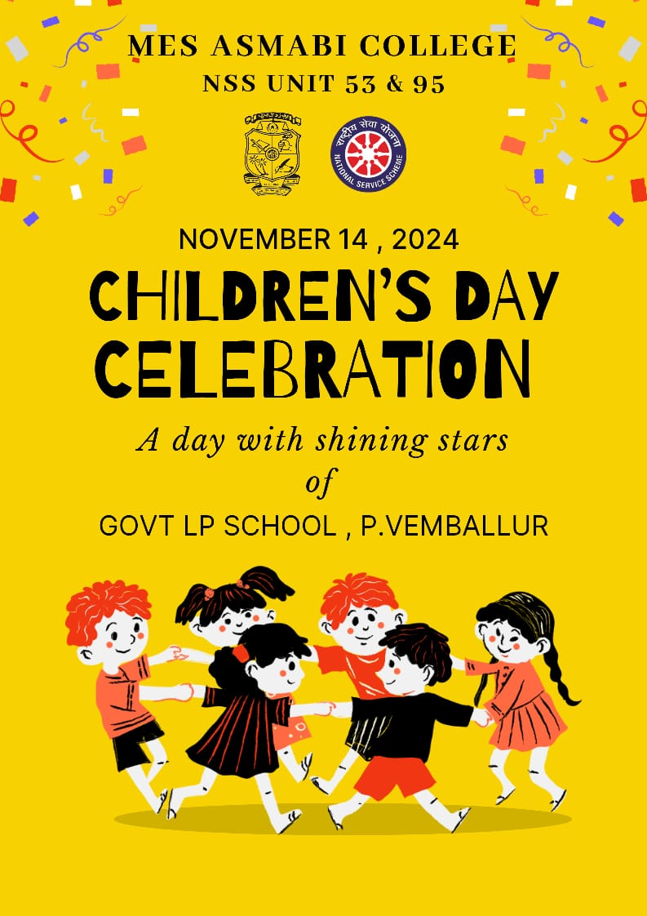
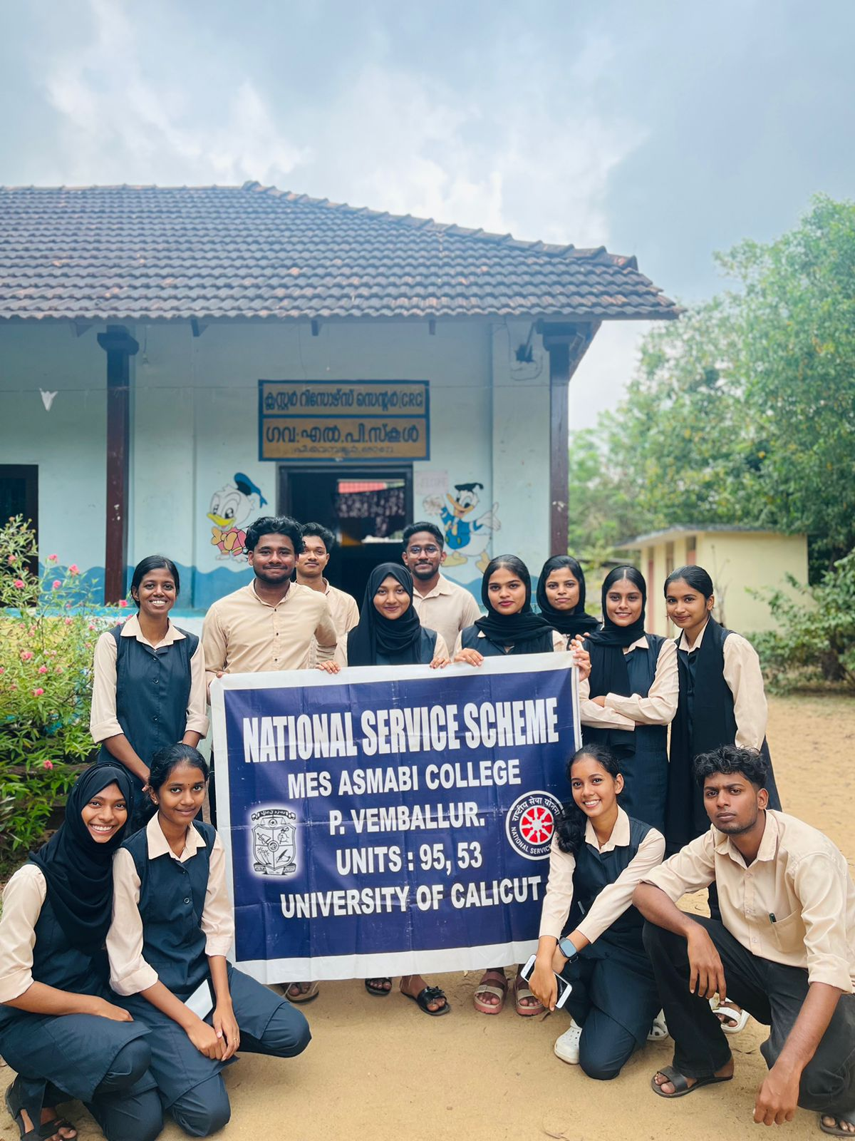 | 