Report on Mass Clean-Up Drive
Date: 1st November 2024
Organised by: Thrissur Tourism Club in association with the District Tourism Promotion Council (DTPC)
Venue: Snehatheeram Beach, Thriprayar
Participants: NSS Units 53 & 95, MES Asmabi College, along with students from various campuses in Thrissur District
In celebration of Keralapiravi, a Mass Clean-Up Drive was conducted on 1st November 2024, spearheaded by the Thrissur Tourism Club in association with the District Tourism Promotion Council (DTPC). The event took place at Snehatheeram Beach in Thriprayar, to enhance the cleanliness and beauty of this popular tourist spot. NSS volunteers from Units 53 and 95 of MES Asmabi College actively participated in this initiative, alongside student volunteers from various institutions across the district. The Mass Clean-Up Drive was organized not only to celebrate Keralapiravi but also to promote environmental consciousness and responsible tourism. The drive served as a reminder of Kerala’s heritage and the importance of protecting its unique landscapes for future generations.
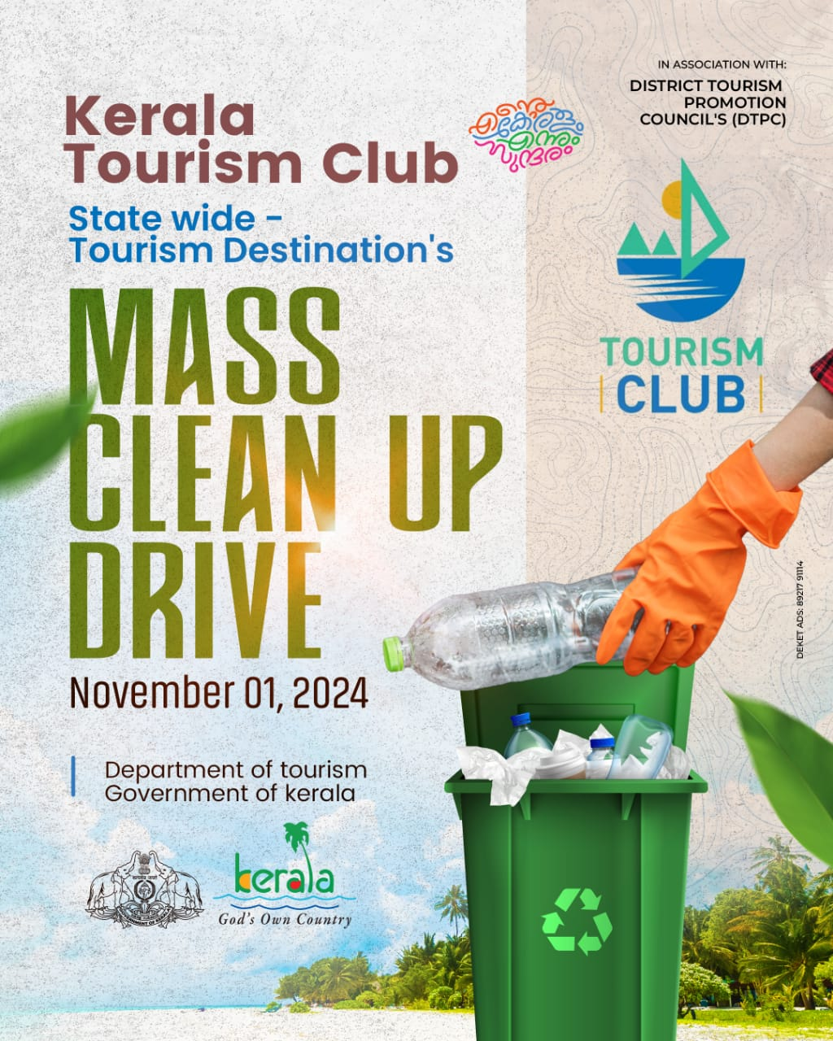
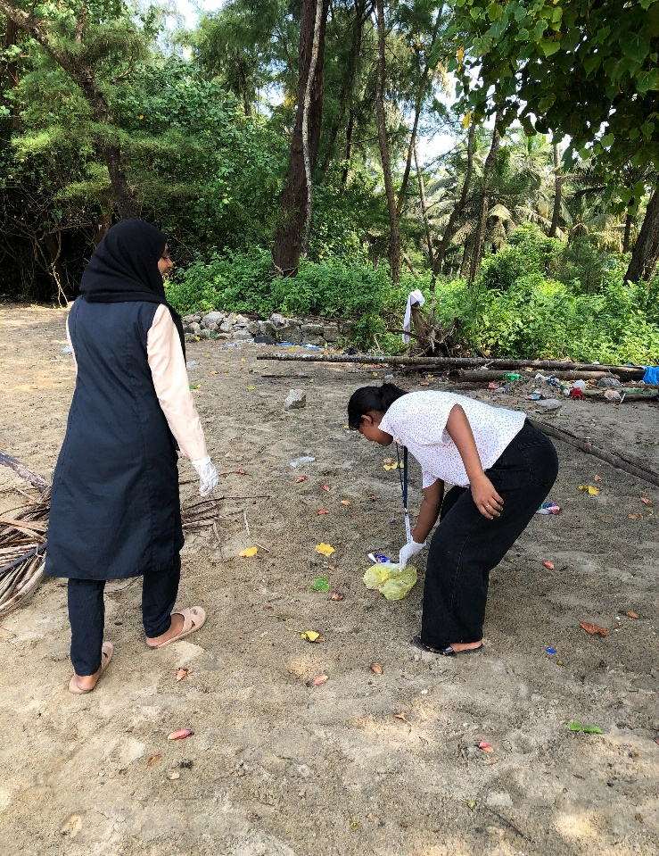 | 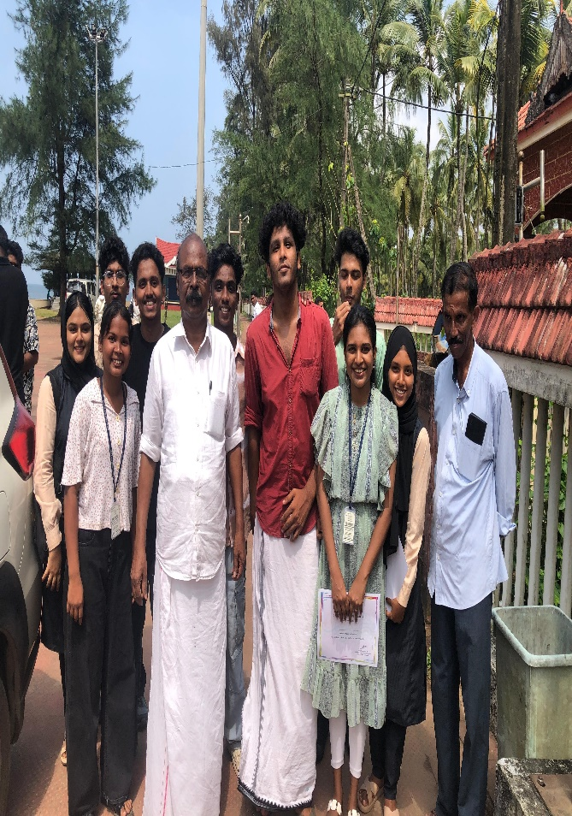
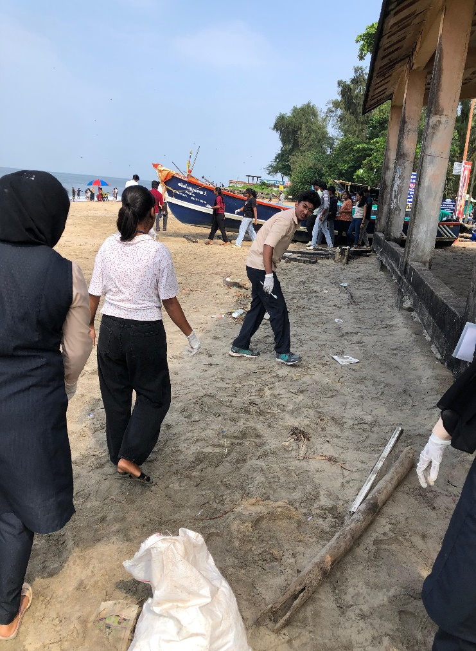 | 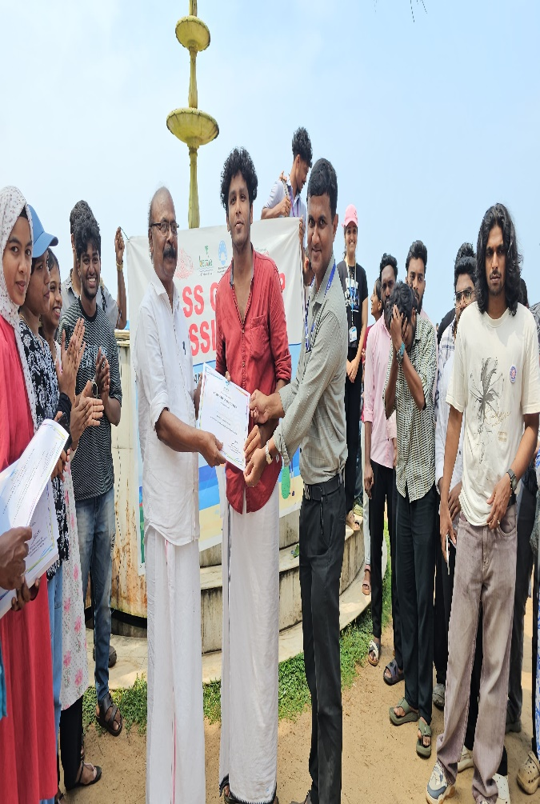
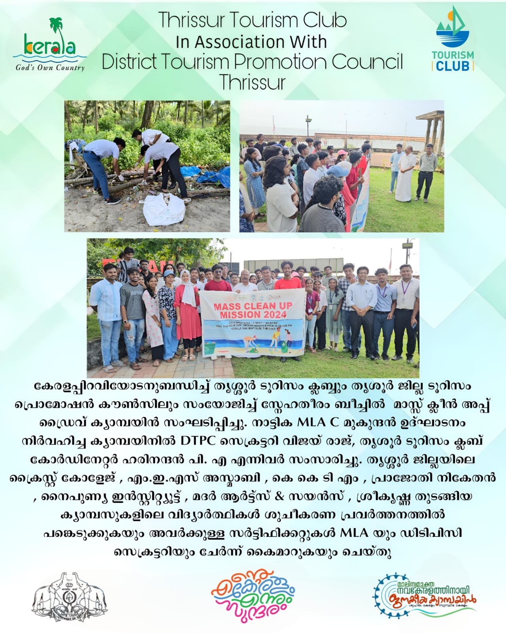 | 