Report on Self Defence Programme
Date: 25th September 2024
Organized by: NSS Units 53 & 95, MES Asmabi College, P. Vemballur in association with Kaizen Gojo Ryu
Venue: MES Asmabi College
Time: 10:00 AM
On 25th September 2024, a Self Defence Programme was successfully conducted by NSS Units 53 & 95 of MES Asmabi College, P. Vemballur in association with Kaizen Gojo Ryu, as part of the NSS Day celebrations. The programme aimed at empowering students, particularly young women, with essential self-defence skills to enhance their personal safety and boost their confidence.
Expert trainers from Kaizen Gojo Ryu demonstrated basic yet highly effective self-defence techniques. The interactive session allowed participants to learn hands-on defence strategies, enabling them to respond to physical threats effectively. The initiative aligned with the broader objectives of NSS, promoting social awareness, self-empowerment, and safety.
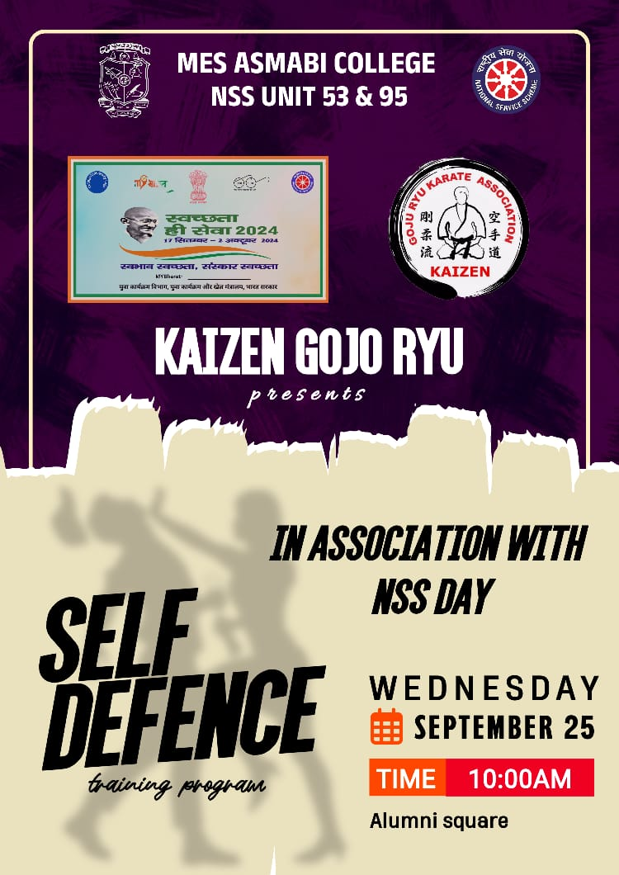
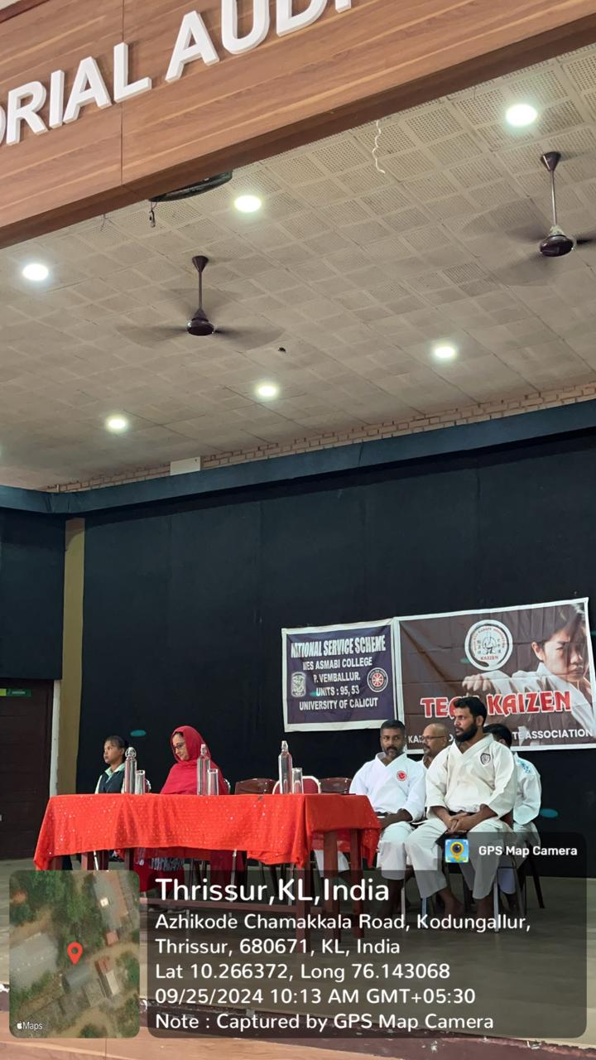 | 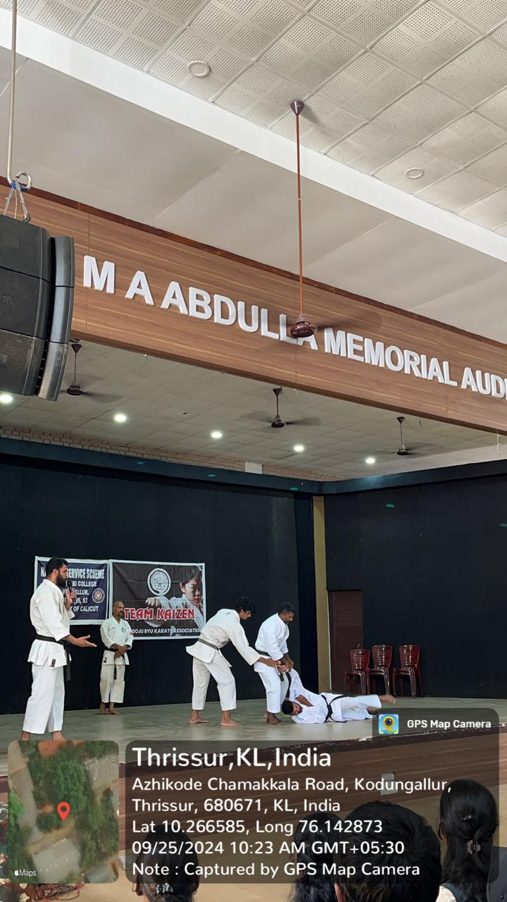
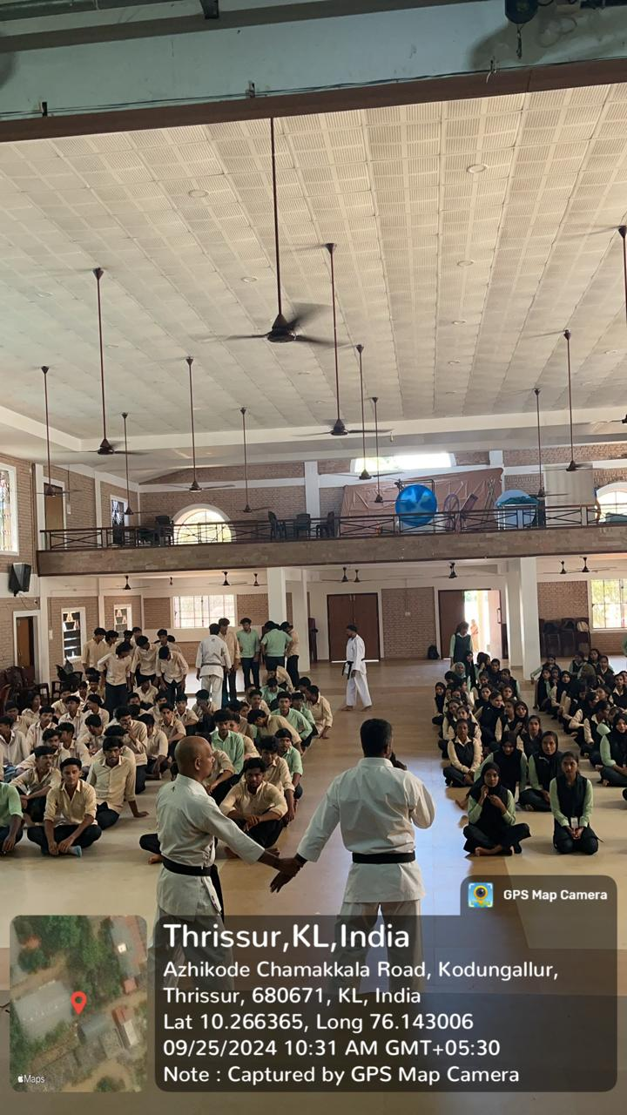 | 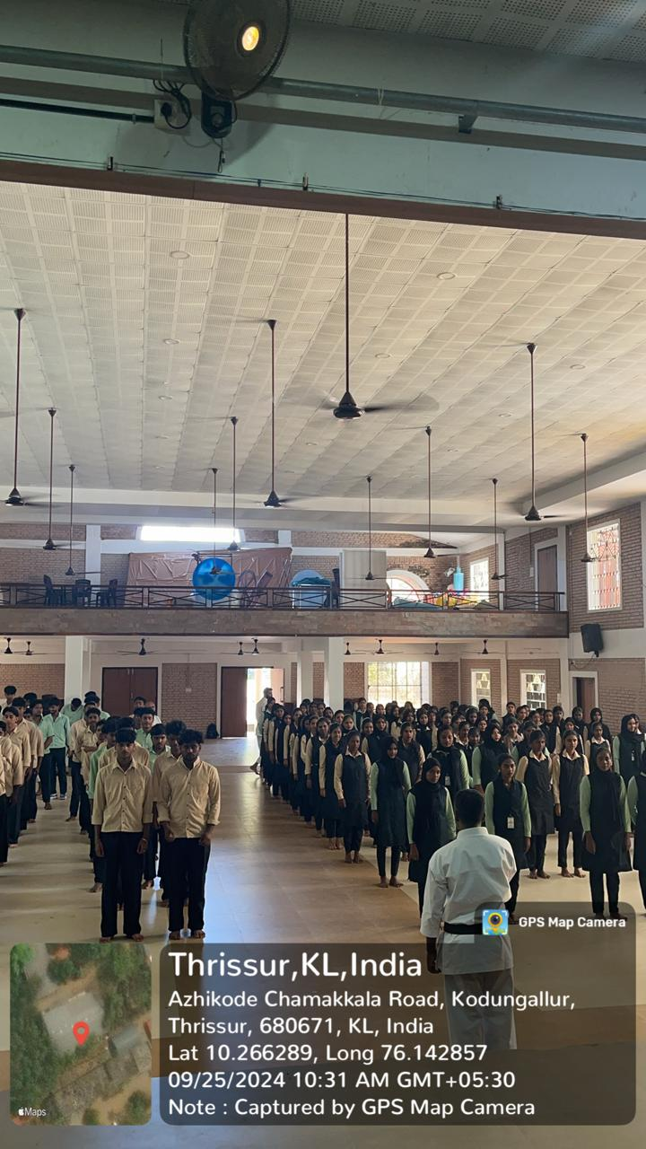
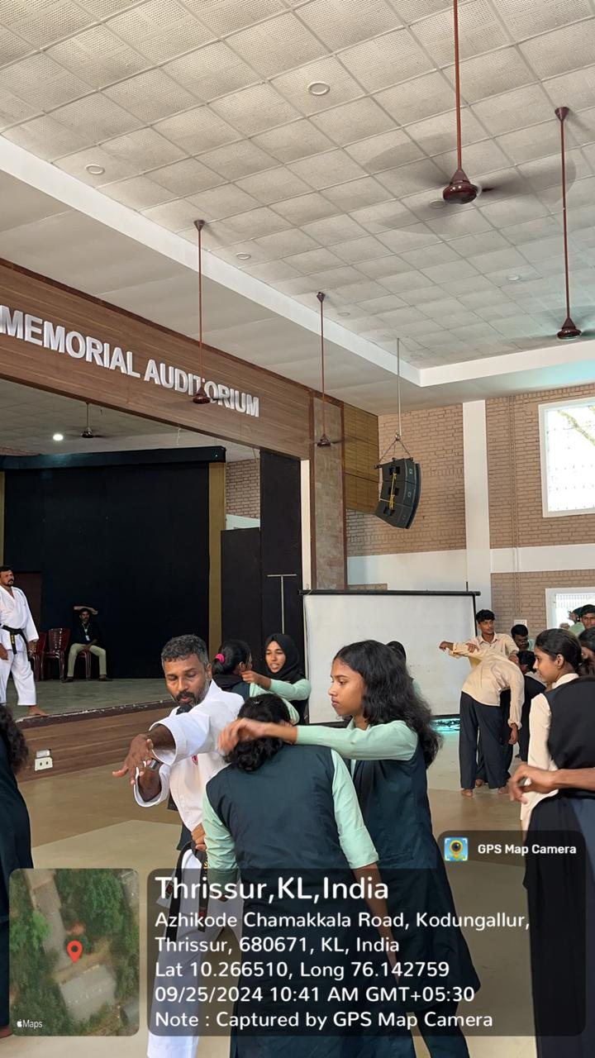 | 