MES Asmabi College, P.Vemballur
Research Department of Commerce
First Semester B.Com Cooperation 2024 Adm
FYUG Orientation Program
The MES Asmabi College's Research Department of Commerce successfully organized an FYUG Orientation Program on July 19th, 2024, specifically designed for first-year B.Com Cooperation students. The event, which took place at 2:00 PM in the college's seminar hall, aimed to welcome and familiarize the new batch of students with the academic environment they are about to enter. Dr. Sanad Sadanadhan, Head of the Department of Political Science, was the resource person for the session, offering his expertise and support to help students navigate their new academic journey. During the orientation, Dr. Sadanadhan helped them to understand the academic expectations and opportunities that lie ahead while selecting minor and MDC courses. The session was interactive, allowing students to engage with Dr. Sadanadhan and seek clarity on any concerns they had about their upcoming courses.
The program was meticulously organized under the leadership of Dr. Reena Mohammed, Principal of MES Asmabi College, and Dr. Chithra P, Head of the Research Department of Commerce. Princy Francis, the Program Coordinator, played a crucial role in ensuring the event's smooth execution, overseeing all logistical aspects and making sure that the students felt welcomed and supported. The orientation was a vital step in setting the tone for the students' academic journey, providing them with a strong foundation and a sense of belonging as they embark on their studies in B.Com Cooperation.

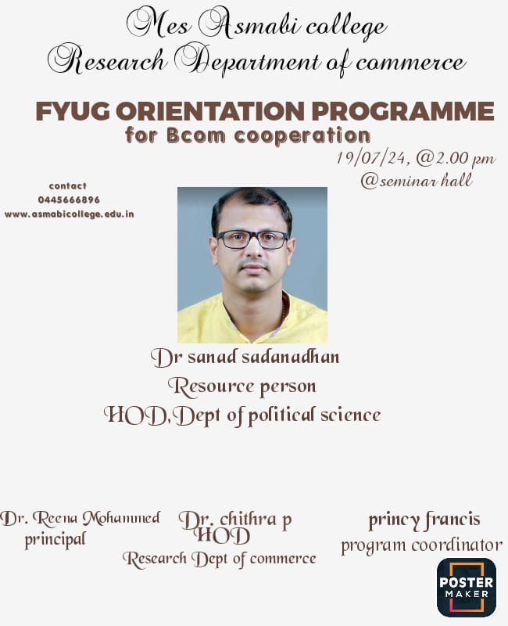 | 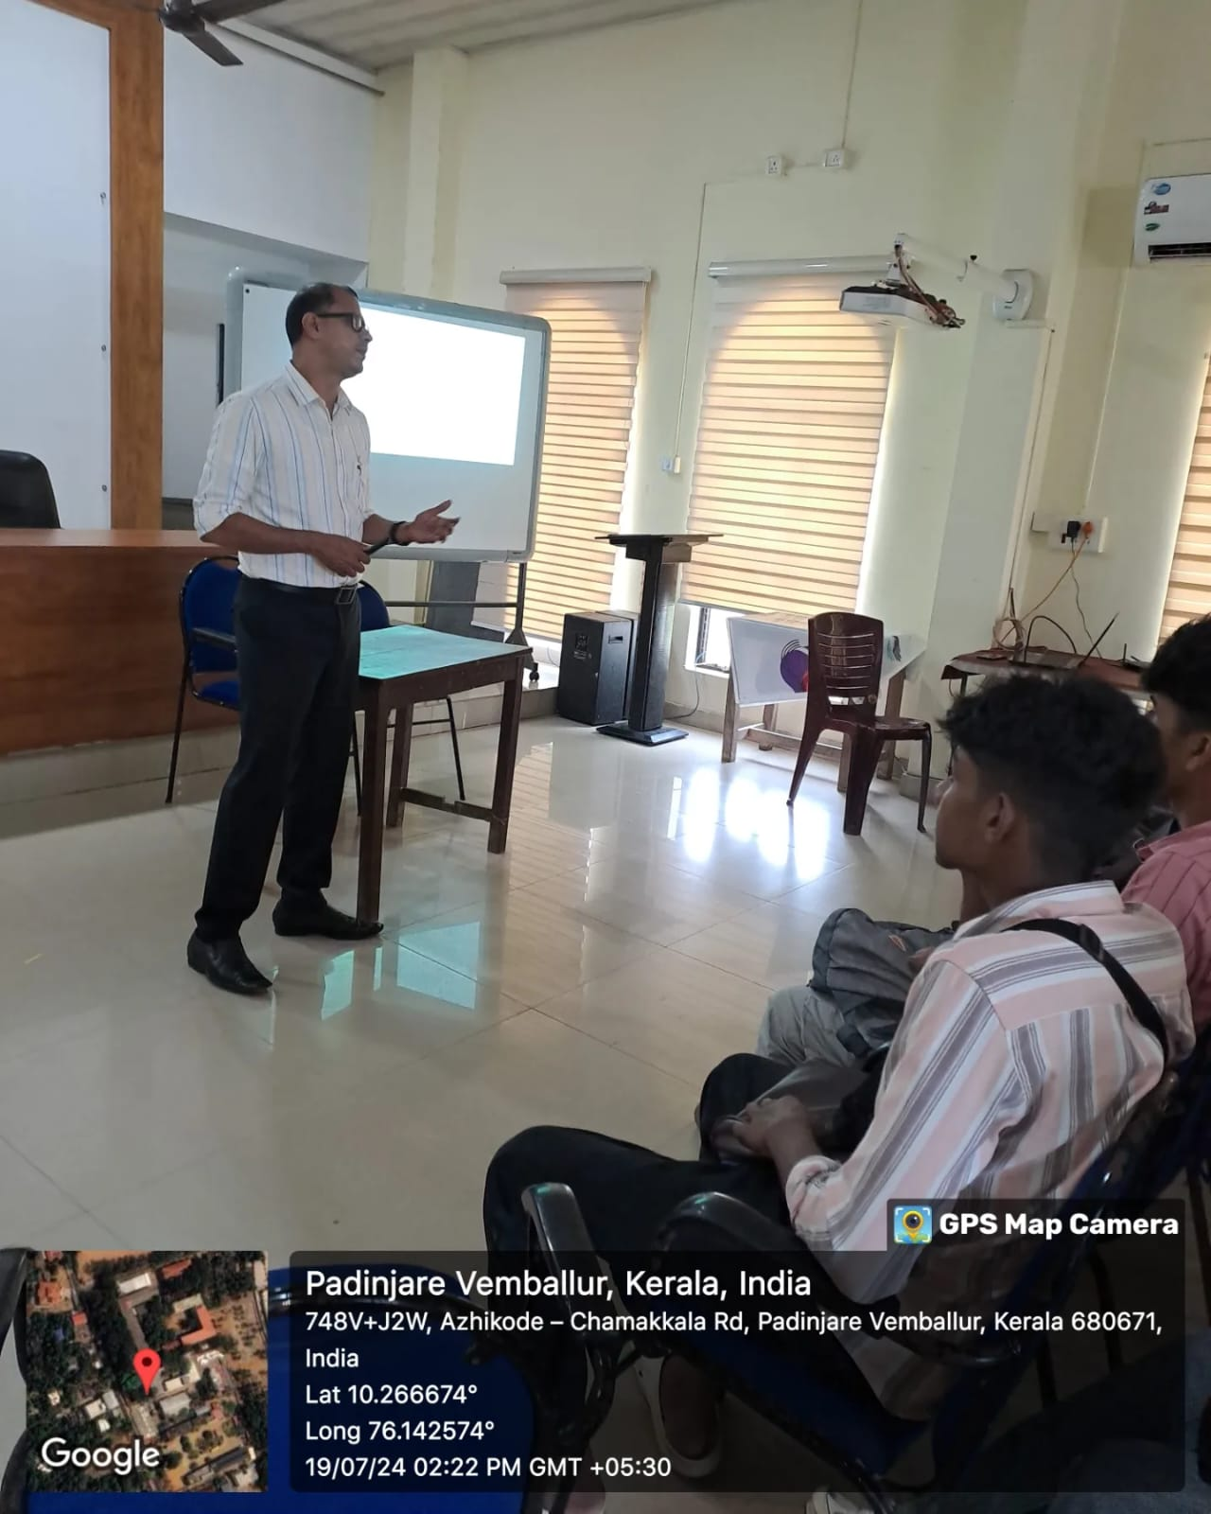
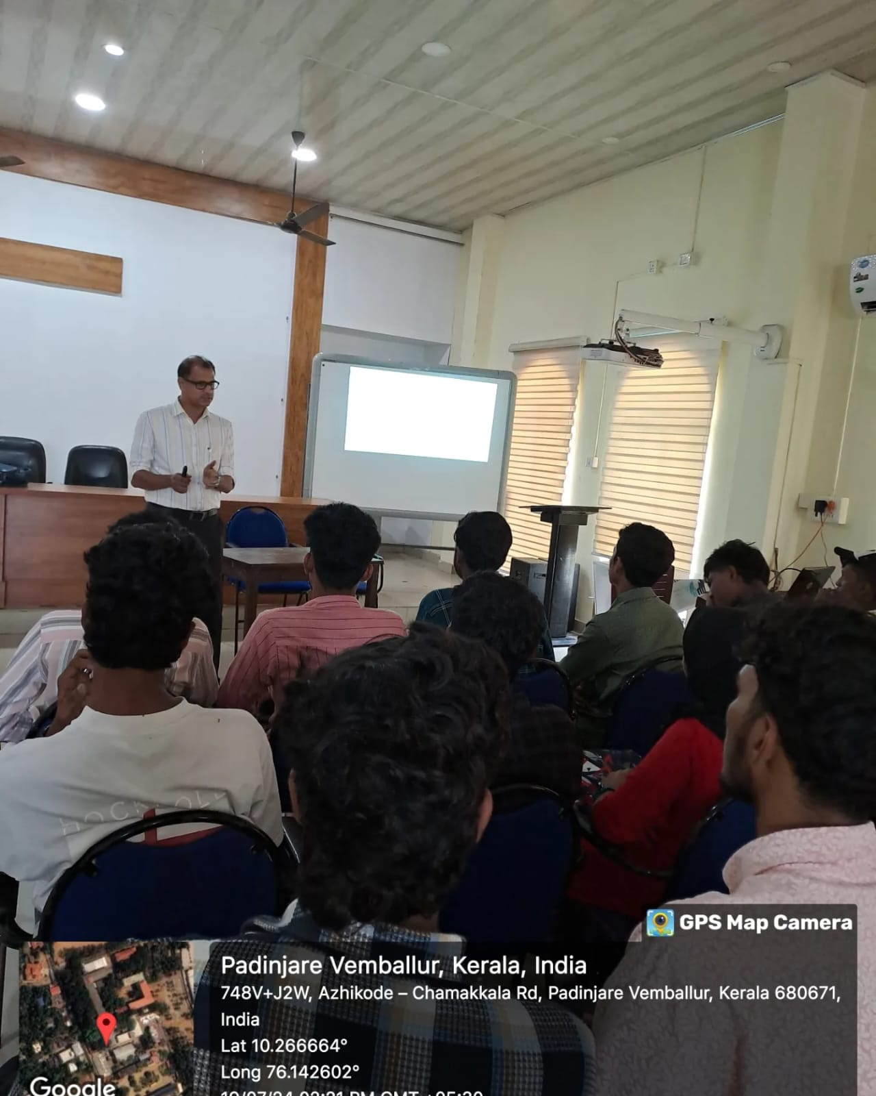 | 