M.E.S. ASMABI COLLEGE
DEPARTMENT OF PHYSICS
STUDY TOUR REPORT 23 - 24

VIGYAN SAGAR SCIENCE AND TECHNOLOGY PARK

One day industrial visit of final year BSc Physics Students of MES ASMABI COLLEGE for the year 2021-2024 was conducted to Vigyan Sagar science and technology park on March 2 2024. There were 25 students in the group, accompanied by teacher from the Department of Physics, Mr Jiswin Varghese.
Situated in Thrissur, the park serves as a dynamic center for research, education, and collaboration in various scientific disciplines. During the visit to the Vigyan Sagar the students had an interaction with one of the best Young Scientists who was awarded in Physical Sciences by KSCSTE, Government of Kerala , Dr. S Shanakara Narayanan Potty. He explained the opportunities after taking degree in Physics and also about the internships and projects.We left inspired and motivated to further explore the exciting possibilities within the realm of science and technology. The Space explorium features a wide range of exhibits and attractions, showcasing ISRO's achievements in satellite technology, rocketry, planetary exploration, and space research.
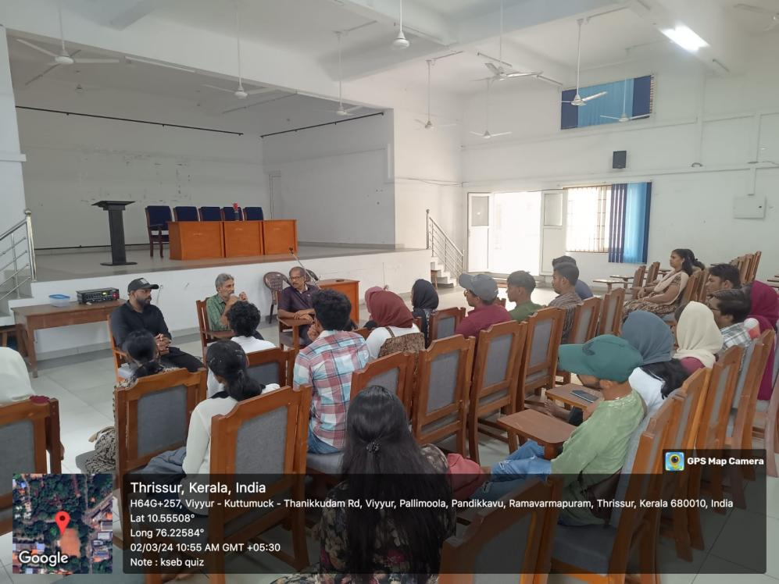

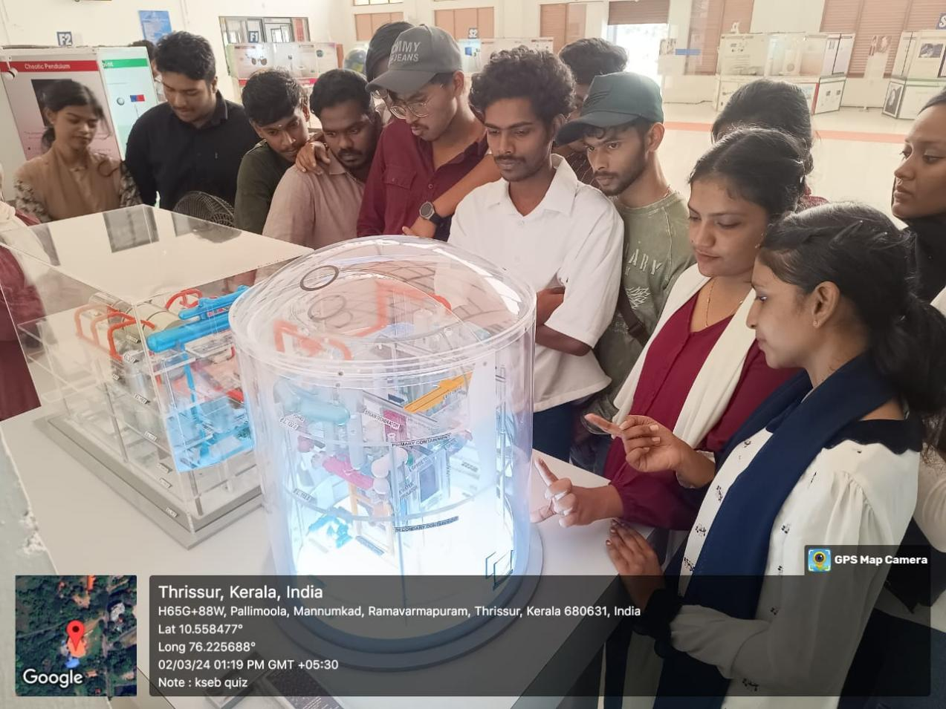
The visit to Vigyan Sagar science and technology park provided an enriching experience, offering insights into the realm of scientific exploration and technological innovation.

