RESEARCH AND PG DEPARTMENT OF ENGLISH
ORIENTATION PROGRAMME FOR I UG ENGLISH 2023-24 ADMISSIONS

Title of the program : ORIENTATION PROGRAMME FOR I UG ENGLISH STUDENTS 2023 ADMISSIONS
Date of the program : 05 OCT 2023
Coordinator : VEENALEKSHMI UR
No. Of Participants : 41
Objectives of the Program :
- Introduce students to the ‘what’, ‘why’ and ‘how’ of literature.
- Equip students with skills that will help them to navigate the curriculum with ease and precision

Report of the program : An Orientation Programme was organized by Research and PG Department of English for I year English Students on 05 Oct 2023. Dr Sijo Varghese C, Associate Profeesor, Sri C Achuth Menon Govt College, Kuttanellur, was the resource person of the programme. The focus of the session was to acquaint students to the ‘what’, ‘why’ and ‘how’ of literature.
Veenalekshmi UR, I BA English Tutor welcomed the gathering.
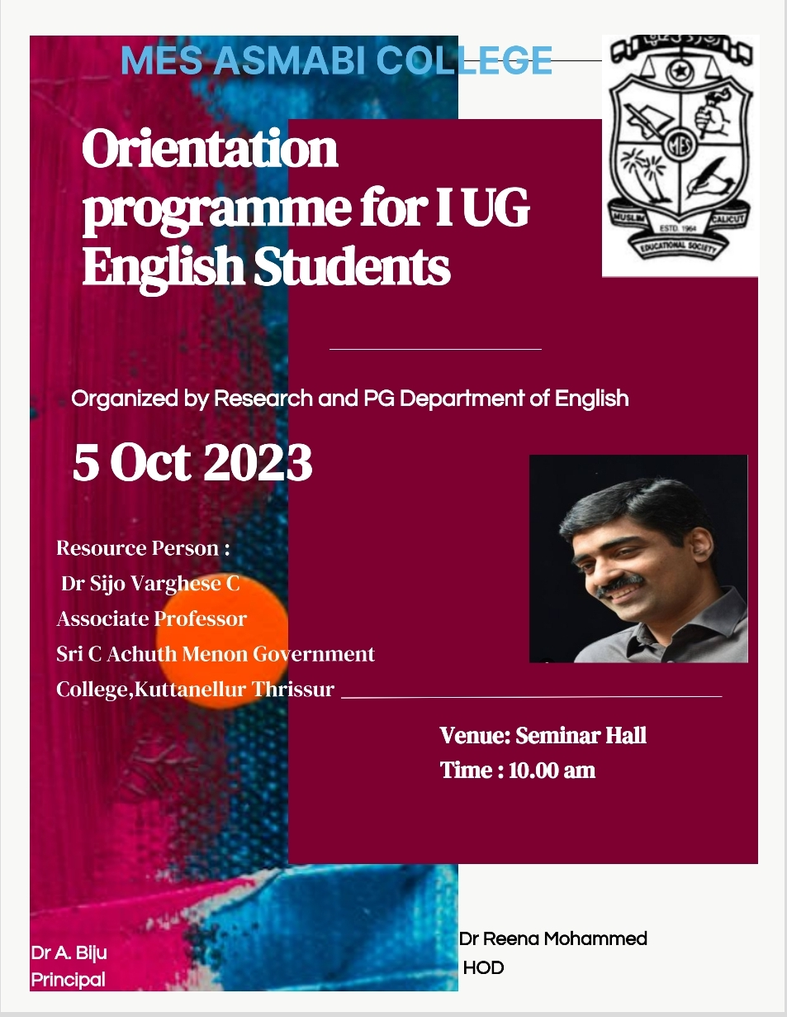
BROCHURE OF THE PROGRAMME
The session was interactive, divided into different activities and games. Brain Gym activity, vocabulary building games, ‘out of the box’ games made the session collaborative. The resource person, in the course of the orientation programme, stressed on the importance of building a rich vocabulary and the tasks that the students can engage in to construct a strong vocabulary.
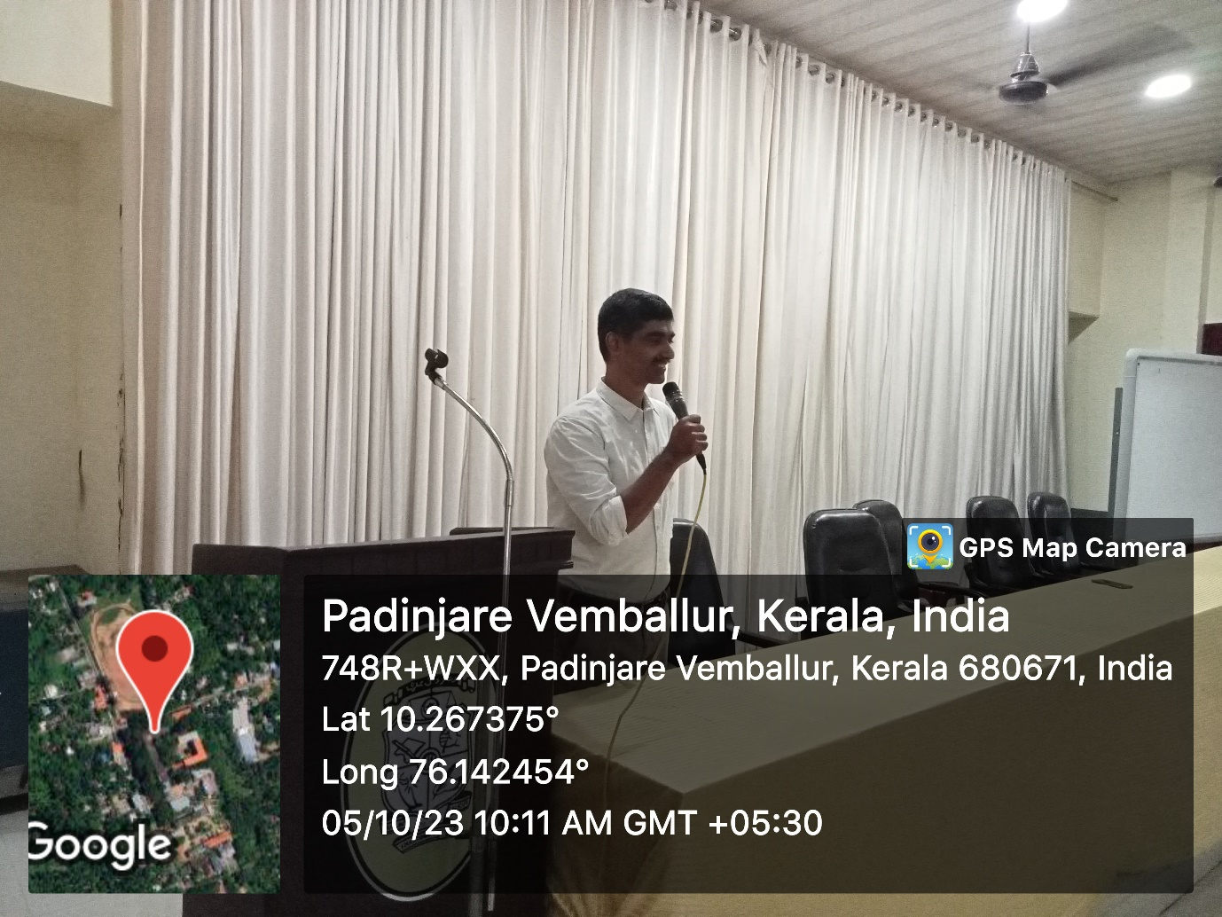
Resource Person Dr Sijo Varghese addressing students
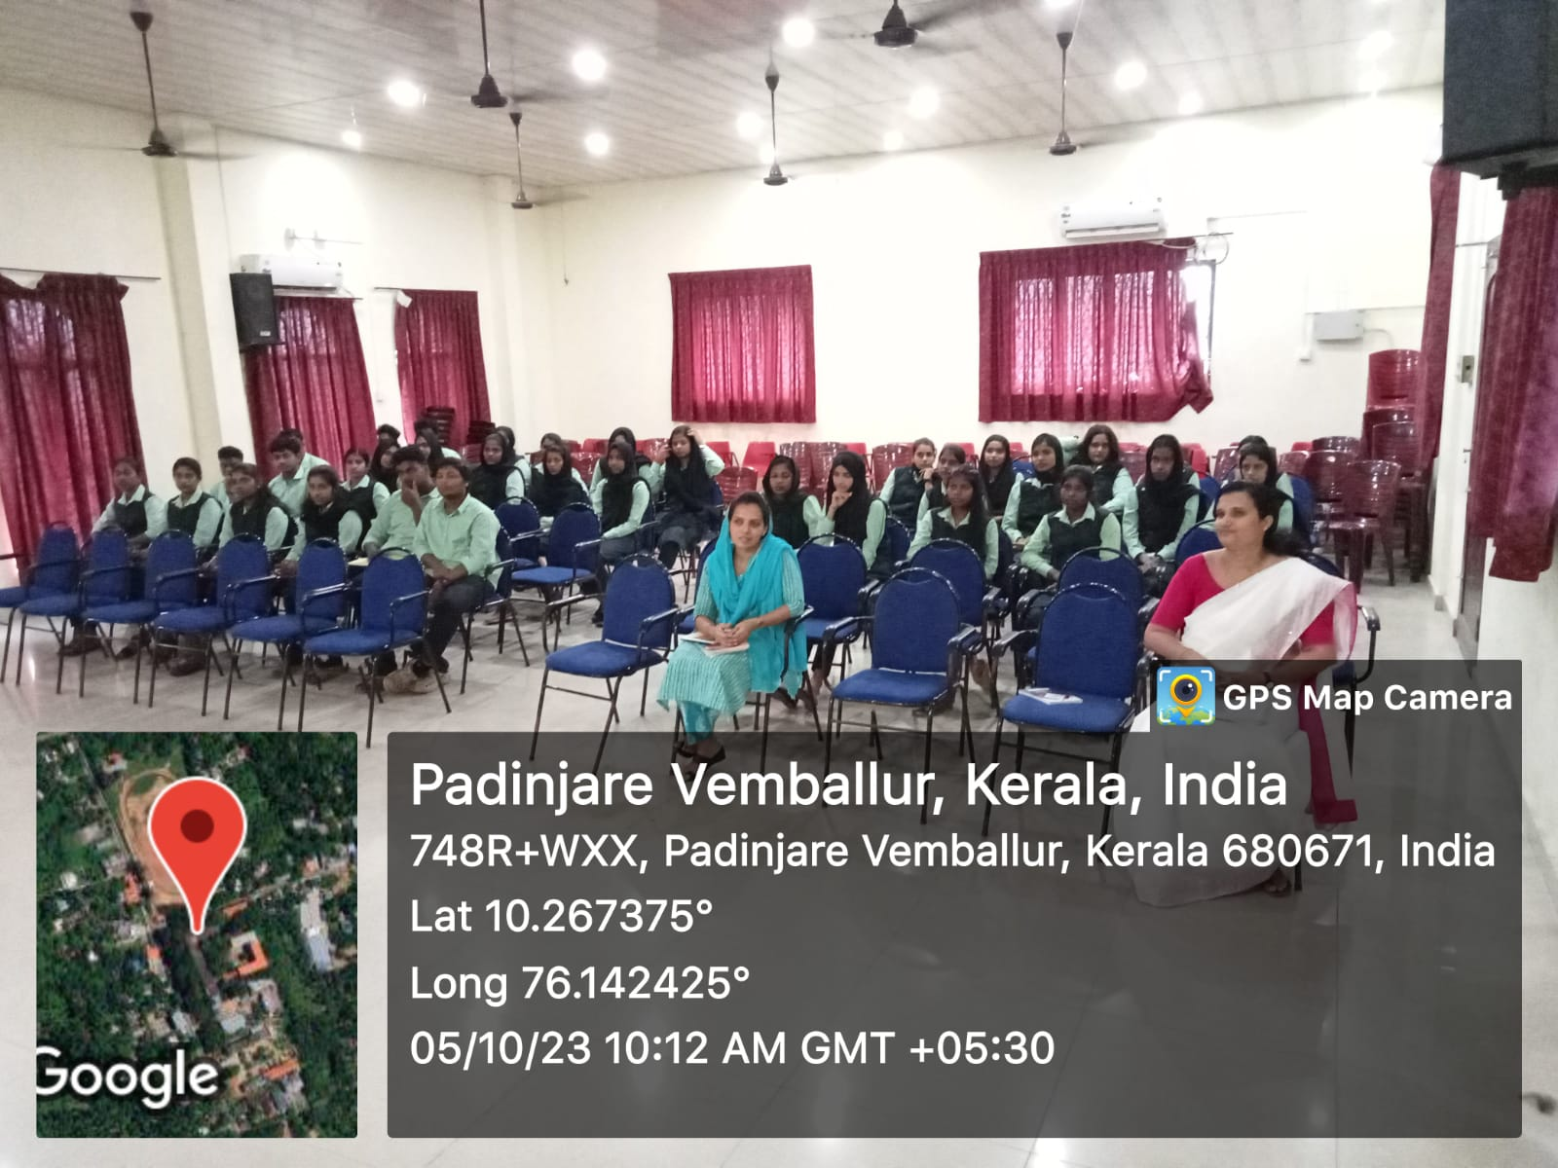
Student Participation
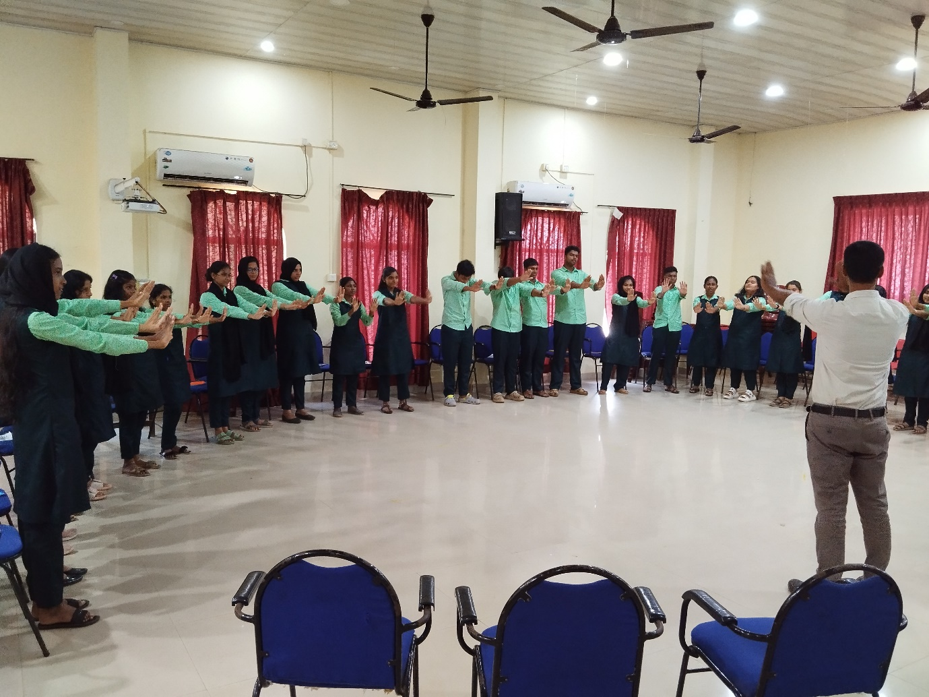
Activity Oriented Session
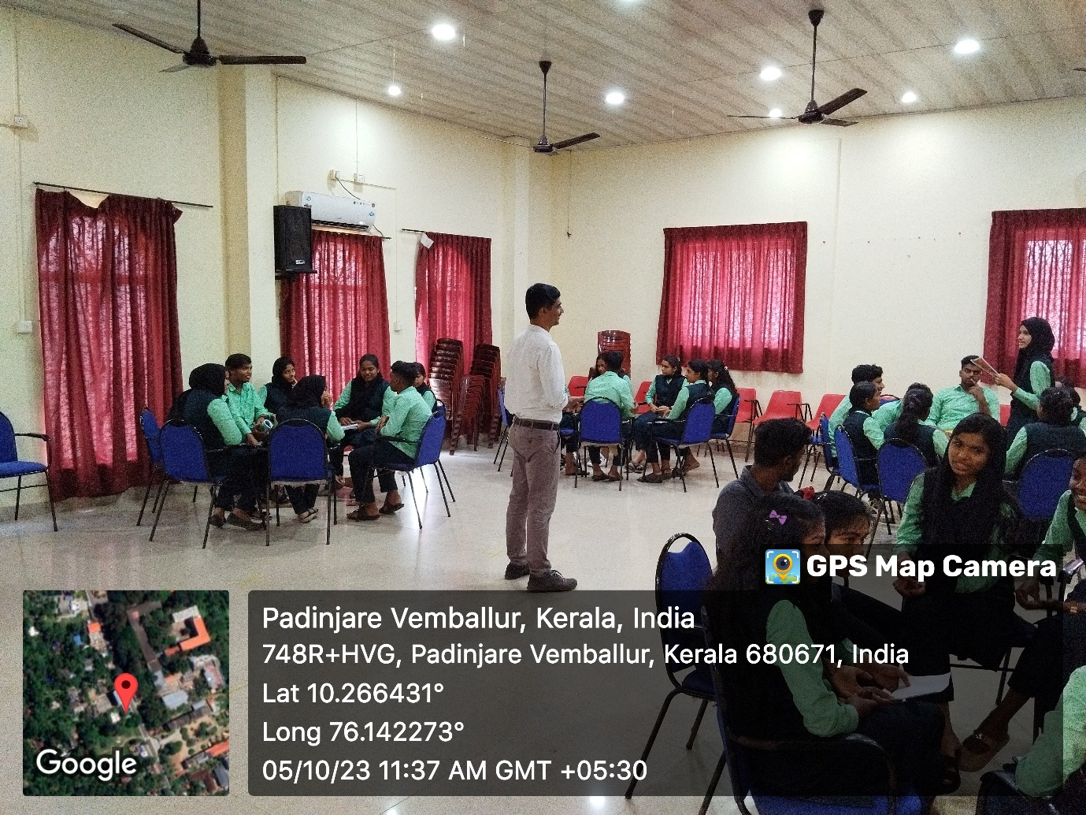
Students engaged in vocabulary building activity
The following tasks were assigned to students at the end of the session
- Open a notebook to regularly write book reviews
- Set a career goal
- Learn a new word each day

I year student Nadiya Noufal gave feedback of the session. Vote of thanks was proposed by I year student Fathimath Labeeba.

Outcome of the Program : The objectives envisioned for the programme have been successfully fulfilled.

Feedback : Students recorded that the session helped them to get acquainted with essential skills that a language learner must nurture over the years of learning.

LIST OF PARTICIPANTS
SL NO | NAME OF STUDENT | SIGNATURE
1 | FADHIYA KF
2 | FASEEHU SHAHANA
3 | RISLA NESRIN
4 | SHAHANAS CA
5 | ABEENA A
6 | ABIJITH CHANDRAN
7 | FATHIMA KM
8 | GOUTHAM KRISHNA CS
9 | HANEENA SULATANA PH
10 | HARIKRISHNAN KR
11 | KRISHNA BABU
12 | MOHAMMED ASLAM
13 | MOHAMMED ALIF
14 | NADIYA NOUFAL
15 | NAISANA EM
16 | NAJA FATHIMA PN
17 | SHAMMAS CU
18 | AASHIYA KS
19 | ADHEELA MEHARIN
20 | ALFIYA FATIMA
21 | AMINA KP
22 | ANJALINA PJ
23 | APARNA PB
24 | ARCHANA ER
25 | DUATHANA KS
26 | FATHIMATH LABEEBA KM
27 | GRIJITH MS
28 | HAREEKRISHNAN VG
29 | HOUFIYA NASRIN RK
30 | IHSAN KI
31 | IRFAN SHAHID UP
32 | KAVYA PK
33 | NIHALA THASNIM PM
34 | NIRANJANA CR
35 | SAFA THASNEEM MM
36 | SAHALAN AYISHA
37 | SHAZA FATHIMA K
38 | SREELAKSHMI NS
39 | TS SIVANJALI PANCHA
40 | UNNIMAYA KU
41 | HANEEN KM

