MES ASMABI COLLEGE
DEPARTMENT OF PHYSICS
REPORT OF SASTHRASAMETHAM - SCIENCE POPULARISATION PROGRAMME
11 January 2024
With the aim of inculcating scientific aptitude among school students, Thrissur District Panchayat in collaboration with Public Education Department organized a science popularisation programme on 11th January 2024 at MES Asmabi College. About 50 students who won prizes in various science competitions in high school and higher secondary sections from schools under the Kodungallur sub-educational district participated in this programme.
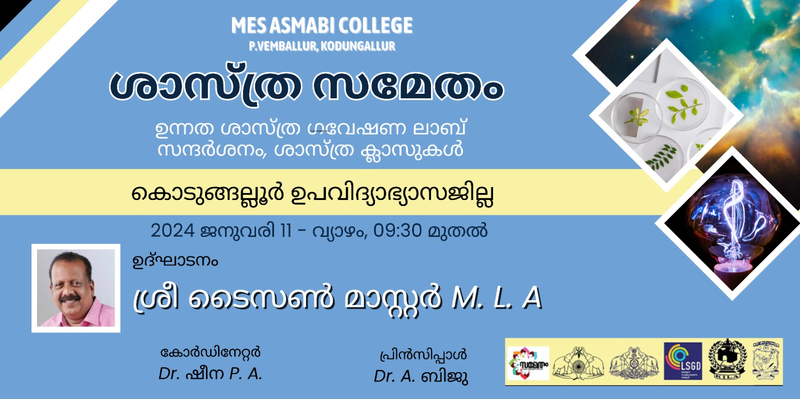

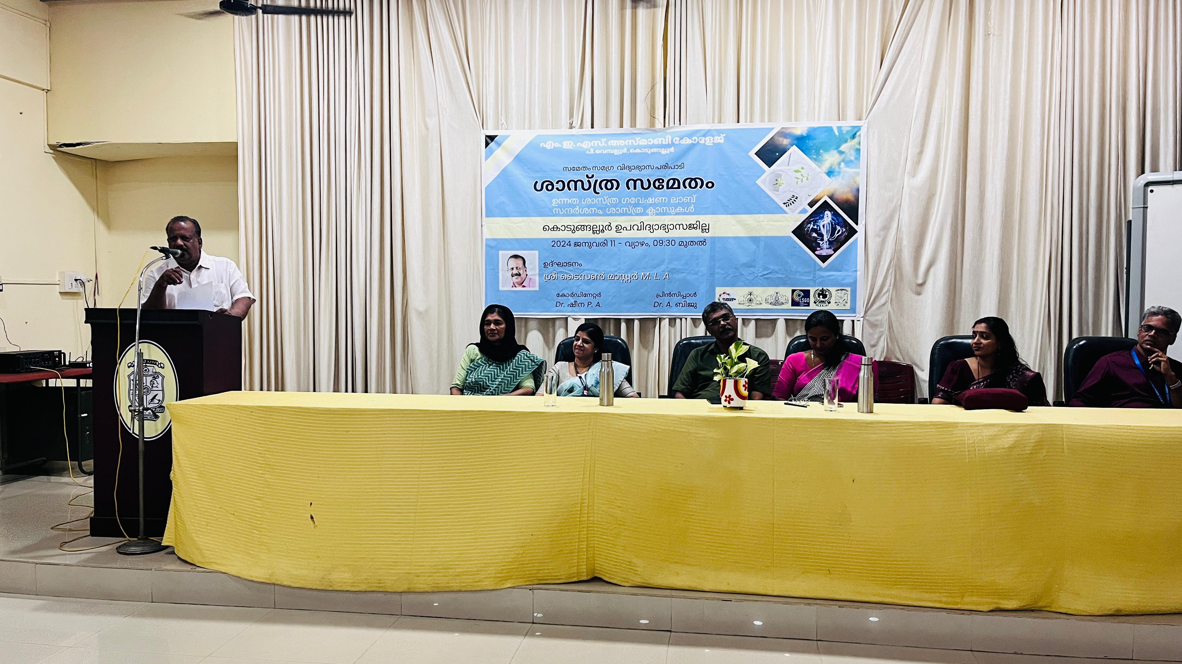

Kaipamangalam MLA Shri Taison Master inaugurated the programme in the meeting presided over by District Panchayat member Mrs. Jaya K. Mr. Manoj V Assistant Coordinator explained the project. Dr Reena Muhammad, Vice Principal, M E S Asmabi College offered felicitation for the programme. Kodungallur Sub-District Education Officer Mrs Geeta C R welcomed the gathering and Science Club Convener Mrs Simla P C proposed vote of thanks.
Dr Amita Bachan K H, Assistant Professor, Department of Botany and Mr Mohammed Areej, Assistant Professor, Department of Biochemistry conducted science awareness classes.
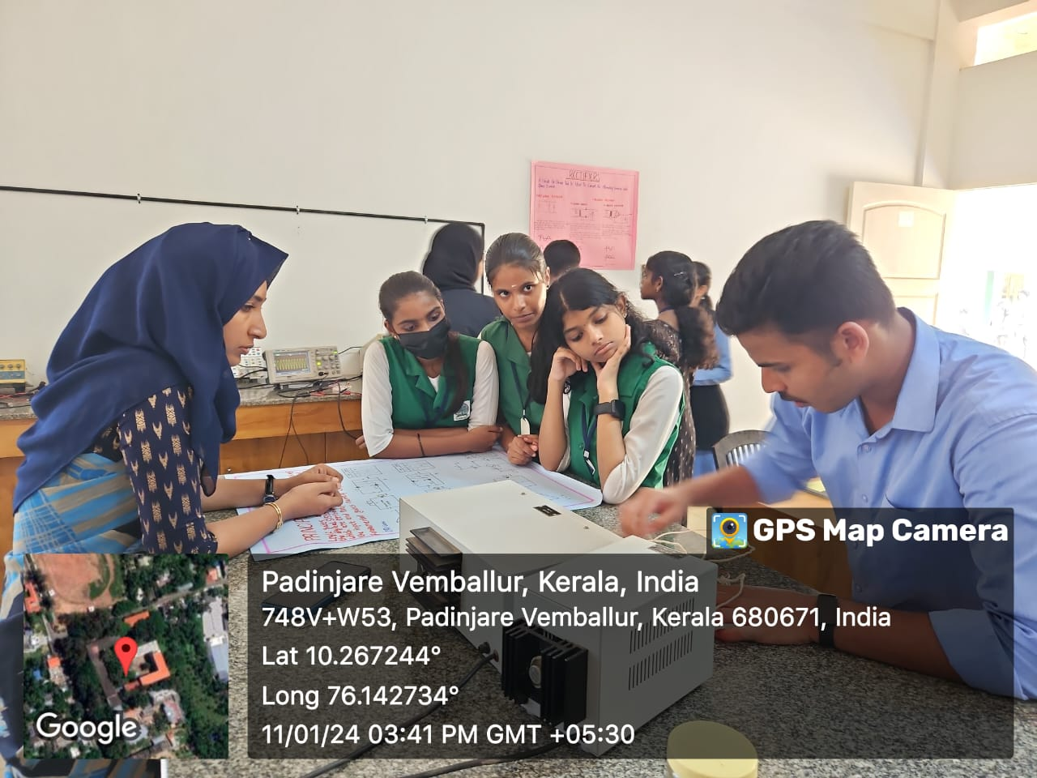
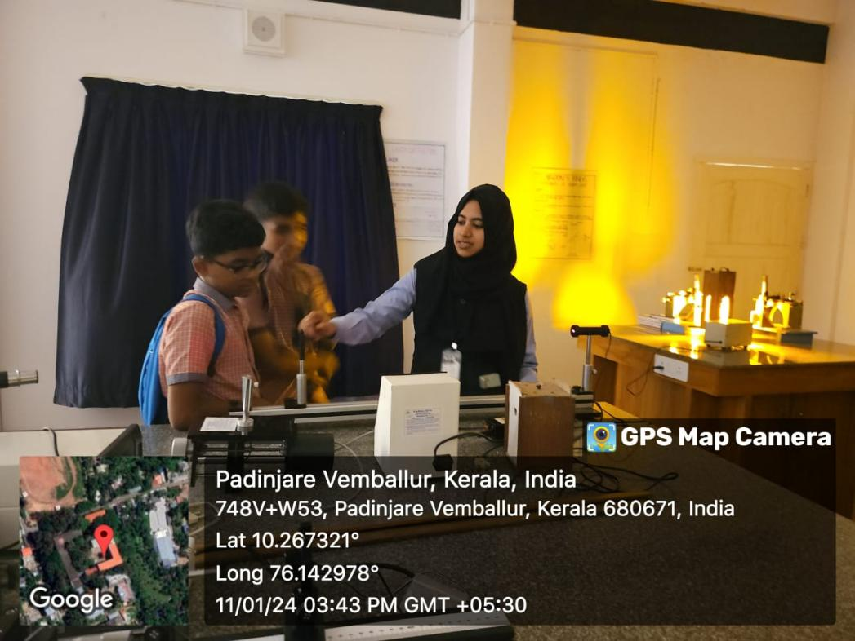
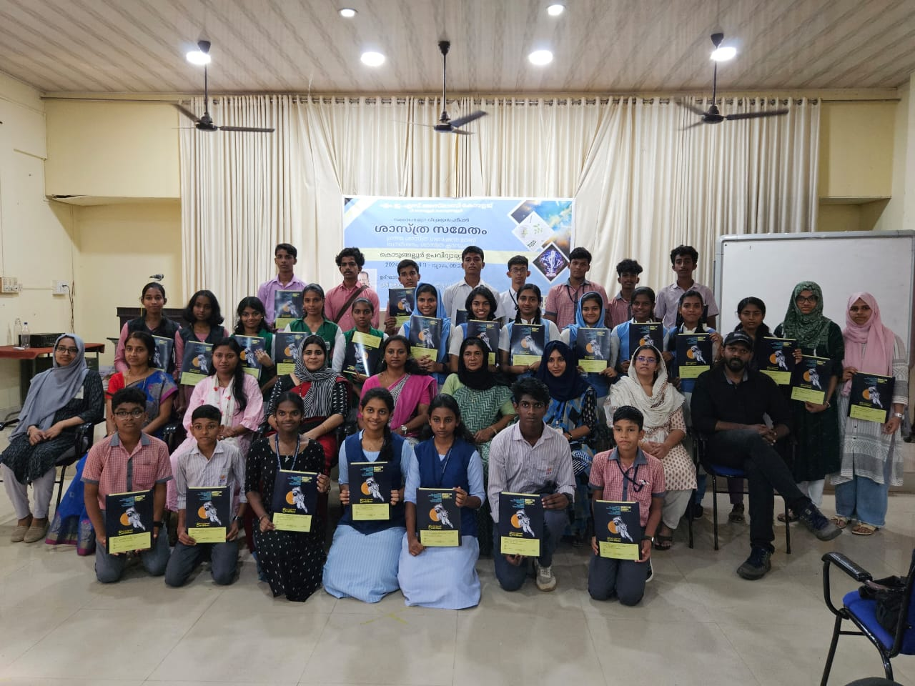
After the class, the students were given an opportunity to visit the laboratories of the Departments of Botany, Physics, Aquaculture, Psychology and Fish Processing Technology. In the Deparment of Physics students visited UG lab, Optics lab, PG Electronics lab and Modern Physics lab. The students and teachers of the department demonstrated the experiments. At the closing ceremony, Dr Reena Mohammed distributed certificates to the participants and College Coordinator Dr SheenaP A delivered vote of thanks.

